***Sound & Stage Entertainment***

Sound & Stage Entertainment was founded in 1995. It started as an event management company but later acquired land and developed 15 world class movie theaters across the United States. Each of these theaters is a multiplex that shows two to four movies at a time. The company generates considerable revenue from these theaters.

The Current System

Sound & Stage Entertainment manages 15 movie theatres. Each theatres has a booking counter where people can buy tickets for the current and upcoming shows. In addition, people can enquire about seat availability for a particular show over the phone.

In the last board meeting, the CEO of Sound & Stage Entertainment, Roger Hanks, pointed out the following problems in the existing system:

§ People need to stand in long queues to buy their tickets.

§ People need to visit the theater to book tickets for upcoming shows.

§ Advance ticket booking is permitted only during the theater’s working hours.

§ People find phone lines busy most of the times whenever they want to enquire about seat availability for a particular show. As a result, they have to visit the theater personally to check the seat availability for a particular show.

§ People need to visit the theater or read the newspapers to know about the new releases.

Roger Hanks has observed that the number of people visiting the theaters has rapidly increased. The theaters have a good seating capacity, and the shows are running house full. At the same time, many people are not able to get tickets for the current shows after spending a lot of time in the queue.

The Envisioned System

Sound & Stage Entertainment wants to set up and use an automated system to facilitate across the counter and online booking. The online option will enable users to book their tickets in advance, select preferred seats, and place an order for snacks.

Each theater consists of four halls. Sound & Stage Entertainment wants to use the new system for all its 60 halls. In addition, the new system should be scalable.

In an attempt to unify all its systems, the company proposes to create and use the following components:

§ An Internet-enabled application will be created.

§ A central repository that will store all information.

§ An online website that can provide real-time information about the availability of seats and enable users to book movie tickets. This website will connect to the central repository to fetch and store all data. Users who book tickets online will be assigned a unique code. They need to provide this unique code at the theater in order to collect the tickets. This online system should provide a real-time view of the availability and status of tickets.

§ A real-time Web-based interface that can be used for making bookings at the ticket counters. This Web interface will connect to the central repository to fetch and store data. This ticketing system should be able to generate tickets at a considerable rate to cope up with the heavy footfall at the theaters.

The central repository will contain all master data, including the data captured during the ticket booking procedure. It should be able to generate seating plans dynamically for each hall. The technical team needs to consider the following facts:

§ Each theater consists of four halls.

§ Each hall has a different seating plan, which needs to be digitally stored in the repository such that:

· Each seat can be uniquely identified.

· The complete seating plan can be displayed to assist online users as well as point-of-sales (POS) officers to pick and choose seats during a ticket sale.

· Booking a seat should mark it as reserved, and it cannot be booked again unless the ticket is cancelled. Seats marked as red in the seating arrangement figure are deemed as booked.

· The seats that have not been booked are shown in the grey colour. The seats that fall at invalid locations (such as the aisles, or halls with curved seating arrangements) cannot be booked. The following figure shows a sample of the seating arrangement.

The Seating Arrangement Sample

· Each hall has multiple shows in a day, specified by a show start time and a show end time.

· There should be a list of snacks in the repository such that users and POS officers can select items when booking a ticket.

The ticketing counter application will be a Web-based interface to be used at the ticket counters at the 15 theaters. This system will be used only by POS officers. It will have the following features:

§ The system will be Internet enabled and will run as a website.

§ The POS officers will be able to see the status of each seat for a show and then book or cancel tickets.

§ All POS officers will be given a username and a password.

§ The POS officers should be able to print a ticket by entering the unique code provided by the customers who have booked tickets online.

§ The POS officers will be given the option to log on, log off, and change their password.

Similar to the ticketing counter application, the online ticket purchase system will be connected to the central repository. The online system will have the following features:

§ Users will be able to select their movie, preferred seats, and the show timing.

§ Users will be provided with a seating plan for the theater they’ve chosen along with a suggested seating pattern based on the availability of seats.

§ Users will be able to select an available seat by clicking the seat shown in the map.

§ Users will be able to select snacks and specify the quantity.

§ After selecting the seats and snacks, users will proceed to the checkout section to pay the total amount by using a credit card.

§ After the payment transaction is complete, users will be provided with a unique code that they need to specify for collecting the tickets at the theater.

**System Architecture**

The system follows a three-tier approach along with the MVC - 1 design pattern.

The new system will be designed by using the three-tier architecture, which consists of the following tiers:

§ Presentation tier: This layer consists of Web pages. The pages can be used to accept data and display the final results to the users. In addition, these pages can be used to view data such as statement and account summary.

§ Business logic layer tier: This layer contains the code required to manage the data.

§ Data tier: This layer consists of the SQL Server 2005 database used to store the relevant data.

The following pages are quintessential in the system:

§ Log on Page

§ Administration Pages

§ Operational Pages

**Log on Page**

**login**

· Description: Allows users to log on to the system. This page is used only by the ticketing counter (POS) officers.

· Information Available/Required

Username: Logon name of the user.

Password: Password for the user.

· Functions Available

Logon: Fires the Logon routine with the username and password, assigns the required rights, and updates the relevant session variables.

Exit: Closes the Web page.

Administration Pages

**sites**

§ Description: Displays a list of sites in the system. Each site has multiple theaters in it.

§ Information Available/Required

· Site Code: A unique code for each site.

· Site Location: Geographical location of the site.

§ Functions Available

· List All: Lists all sites.

· Add a Theatre: Allows addition of a site.

· Delete a Site: Deletes a site.

· Edit Site Details: Edits a site.

**movie theaters**

§ Description: Displays the list of movie theaters in the system and allows addition/updation/deletion of movie theaters. Only the administrator will be able to update the details of the movie theater.

§ Information Available/Required

· Hall Code: A unique code for a movie hall.

· Hall Plan: The plan layout of the hall.

· Site: The site to which this theater belongs.

§ Functions Available

· List All: Lists all movie theaters.

· Add a Theatre: Allows addition of a theater.

· Delete a Theatre: Deletes a theater from the system.

· Edit Theater Details: Edits a theater.

**plan_layout**

§ Description: Allows creation/updation/deletion of the movie theater plans. Each plan is made up of rows and columns. The final image on the screen is rendered as an m x n matrix where m is the number of rows and n is the number of columns. Administrators can design the plan by marking seats as valid/invalid. All valid seats can be booked whereas; invalid seats are not rendered on the screen.

§ Information Available/Required

· Plan Code: A unique code for the plan.

· Design Matrix: The design matrix is an m x n matrix that shows the seats in the plan. Administrators can design the plan by marking seats as valid/invalid. All valid seats can be booked whereas invalid seats are not rendered on the screen. Administrator will be able to flag a seat valid/invalid by clicking/checking on them.

§ Functions Available

· List All: Lists all plans.

· Add a Plan: Allows addition of a new plan. The system takes as input the number of rows and columns in the layout plan and generates a matrix.

· Delete a Layout Plan: Deletes a layout plan.

· Edit Layout Plan: Edits a layout plan.

**seats_mapping**

· Description: Allows linking seats to a particular movie theater. After a plan layout is applied to a theater, the physical seats should be mapped to a unique code for every seat. This unique code will be used by the POS officers while booking the ticket.

· Information Available/Required

Plan: The plan for which the seat mapping is defined.

Movie Theater: The movie theater for which this mapping is applicable.

Mapping Matrix: The mapping matrix shows a matrix that can be used to assign the mapping between the unique code of the seat and the physical name of the seat in the theater.

· Functions Available

Show Seat Mapping by Theater: Shows the seat map after selecting a theater name from a drop-down list.

Create Seat Mapping: Generates a mapping for a plan.

Delete Seat Mapping: Deletes all seat mappings for a plan code.

Edit a Seat Mapping: Edits an existing seat mapping.

movies

§ Description: Allows creation/updation/deletion of movies in the system.

§ Information Available/Required

· Movie Name: Name of the movie.

· Movie Intro: An introduction of the movie.

· Genre: Genre of the movie.

· Cast Of Characters: Cast of the movie.

§ Functions Available

· List All Playing Movies: Lists all movies that are playing.

· Add New Movie: Adds a new movie to the system.

· Delete a Movie: Deletes a movie from the system.

· Edit a Movie: Edits details of a movie in the system.

**shows**

§ Description: Allows creating multiple shows for a movie.

§ Information Available/Required

· Movie Name: Name of the movie.

· Show Start Timings: The start time of the movie.

· Show End Time: The end time of the movie.

· Movie Hall: The hall in which the movie will be screened.

· Price: The price of the ticket for the particular show.

§ Functions Available

· List all Shows by Movie: Lists all the shows by movie name.

· Add a New Show: Adds a new show.

· Delete a Show: Deletes a show for a movie.

· Edit Show: Edits details of the show.

**snack**

§ Description: Maintains a master list of the snacks according to a theater.

§ Information Available/Required

· Snack Name: Name of the snack.

· Price: Price of the snack.

§ Functions Available

· List All Snacks: Lists all snacks in the system.

· Add a New Snack: Adds a new snack to the system.

· Delete a Snack: Deletes the details of a snack from the system.

· Edit a Snack: Edits details for a snack in the system.

**Operational Pages**

**onlineticket**

§ Description: Allows online booking a ticket for a movie show.

§ Information Available/Required

· Movie Name: The name of the movie for which the ticket is to be booked. This is selected from a drop-down list.

· Location: The location of the theater where the user wants to watch the movie.

· Show Timings: The timing of the show for which the ticket is desired.

· Price of the Ticket: The total amount payable.

· Snack List: A list of snacks that the user can select from. The price of a snack will be automatically added to the total amount.

· Layout Plan: Shows the plan of the theater and from which the user can select the required seats by clicking on them.

§ Functions Available

· Hold Seat: Reserves a seat when the user clicks on any seat. The seat is tentatively marked as booked. However, a seat held for more than five minutes will be reset.

· Buy Tickets: Generates a collection code after the payment is realized. The collection code is given to the user and the payment is processed at the payment gateway.

· Refresh Availability Status: Refreshes the page and allows the user to see the availability of seats.

**pos**

§ Description: This page is used to create the Web interface to be used at a ticketing counter. The POS Officer can select the movie, the show time, and the location. A matrix showing each seat as a hyperlink is displayed.

Clicking on the hyperlink will allow the POS officer to book the ticket. Additionally, there are messages displaying the total availability status.

§ Information Available/Required

· Movie Name: The name of the movie for which the ticket is to be booked. This is selected from a drop-down list.

· Show Timings: The timing of the show for which the ticket is required.

· Price of the Ticket: The total amount payable.

· Snack List: A list of snacks that the user can select from. Price is automatically added to the total amount.

· Layout Plan: This plan shows the plan of the theater and the user can select the required seats by clicking on them.

§ Functions Available

· Print Ticket by Code: Allows the system to print a ticket with the collection code.

· Generate Ticket: Generates the ticket based on the options specified by a user. A ticket code is generated and printed on the ticket.

· Refresh Availability Status: Refreshes the page and allows the user to see the availability of seats.

· Cancel Ticket: Cancels the ticket by using the ticket code.

**checkout**

§ Description: Handles activities related to bill payment and payment gateway.

logs

§ Description: Displays a log of all the activities in the system within a specified time frame. Will be used by administrators only.

§ Information Available/Required

· A grid consisting of the following columns:

§ - Timestamp of an activity

§ - Activity description

§ - User who has carried out the activity

The following figure shows the ER diagram for the Sound & Stage Entertainment solution.

ER Diagram for the Sound & Stage Entertainment Solution

Create an application to demonstrate the skills you have acquired by developing the described solution.

***CODE***

**code for database table creation:**

create table profiles

(

id int primary key not null GENERATED ALWAYS AS IDENTITY(START WITH 1, INCREMENT BY 1),

username varchar(200),

password varchar(200),

email varchar(200),

phone_no varchar(200),

address varchar(200),

role_name varchar(200),

login_status varchar(200)

);

create table sites

(

id int primary key not null GENERATED ALWAYS AS IDENTITY(START WITH 1, INCREMENT BY 1),

site_name varchar(200),

site_location varchar(200)

);

create table halls

(

id int primary key not null GENERATED ALWAYS AS IDENTITY(START WITH 1, INCREMENT BY 1),

hall_code varchar(200),

hall_plan varchar(200),

site_name varchar(200),

snacks varchar(2000)

);

create table layouts

(

id int primary key not null GENERATED ALWAYS AS IDENTITY(START WITH 1, INCREMENT BY 1),

plan_code varchar(200),

t_rows varchar(200),

t_cols varchar(200),

invalid_seats varchar(2000)

);

create table seat_mappings

(

id int primary key not null GENERATED ALWAYS AS IDENTITY(START WITH 1, INCREMENT BY 1),

hall_code varchar(200),

plan_code varchar(200)

);

create table movies

(

id int primary key not null GENERATED ALWAYS AS IDENTITY(START WITH 1, INCREMENT BY 1),

movie_name varchar(200),

movie_intro varchar(200),

genre varchar(200),

cast_of_characters varchar(200),

pic_url varchar(100)

);

create table shows

(

id int primary key not null GENERATED ALWAYS AS IDENTITY(START WITH 1, INCREMENT BY 1),

show_code varchar(200),

movie_name varchar(200),

start_time varchar(200),

end_time varchar(200),

hall_code varchar(200),

price varchar(200)

);

create table snacks

(

id int primary key not null GENERATED ALWAYS AS IDENTITY(START WITH 1, INCREMENT BY 1),

snack_name varchar(200),

price varchar(200)

);

create table online_tickets

(

id int primary key not null GENERATED ALWAYS AS IDENTITY(START WITH 1, INCREMENT BY 1),

movie_name varchar(200),

location varchar(200),

start_time varchar(200),

end_time varchar(200),

selected_seats varchar(200),

selected_seats_count varchar(200),

price varchar(200),

qty varchar(200),

snacks varchar(200),

total_price varchar(200)

);

create table pos

(

id int primary key not null GENERATED ALWAYS AS IDENTITY(START WITH 1, INCREMENT BY 1),

site_location varchar(200),

start_time varchar(200),

end_time varchar(200),

price varchar(200),

snack_list varchar(200),

plan_code varchar(200)

);

**Query to create database admin control:**

update PROFILES SET Role_Name='Admin' where username = 'vasudev'

**Home.jsp**

<%--

Document : Home

Created on : 4 May, 2016, 2:48:06 PM

Author : Vasudev

--%>

<%@page import="java.sql.ResultSet"%>

<%@page import="java.sql.PreparedStatement"%>

<%@page import="java.sql.Connection"%>

<%@page import="javax.sql.DataSource"%>

<%@page import="javax.naming.InitialContext"%>

<%@page import="javax.naming.Context"%>

<%@ taglib prefix="c" uri="http://java.sun.com/jsp/jstl/core" %>

<%@page contentType="text/html" pageEncoding="UTF-8"%>

<!DOCTYPE html>

<html>

<head>

<meta http-equiv="Content-Type" content="text/html; charset=UTF-8">

<title>JSP Page</title>

</head>

<body>

<%

System.out.println("Welcome to Home");

Context ctx = new InitialContext();

DataSource ds = (DataSource)ctx.lookup("jdbc/SnS");

Connection conn = ds.getConnection();

if( conn != null )

{

System.out.println("Connected");

String query = "Select Login_Status from Profiles where username=?";

PreparedStatement psmt = conn.prepareStatement(query);

psmt.setString(1, (String)request.getAttribute("login_name"));

System.out.println( (String)request.getAttribute("login_name") );

ResultSet rs = psmt.executeQuery();

boolean flag = false;

String role = "";

while( rs.next() )

{

if( rs.getString(1).equals("Logged_In") )

{

flag = true;

break;

}

}

if( flag )

{

%>

<h1 style="

position: absolute;

top: -10px;

left: 0px;

right: 0px;

height: 60px;

background-color: rgb(128,0,0);

color: #FFFFFF;

text-align: center;

vertical-align: middle;

line-height: 60px;

border: 2px solid #FFC706;

box-shadow: 5px 25px 40px #555555;

font-style: italic;

font-weight: bold;

font-family: 'Calibri';

">Sound and Stage Entertainment</h1>

<a style="

position: absolute;

top: 15px;

right: 120px;

height: 50px;

line-height: 50px;

background-color: rgb(220,220,0);

color: #333333;

text-align: center;

vertical-align: middle;

border: 2px solid #FFC706;

box-shadow: 5px 25px 40px #000000;

font-style: italic;

font-weight: bold;

font-family: 'Calibri';

padding-left: 20px;

padding-right: 20px;

" href="index.html">Log Out</a>

<iframe style="

position: absolute;

top: 85px;

left: 5px;

width: 98.9%;

height: 85%;

background-color: rgb(250,258,255);

color: #FFFFFF;

vertical-align: middle;

line-height: 60px;

border: 2px solid #FFC706;

box-shadow: 5px 25px 40px #000000;

background-image: url('./images/now_showing.jpg');

background-repeat: repeat;

background-size: auto;

"/>

<%

if( role.equals("Normal") )

{

}

else if( role.equals("Admin") )

{

}

}

else

{

%>

<h1>Invalid Login</h1>

<%

}

conn.close();

}

%>

</body>

</html>

**Registrationpage.jsp**

<%@page import="java.sql.ResultSetMetaData"%>

<%@page import="java.sql.ResultSet"%>

<%@page import="java.sql.PreparedStatement"%>

<%@page import="java.sql.Connection"%>

<%@page import="javax.sql.DataSource"%>

<%@page import="javax.naming.Context"%>

<%@page import="javax.persistence.EntityManagerFactory"%>

<%@page import="javax.persistence.PersistenceUnit"%>

<%@page import="javax.naming.InitialContext"%>

<%@page import="java.util.List"%>

<%@page import="javax.annotation.Resource"%>

<%@page import="javax.persistence.EntityManager"%>

<%@page import="javax.persistence.PersistenceContext"%>

<%@page import="databasepack.Profiles"%>

<%@ taglib prefix="c" uri="http://java.sun.com/jsp/jstl/core" %>

<%@page contentType="text/html" pageEncoding="UTF-8"%>

<!DOCTYPE html>

<html>

<head>

<meta http-equiv="Content-Type" content="text/html; charset=UTF-8">

<title>JSP Page</title>

</head>

<body>

<c:set var="error_msg" value=""/>

<%

String values[] = request.getParameterValues("registration");

String errormsg = "";

if( values != null )

{

for( String x: values )

{

if( x.equals("") )

{

errormsg = "Empty Value(s) not allowed.";

%>

<c:set var="error_msg" value="<%=errormsg%>"/>

<%

break;

}

}

if( errormsg.equals("") )

{

if( !values[2].equals(values[3]) )

{

errormsg = "Passwords must match";

%>

<c:set var="error_msg" value="<%=errormsg%>"/>

<%

}

}

if( errormsg.equals("") )

{

try

{

Long.parseLong(values[4]);

if( values[4].length() < 10 )

{

errormsg = "Phone number length Invalid";

%>

<c:set var="error_msg" value="<%=errormsg%>"/>

<%

}

else

{

errormsg = "All good";

}

}

catch(Exception e)

{

errormsg = "Invalid Phone Number.";

%>

<c:set var="error_msg" value="<%=errormsg%>"/>

<%

}

}

if( errormsg.equals("All good") )

{

Context ctx = new InitialContext();

DataSource ds = (DataSource)ctx.lookup("jdbc/SnS");

Connection conn = ds.getConnection();

if( conn != null )

{

String query = "Select * from Profiles where username=?";

PreparedStatement psmt = conn.prepareStatement(query);

psmt.setString(1, values[0]);

ResultSet rs = psmt.executeQuery();

//ResultSetMetaData rsmd = rs.getMetaData();

int count = 0;

while( rs.next() ) count++;

if( count != 0 )

{

errormsg = "User Already Exists";

%>

<c:set var="error_msg" value="<%=errormsg%>"/>

<%

}

else

{

query = "insert into Profiles "

+ "(username,"

+ "password ,"

+ "email ,"

+ "phone_no ,"

+ "address ,"

+ "role_name,"

+ "login_status)"

+ " values "

+ "(?,?,?,?,?,'Normal','Logged_Out')"

+ "";

psmt = conn.prepareStatement(query);

psmt.setString(1, values[0]);

psmt.setString(2, values[2]);

psmt.setString(3, values[1]);

psmt.setString(4, values[4]);

psmt.setString(5, values[5]);

psmt.executeUpdate();

errormsg = "User Updated Successfully";

%>

<c:set var="error_msg" value="<%=errormsg%>"/>

<%

}

conn.close();

}

}

}

%>

<h1 style="

position: absolute;

top: -10px;

left: 0px;

right: 0px;

height: 60px;

background-color: rgb(128,0,0);

color: #FFFFFF;

text-align: center;

vertical-align: middle;

line-height: 60px;

border: 2px solid #FFC706;

box-shadow: 5px 25px 40px #555555;

font-style: italic;

font-weight: bold;

font-family: 'Calibri';

">Sound and Stage Entertainment</h1>

<a style="

position: absolute;

top: 15px;

right: 120px;

height: 50px;

line-height: 50px;

background-color: rgb(220,220,0);

color: #333333;

text-align: center;

vertical-align: middle;

border: 2px solid #FFC706;

box-shadow: 5px 25px 40px #000000;

font-style: italic;

font-weight: bold;

font-family: 'Calibri';

padding-left: 20px;

padding-right: 20px;

" href="index.html">Home</a>

<div style="

position: absolute;

top: 15px;

left: 20px;

height: 50px;

width: 250px;

line-height: 50px;

background: none;

color: #FFFFFF;

text-align: center;

vertical-align: middle;

border: 0px solid #FFC706;

box-shadow: 0px 5px 20px #000000;

font-style: italic;

font-weight: bold;

font-family: 'Calibri';

padding-left: 20px;

padding-right: 20px;

">${error_msg}</div>

<form method="post" action="Registration.jsp" style="

position: absolute;

top: 85px;

left: 5px;

width: 98.9%;

height: 85%;

background-color: rgb(250,258,255);

color: #FFFFFF;

vertical-align: middle;

line-height: 60px;

border: 2px solid #FFC706;

box-shadow: 5px 25px 40px #000000;

background-image: url('./registration.jpg');

background-repeat: no-repeat;

background-size: cover;

">

<input type="text" name="registration" autofocus="true" placeholder="Enter Username..." style="

position: absolute;

top: 85px;

left: 145px;

width: 25%;

height: 10%;

background-color: rgb(250,258,255);

color: #000000;

vertical-align: middle;

line-height: 60px;

border: 2px solid #FFC706;

box-shadow: 5px 25px 40px #000000;

padding-left: 10px;

padding-right: 10px;

font-family: 'Calibri';

font-size: 20px;

<%

if( values != null )

{

%>

" value="<%=values[0]%>"/>

<%

}

else

{

%>

"/>

<%

}

%>

<input type="email" name="registration" placeholder="Enter Email ID..." style="

position: absolute;

top: 85px;

right: 145px;

width: 25%;

height: 10%;

background-color: rgb(250,258,255);

color: #000000;

vertical-align: middle;

line-height: 60px;

border: 2px solid #FFC706;

box-shadow: 5px 25px 40px #000000;

padding-left: 10px;

padding-right: 10px;

font-family: 'Calibri';

font-size: 20px;

<%

if( values != null )

{

%>

" value="<%=values[1]%>"/>

<%

}

else

{

%>

"/>

<%

}

%>

<input type="password" name="registration" placeholder="Enter Password..." style="

position: absolute;

top: 185px;

left: 195px;

width: 25%;

height: 10%;

background-color: rgb(250,258,255);

color: #000000;

vertical-align: middle;

line-height: 60px;

border: 2px solid #FFC706;

box-shadow: 5px 25px 40px #000000;

padding-left: 10px;

padding-right: 10px;

font-family: 'Calibri';

font-size: 20px;

<%

if( values != null )

{

%>

" value="<%=values[2]%>"/>

<%

}

else

{

%>

"/>

<%

}

%>

<input type="password" name="registration" placeholder="Confirm Password..." style="

position: absolute;

top: 185px;

right: 195px;

width: 25%;

height: 10%;

background-color: rgb(250,258,255);

color: #000000;

vertical-align: middle;

line-height: 60px;

border: 2px solid #FFC706;

box-shadow: 5px 25px 40px #000000;

padding-left: 10px;

padding-right: 10px;

font-family: 'Calibri';

font-size: 20px;

<%

if( values != null )

{

%>

" value="<%=values[3]%>"/>

<%

}

else

{

%>

"/>

<%

}

%>

<input type="phone" name="registration" placeholder="Enter Phone No. ..." style="

position: absolute;

top: 290px;

left: 245px;

width: 25%;

height: 10%;

background-color: rgb(250,258,255);

color: #000000;

vertical-align: middle;

line-height: 60px;

border: 2px solid #FFC706;

box-shadow: 5px 25px 40px #000000;

padding-left: 10px;

padding-right: 10px;

font-family: 'Calibri';

font-size: 20px;

<%

if( values != null )

{

%>

" value="<%=values[4]%>"/>

<%

}

else

{

%>

"/>

<%

}

%>

<input type="text" name="registration" placeholder="Enter Address..." style="

position: absolute;

top: 290px;

right: 245px;

width: 25%;

height: 10%;

background-color: rgb(250,258,255);

color: #000000;

vertical-align: middle;

line-height: 60px;

border: 2px solid #FFC706;

box-shadow: 5px 25px 40px #000000;

padding-left: 10px;

padding-right: 10px;

font-family: 'Calibri';

font-size: 20px;

<%

if( values != null )

{

%>

" value="<%=values[5]%>"/>

<%

}

else

{

%>

"/>

<%

}

%>

<input type="submit" value="Go" style="

position: absolute;

top: 410px;

right: 495px;

width: 25%;

height: 60px;

background-color: rgb(0,244,255);

color: #000000;

vertical-align: middle;

line-height: 40px;

border: 5px solid #FFFFFF;

box-shadow: 5px 25px 40px #000000;

padding-left: 10px;

padding-right: 10px;

font-family: 'Calibri';

font-size: 20px;

"/>

</form>

</body>

</html>

***CODE FOR ADMINISTRATIVE PAGES:***

**1.AdminHome:**

<%@page import="java.sql.ResultSet"%>

<%@page import="java.sql.PreparedStatement"%>

<%@page import="java.sql.Connection"%>

<%@page import="javax.sql.DataSource"%>

<%@page import="javax.naming.InitialContext"%>

<%@page import="javax.naming.Context"%>

<%@ taglib prefix="c" uri="<http://java.sun.com/jsp/jstl/core>" %>

<%@page contentType="text/html" pageEncoding="UTF-8"%>

<!DOCTYPE html>

<html>

<head>

<meta http-equiv="Content-Type" content="text/html; charset=UTF-8">

<title>Admin Home</title>

</head>

<body>

<h1 style="

position: absolute;

top: -10px;

left: 0px;

right: 0px;

height: 60px;

background-color: rgb(128,0,0);

color: #FFFFFF;

text-align: center;

vertical-align: middle;

line-height: 60px;

border: 2px solid #FFC706;

box-shadow: 5px 25px 40px #555555;

font-style: italic;

font-weight: bold;

font-family: 'Calibri';

">Sound and Stage Entertainment</h1>

<a style="

position: absolute;

top: 15px;

right: 120px;

height: 50px;

line-height: 50px;

background-color: rgb(220,220,0);

color: #333333;

text-align: center;

vertical-align: middle;

border: 2px solid #FFC706;

box-shadow: 5px 25px 40px #000000;

font-style: italic;

font-weight: bold;

font-family: 'Calibri';

padding-left: 20px;

padding-right: 20px;

" href="index.html">Log Out</a>

<div style="

position: absolute;

top: 85px;

left: 5px;

width: 98.9%;

height: 85%;

background-color: rgb(250,258,255);

color: #FFFFFF;

vertical-align: middle;

line-height: 60px;

border: 2px solid #FFC706;

box-shadow: 5px 25px 40px #000000;

background-image: url('./images/now_showing.jpg');

background-repeat: repeat;

background-size: auto;

">

<hr style="position: absolute; top: 105px; width: 100%;"/>

<a style="

position: absolute;

top: 35px;

left: 150px;

height: 50px;

line-height: 50px;

background-color: rgb(120,220,120);

color: #333333;

text-align: center;

vertical-align: middle;

border: 2px solid #FFFFFF;

box-shadow: 5px 25px 40px #000000;

font-style: italic;

font-weight: bold;

font-family: 'Calibri';

padding-left: 20px;

padding-right: 20px;

z-index: 2;

" href="AdminSites.jsp">Sites</a>

<a style="

position: absolute;

top: 35px;

right: 280px;

height: 50px;

line-height: 50px;

background-color: rgb(120,220,120);

color: #333333;

text-align: center;

vertical-align: middle;

border: 2px solid #FFFFFF;

box-shadow: 5px 25px 40px #000000;

font-style: italic;

font-weight: bold;

font-family: 'Calibri';

padding-left: 20px;

padding-right: 20px;

z-index: 2;

" href="index.html">Movie Theaters</a>

<a style="

position: absolute;

top: 35px;

left: 250px;

height: 50px;

line-height: 50px;

background-color: rgb(120,220,120);

color: #333333;

text-align: center;

vertical-align: middle;

border: 2px solid #FFFFFF;

box-shadow: 5px 25px 40px #000000;

font-style: italic;

font-weight: bold;

font-family: 'Calibri';

padding-left: 20px;

padding-right: 20px;

z-index: 2;

" href="index.html">Plan Layout</a>

<a style="

position: absolute;

top: 35px;

left: 400px;

height: 50px;

line-height: 50px;

background-color: rgb(120,220,120);

color: #333333;

text-align: center;

vertical-align: middle;

border: 2px solid #FFFFFF;

box-shadow: 5px 25px 40px #000000;

font-style: italic;

font-weight: bold;

font-family: 'Calibri';

padding-left: 20px;

padding-right: 20px;

z-index: 2;

" href="index.html">Seats Mapping</a>

<a style="

position: absolute;

top: 35px;

left: 570px;

height: 50px;

line-height: 50px;

background-color: rgb(120,220,120);

color: #333333;

text-align: center;

vertical-align: middle;

border: 2px solid #FFFFFF;

box-shadow: 5px 25px 40px #000000;

font-style: italic;

font-weight: bold;

font-family: 'Calibri';

padding-left: 20px;

padding-right: 20px;

z-index: 2;

" href="index.html">Movies</a>

<a style="

position: absolute;

top: 35px;

left: 690px;

height: 50px;

line-height: 50px;

background-color: rgb(120,220,120);

color: #333333;

text-align: center;

vertical-align: middle;

border: 2px solid #FFFFFF;

box-shadow: 5px 25px 40px #000000;

font-style: italic;

font-weight: bold;

font-family: 'Calibri';

padding-left: 20px;

padding-right: 20px;

z-index: 2;

" href="index.html">Shows</a>

<a style="

position: absolute;

top: 35px;

left: 805px;

height: 50px;

line-height: 50px;

background-color: rgb(120,220,120);

color: #333333;

text-align: center;

vertical-align: middle;

border: 2px solid #FFFFFF;

box-shadow: 5px 25px 40px #000000;

font-style: italic;

font-weight: bold;

font-family: 'Calibri';

padding-left: 20px;

padding-right: 20px;

z-index: 2;

" href="index.html">Snacks</a>

<div style="

position: absolute;

top: 125px;

left: 5px;

width: 98.9%;

height: 60%;

background-color: rgb(250,258,255);

text-align: center;

color: #FFFFFF;

vertical-align: middle;

padding-top: 90px;

border: 2px solid #FFC706;

box-shadow: 5px 25px 40px #000000;

background-image: url('./images/now_showing.jpg');

background-repeat: repeat;

background-size: auto;

font-family: 'Calibri';

">

<h1> Please click on any of the above mentioned links, to begin configuring the system </h1>

</div>

</div>

</body>

</html>

**2.AdminMovieTheatres:**

<%@page import="java.sql.ResultSetMetaData"%>

<%@page import="java.sql.ResultSet"%>

<%@page import="java.sql.PreparedStatement"%>

<%@page import="java.sql.Connection"%>

<%@page import="javax.sql.DataSource"%>

<%@page import="javax.naming.InitialContext"%>

<%@page import="javax.naming.Context"%>

<%@ taglib prefix="c" uri="<http://java.sun.com/jsp/jstl/core>" %>

<%@page contentType="text/html" pageEncoding="UTF-8"%>

<!DOCTYPE html>

<html>

<head>

<meta http-equiv="Content-Type" content="text/html; charset=UTF-8">

<title>Admin Movie Theatres</title>

</head>

<body>

<c:set var="error_msg" value=""/>

<%

String values[] = request.getParameterValues("halls");

String errormsg = "";

String delete = null;

try

{

if( values != null )

{

System.out.println( values[3] );

delete = values[3];

for( String x: values )

{

System.out.println( x );

if( x.equals("") )

{

errormsg = "Empty Value(s) not allowed.";

%>

<c:set var="error_msg" value="<%=errormsg%>"/>

<%

break;

}

}

if( errormsg.equals("") )

{

Context ctx = new InitialContext();

DataSource ds = (DataSource)ctx.lookup("jdbc/SnS");

Connection conn = ds.getConnection();

if( conn != null )

{

String query;

PreparedStatement pstmt;

if( delete.equals("false") )

{

/////////////

query = "select * from halls where hall_code=?";

pstmt = conn.prepareStatement(query);

pstmt.setString(1, values[0]);

ResultSet rs = pstmt.executeQuery();

int count = 0;

while( rs.next() ) count++;

if( count == 0 )

{

query = "insert into halls (hall_code,hall_plan,site_name,snacks) values (?,?,?,?)";

pstmt = conn.prepareStatement(query);

pstmt.setString(1, values[0]);

pstmt.setString(2, values[1]);

pstmt.setString(3, values[2]);

String temp = "";

for( int i = 4 ; i < values.length-1 ; i++ )

temp += values[i] + ",";

temp += values[values.length-1];

pstmt.setString(4, temp);

pstmt.executeUpdate();

errormsg = "Added Successfully.";

%>

<c:set var="error_msg" value="<%=errormsg%>"/>

<%

}

else

{

query = "update halls set hall_code = ? , hall_plan = ? , site_name = ? , snacks = ? where hall_code=?";

pstmt = conn.prepareStatement(query);

pstmt.setString(1, values[0]);

pstmt.setString(2, values[1]);

pstmt.setString(3, values[2]);

String temp = "";

for( int i = 4 ; i < values.length-1 ; i++ )

temp += values[i] + ",";

temp += values[values.length-1];

pstmt.setString(4, temp);

pstmt.setString(5, values[0]);

pstmt.executeUpdate();

errormsg = "Updated Successfully.";

%>

<c:set var="error_msg" value="<%=errormsg%>"/>

<%

}

/////////////

}

else

{

query = "delete from halls where hall_code = ?";

pstmt = conn.prepareStatement(query);

pstmt.setString(1, values[0]);

pstmt.executeUpdate();

errormsg = "Deleted Successfully.";

%>

<c:set var="error_msg" value="<%=errormsg%>"/>

<%

values=null;

}

conn.close();

}

}

}

}

catch(Exception e)

{

e.printStackTrace();

errormsg = "Error on Page";

%>

<c:set var="error_msg" value="<%=errormsg%>"/>

<%

}

%>

<h1 style="

position: absolute;

top: -10px;

left: 0px;

right: 0px;

height: 60px;

background-color: rgb(128,0,0);

color: #FFFFFF;

text-align: center;

vertical-align: middle;

line-height: 60px;

border: 2px solid #FFC706;

box-shadow: 5px 25px 40px #555555;

font-style: italic;

font-weight: bold;

font-family: 'Calibri';

">Sound and Stage Entertainment</h1>

<a style="

position: absolute;

top: 15px;

right: 120px;

height: 50px;

line-height: 50px;

background-color: rgb(220,220,0);

color: #333333;

text-align: center;

vertical-align: middle;

border: 2px solid #FFC706;

box-shadow: 5px 25px 40px #000000;

font-style: italic;

font-weight: bold;

font-family: 'Calibri';

padding-left: 20px;

padding-right: 20px;

" href="index.html">Log Out</a>

<div style="

position: absolute;

top: 15px;

left: 20px;

height: 50px;

width: 250px;

line-height: 50px;

background: none;

color: #FFFFFF;

text-align: center;

vertical-align: middle;

border: 0px solid #FFC706;

box-shadow: 0px 5px 20px #000000;

font-style: italic;

font-weight: bold;

font-family: 'Calibri';

padding-left: 20px;

padding-right: 20px;

">${error_msg}</div>

<div style="

position: absolute;

top: 85px;

left: 5px;

width: 98.9%;

height: 85%;

background-color: rgb(250,258,255);

color: #FFFFFF;

vertical-align: middle;

line-height: 60px;

border: 2px solid #FFC706;

box-shadow: 5px 25px 40px #000000;

background-image: url('./images/now_showing.jpg');

background-repeat: repeat;

background-size: auto;

">

<hr style="position: absolute; top: 105px; width: 100%;"/>

<a style="

position: absolute;

top: 35px;

left: 120px;

width: 100px;

height: 50px;

line-height: 50px;

background-color: rgb(120,220,120);

color: #333333;

text-align: center;

vertical-align: middle;

border: 2px solid #FFFFFF;

box-shadow: 5px 25px 40px #000000;

font-style: italic;

font-weight: bold;

font-family: 'Calibri';

padding-left: 20px;

padding-right: 20px;

z-index: 2;

" href="AdminSites.jsp">Sites</a>

<a style="

position: absolute;

top: 35px;

left: 1020px;

width: 120px;

height: 50px;

line-height: 50px;

background-color: rgb(120,220,120);

color: #333333;

text-align: center;

vertical-align: middle;

border: 2px solid #FFFFFF;

box-shadow: 5px 25px 40px #000000;

font-style: italic;

font-weight: bold;

font-family: 'Calibri';

padding-left: 20px;

padding-right: 20px;

z-index: 2;

" href="AdminMovieTheatres.jsp">Movie Theaters</a>

<a style="

position: absolute;

top: 35px;

left: 300px;

width: 100px;

height: 50px;

line-height: 50px;

background-color: rgb(120,220,120);

color: #333333;

text-align: center;

vertical-align: middle;

border: 2px solid #FFFFFF;

box-shadow: 5px 25px 40px #000000;

font-style: italic;

font-weight: bold;

font-family: 'Calibri';

padding-left: 20px;

padding-right: 20px;

z-index: 2;

" href="AdminPlanLayout.jsp">Plan Layout</a>

<a style="

position: absolute;

top: 35px;

left: 480px;

height: 50px;

width: 100px;

line-height: 50px;

background-color: rgb(120,220,120);

color: #333333;

text-align: center;

vertical-align: middle;

border: 2px solid #FFFFFF;

box-shadow: 5px 25px 40px #000000;

font-style: italic;

font-weight: bold;

font-family: 'Calibri';

padding-left: 20px;

padding-right: 20px;

z-index: 2;

" href="AdminMovies.jsp">Movies</a>

<a style="

position: absolute;

top: 35px;

left: 660px;

height: 50px;

width: 100px;

line-height: 50px;

background-color: rgb(120,220,120);

color: #333333;

text-align: center;

vertical-align: middle;

border: 2px solid #FFFFFF;

box-shadow: 5px 25px 40px #000000;

font-style: italic;

font-weight: bold;

font-family: 'Calibri';

padding-left: 20px;

padding-right: 20px;

z-index: 2;

" href="AdminShows.jsp">Shows</a>

<a style="

position: absolute;

top: 35px;

left: 840px;

width: 100px;

height: 50px;

line-height: 50px;

background-color: rgb(120,220,120);

color: #333333;

text-align: center;

vertical-align: middle;

border: 2px solid #FFFFFF;

box-shadow: 5px 25px 40px #000000;

font-style: italic;

font-weight: bold;

font-family: 'Calibri';

padding-left: 20px;

padding-right: 20px;

z-index: 2;

" href="AdminSnacks.jsp">Snacks</a>

<div style="

position: absolute;

top: 125px;

left: 5px;

width: 98.9%;

height: 60%;

background-color: rgb(250,258,255);

text-align: center;

color: #FFFFFF;

vertical-align: middle;

padding-top: 90px;

border: 2px solid #FFC706;

box-shadow: 5px 25px 40px #000000;

background-image: url('./images/now_showing.jpg');

background-repeat: repeat;

background-size: auto;

font-family: 'Calibri';

">

<div >

<form id="myForm" action="AdminMovieTheatres.jsp" method="post"style="

position: absolute;

top: 0px;

left: 0px;

width: 100%;

height: 35%;

box-shadow: 5px 25px 40px #000000;

background-image: url('./images/now_showing.jpg');

background-repeat: repeat;

background-size: auto;

border-bottom : 2px solid #FFFFFF;

font-family: 'Calibri';

overflow-y: auto;

">

<input type="text" name="halls" autofocus="true" placeholder="Enter Hall Code..." style="

position: absolute;

top: 45px;

left: 165px;

width: 25%;

height: 60px;

background-color: rgb(250,258,255);

color: #000000;

vertical-align: middle;

line-height: 60px;

border: 2px solid #FFC706;

box-shadow: 5px 25px 40px #000000;

padding-left: 10px;

padding-right: 10px;

font-family: 'Calibri';

font-size: 20px;

<%

if( values != null )

{

%>

" value="<%=values[0]%>"/>

<%

}

else

{

%>

"/>

<%

}

%>

<input type="text" name="halls" autofocus="true" placeholder="Enter Hall Plan..." style="

position: absolute;

top: 45px;

left: 765px;

width: 25%;

height: 60px;

background-color: rgb(250,258,255);

color: #000000;

vertical-align: middle;

line-height: 60px;

border: 2px solid #FFC706;

box-shadow: 5px 25px 40px #000000;

padding-left: 10px;

padding-right: 10px;

font-family: 'Calibri';

font-size: 20px;

<%

if( values != null )

{

%>

" value="<%=values[1]%>"/>

<%

}

else

{

%>

"/>

<%

}

%>

<select name="halls" autofocus="true" placeholder="Site Name..." style="

position: absolute;

top: 145px;

left: 165px;

width: 25%;

height: 60px;

background-color: rgb(250,258,255);

color: #000000;

vertical-align: middle;

line-height: 60px;

border: 2px solid #FFC706;

box-shadow: 5px 25px 40px #000000;

padding-left: 10px;

padding-right: 10px;

font-family: 'Calibri';

font-size: 20px;

<%

if( values != null )

{

%>

" value="<%=values[2]%>">

<%

}

else

{

%>

">

<%

}

Context ctx = new InitialContext();

DataSource ds = (DataSource)ctx.lookup("jdbc/SnS");

Connection conn = ds.getConnection();

if( conn != null )

{

String query = "select site_location from sites";

PreparedStatement pstmt = conn.prepareStatement(query);

ResultSet rs = pstmt.executeQuery();

while( rs.next() )

{

%>

<option><%=rs.getString(1)%></option>

<%

}

conn.close();

}

%>

</select>

<input type="hidden" name="halls" id="delete" value="false"/>

<select name="halls" style="

position: absolute;

top: 145px;

left: 765px;

width: 25%;

height: 60px;

background-color: rgb(250,258,255);

color: #000000;

vertical-align: middle;

line-height: 60px;

border: 2px solid #FFC706;

box-shadow: 5px 25px 40px #000000;

padding-left: 10px;

padding-right: 10px;

font-family: 'Calibri';

font-size: 20px;" multiple>

<%

ctx = new InitialContext();

ds = (DataSource)ctx.lookup("jdbc/SnS");

conn = ds.getConnection();

if( conn != null )

{

String query = "select snack_name from snacks";

PreparedStatement pstmt = conn.prepareStatement(query);

ResultSet rs = pstmt.executeQuery();

String temp = "";

if( values != null )

{

for( int i = 4 ; i < values.length-1 ; i++ )

temp += values[i] + ",";

temp += values[values.length-1];

}

if( !rs.next() )

{

%>

<option selected="true">None</option>

<%

}

else

{

do

{

if( temp.contains(rs.getString(1)) )

{

%>

<option selected="true"><%=rs.getString(1)%></option>

<%

}

else

{

%>

<option><%=rs.getString(1)%></option>

<%

}

}while( rs.next() );

}

conn.close();

}

%>

</select>

<input type="submit" value="Go" style="

position: absolute;

top: 48px;

right: 578px;

width: 15%;

height: 60px;

background-color: rgb(0,244,255);

color: #000000;

vertical-align: middle;

line-height: 40px;

border: 5px solid #FFFFFF;

box-shadow: 5px 25px 40px #000000;

padding-left: 10px;

padding-right: 10px;

font-family: 'Calibri';

font-size: 20px;

"/>

<input type="submit" value="X" onclick=" document.getElementById('delete').value='true'; " style="

position: absolute;

top: 48px;

right: 100px;

width: 5%;

height: 60px;

background-color: rgb(228,44,55);

color: #FFFFFF;

vertical-align: middle;

line-height: 40px;

border: 5px solid #FFFFFF;

box-shadow: 5px 25px 40px #000000;

padding-left: 10px;

padding-right: 10px;

font-family: 'Calibri';

font-size: 20px;

"/>

</form>

</div>

<!--<hr style="position: absolute; top: 135px; width: 100%;"/>-->

<div style=" position: absolute; top: 40%; left: 10px; width: 98%; height: 55%; border: 1px solid #FFFFFF;; overflow-y: auto;">

<%

try

{

ctx = new InitialContext();

ds = (DataSource)ctx.lookup("jdbc/SnS");

conn = ds.getConnection();

if( conn != null )

{

String query = "Select * from halls";

PreparedStatement pstmt = conn.prepareStatement(query);

ResultSet rs = pstmt.executeQuery();

%>

<center>

<table style="border: 2px solid #FFC706; font-weight: bold; font-size: 20px; background: #FFFFFF; color: #000000; position: absolute; top: 10%; left: 5%; width: 90%; text-align: center; border-spacing: 0; padding: 50px;">

<tr>

<td style="border: 2px solid #FFC706; background: #CCCCFF;" >Hall Code</td>

<td style="border: 2px solid #FFC706; background: #CCCCFF;">Hall Plan</td>

<td style="border: 2px solid #FFC706; background: #CCCCFF;">Site Name</td>

<td style="border: 2px solid #FFC706; background: #CCCCFF;">Snacks</td>

</tr>

<%

int count = 0;

while( rs.next() )

{

count++;

%>

<tr onclick="

oFormObject = document.forms['myForm'];

oformElement = oFormObject.elements[0];

oformElement.value = '<%=rs.getString(2)%>';

oformElement = oFormObject.elements[1];

oformElement.value = '<%=rs.getString(3)%>';

oformElement = oFormObject.elements[2];

oformElement.value = '<%=rs.getString(4)%>';

var str = '<%=rs.getString(5)%>';

el = oFormObject.elements[4];

for (var i = 0; i < el.length; i++)

{

//alert(el[i].text);

if ( str.indexOf(el[i].text) != -1 )

{

el[i].selected = true;

}

else

{

el[i].selected = false;

}

}

//document.getElementById('myForm').submit();

" >

<td style="border: 2px solid #FFC706;"><%=rs.getString(2)%></td>

<td style="border: 2px solid #FFC706;"><%=rs.getString(3)%></td>

<td style="border: 2px solid #FFC706;"><%=rs.getString(4)%></td>

<td style="border: 2px solid #FFC706;"><%=rs.getString(5)%></td>

</tr>

<%

}

if( count == 0 )

{

%>

<tr>

<td style="border: 2px solid #FFC706;" colspan="4">No Data As Of Now</td>

</tr>

<%

}

%>

</table>

</center>

<%

conn.close();

}

}

catch(Exception e)

{

}

%>

</div>

</div>

</div>

</body>

</html>

---------

**3.AdminMovies:**

<%@page import="java.sql.ResultSetMetaData"%>

<%@page import="java.sql.ResultSet"%>

<%@page import="java.sql.PreparedStatement"%>

<%@page import="java.sql.Connection"%>

<%@page import="javax.sql.DataSource"%>

<%@page import="javax.naming.InitialContext"%>

<%@page import="javax.naming.Context"%>

<%@ taglib prefix="c" uri="<http://java.sun.com/jsp/jstl/core>" %>

<%@page contentType="text/html" pageEncoding="UTF-8"%>

<!DOCTYPE html>

<html>

<head>

<meta http-equiv="Content-Type" content="text/html; charset=UTF-8">

<title>Admin Movies</title>

</head>

<body>

<c:set var="error_msg" value=""/>

<%

String values[] = request.getParameterValues("movies");

String errormsg = "";

String delete = null;

try

{

if( values != null )

{

System.out.println( values[4] );

delete = values[4];

for( String x: values )

{

if( x.equals("") )

{

errormsg = "Empty Value(s) not allowed.";

%>

<c:set var="error_msg" value="<%=errormsg%>"/>

<%

break;

}

}

if( errormsg.equals("") )

{

Context ctx = new InitialContext();

DataSource ds = (DataSource)ctx.lookup("jdbc/SnS");

Connection conn = ds.getConnection();

if( conn != null )

{

String query;

PreparedStatement pstmt;

if( delete.equals("false") )

{

/////////////

query = "select * from movies where movie_name=?";

pstmt = conn.prepareStatement(query);

pstmt.setString(1, values[0]);

ResultSet rs = pstmt.executeQuery();

int count = 0;

while( rs.next() ) count++;

if( count == 0 )

{

query = "insert into movies (movie_name,movie_intro,genre,cast_of_characters) values (?,?,?,?)";

pstmt = conn.prepareStatement(query);

pstmt.setString(1, values[0]);

pstmt.setString(2, values[1]);

pstmt.setString(3, values[2]);

pstmt.setString(4, values[3]);

pstmt.executeUpdate();

errormsg = "Added Successfully.";

%>

<c:set var="error_msg" value="<%=errormsg%>"/>

<%

}

else

{

query = "update movies set movie_name = ? , movie_intro = ? , genre = ? , cast_of_characters = ? where movie_name=?";

pstmt = conn.prepareStatement(query);

pstmt.setString(1, values[0]);

pstmt.setString(2, values[1]);

pstmt.setString(3, values[2]);

pstmt.setString(4, values[3]);

pstmt.setString(5, values[0]);

pstmt.executeUpdate();

errormsg = "Updated Successfully.";

%>

<c:set var="error_msg" value="<%=errormsg%>"/>

<%

}

/////////////

}

else

{

query = "delete from movies where movie_name = ?";

pstmt = conn.prepareStatement(query);

pstmt.setString(1, values[0]);

pstmt.executeUpdate();

errormsg = "Deleted Successfully.";

%>

<c:set var="error_msg" value="<%=errormsg%>"/>

<%

values=null;

}

conn.close();

}

}

}

}

catch(Exception e)

{

e.printStackTrace();

errormsg = "Error on Page";

%>

<c:set var="error_msg" value="<%=errormsg%>"/>

<%

}

%>

<h1 style="

position: absolute;

top: -10px;

left: 0px;

right: 0px;

height: 60px;

background-color: rgb(128,0,0);

color: #FFFFFF;

text-align: center;

vertical-align: middle;

line-height: 60px;

border: 2px solid #FFC706;

box-shadow: 5px 25px 40px #555555;

font-style: italic;

font-weight: bold;

font-family: 'Calibri';

">Sound and Stage Entertainment</h1>

<a style="

position: absolute;

top: 15px;

right: 120px;

height: 50px;

line-height: 50px;

background-color: rgb(220,220,0);

color: #333333;

text-align: center;

vertical-align: middle;

border: 2px solid #FFC706;

box-shadow: 5px 25px 40px #000000;

font-style: italic;

font-weight: bold;

font-family: 'Calibri';

padding-left: 20px;

padding-right: 20px;

" href="index.html">Log Out</a>

<div style="

position: absolute;

top: 15px;

left: 20px;

height: 50px;

width: 250px;

line-height: 50px;

background: none;

color: #FFFFFF;

text-align: center;

vertical-align: middle;

border: 0px solid #FFC706;

box-shadow: 0px 5px 20px #000000;

font-style: italic;

font-weight: bold;

font-family: 'Calibri';

padding-left: 20px;

padding-right: 20px;

">${error_msg}</div>

<div style="

position: absolute;

top: 85px;

left: 5px;

width: 98.9%;

height: 85%;

background-color: rgb(250,258,255);

color: #FFFFFF;

vertical-align: middle;

line-height: 60px;

border: 2px solid #FFC706;

box-shadow: 5px 25px 40px #000000;

background-image: url('./images/now_showing.jpg');

background-repeat: repeat;

background-size: auto;

">

<hr style="position: absolute; top: 105px; width: 100%;"/>

<a style="

position: absolute;

top: 35px;

left: 120px;

width: 100px;

height: 50px;

line-height: 50px;

background-color: rgb(120,220,120);

color: #333333;

text-align: center;

vertical-align: middle;

border: 2px solid #FFFFFF;

box-shadow: 5px 25px 40px #000000;

font-style: italic;

font-weight: bold;

font-family: 'Calibri';

padding-left: 20px;

padding-right: 20px;

z-index: 2;

" href="AdminSites.jsp">Sites</a>

<a style="

position: absolute;

top: 35px;

left: 1020px;

width: 120px;

height: 50px;

line-height: 50px;

background-color: rgb(120,220,120);

color: #333333;

text-align: center;

vertical-align: middle;

border: 2px solid #FFFFFF;

box-shadow: 5px 25px 40px #000000;

font-style: italic;

font-weight: bold;

font-family: 'Calibri';

padding-left: 20px;

padding-right: 20px;

z-index: 2;

" href="AdminMovieTheatres.jsp">Movie Theaters</a>

<a style="

position: absolute;

top: 35px;

left: 300px;

width: 100px;

height: 50px;

line-height: 50px;

background-color: rgb(120,220,120);

color: #333333;

text-align: center;

vertical-align: middle;

border: 2px solid #FFFFFF;

box-shadow: 5px 25px 40px #000000;

font-style: italic;

font-weight: bold;

font-family: 'Calibri';

padding-left: 20px;

padding-right: 20px;

z-index: 2;

" href="AdminPlanLayout.jsp">Plan Layout</a>

<a style="

position: absolute;

top: 35px;

left: 480px;

height: 50px;

width: 100px;

line-height: 50px;

background-color: rgb(120,220,120);

color: #333333;

text-align: center;

vertical-align: middle;

border: 2px solid #FFFFFF;

box-shadow: 5px 25px 40px #000000;

font-style: italic;

font-weight: bold;

font-family: 'Calibri';

padding-left: 20px;

padding-right: 20px;

z-index: 2;

" href="AdminMovies.jsp">Movies</a>

<a style="

position: absolute;

top: 35px;

left: 660px;

height: 50px;

width: 100px;

line-height: 50px;

background-color: rgb(120,220,120);

color: #333333;

text-align: center;

vertical-align: middle;

border: 2px solid #FFFFFF;

box-shadow: 5px 25px 40px #000000;

font-style: italic;

font-weight: bold;

font-family: 'Calibri';

padding-left: 20px;

padding-right: 20px;

z-index: 2;

" href="AdminShows.jsp">Shows</a>

<a style="

position: absolute;

top: 35px;

left: 840px;

width: 100px;

height: 50px;

line-height: 50px;

background-color: rgb(120,220,120);

color: #333333;

text-align: center;

vertical-align: middle;

border: 2px solid #FFFFFF;

box-shadow: 5px 25px 40px #000000;

font-style: italic;

font-weight: bold;

font-family: 'Calibri';

padding-left: 20px;

padding-right: 20px;

z-index: 2;

" href="AdminSnacks.jsp">Snacks</a>

<div style="

position: absolute;

top: 125px;

left: 5px;

width: 98.9%;

height: 60%;

background-color: rgb(250,258,255);

text-align: center;

color: #FFFFFF;

vertical-align: middle;

padding-top: 90px;

border: 2px solid #FFC706;

box-shadow: 5px 25px 40px #000000;

background-image: url('./images/now_showing.jpg');

background-repeat: repeat;

background-size: auto;

font-family: 'Calibri';

">

<div >

<form id="myForm" action="AdminMovies.jsp" method="post"style="

position: absolute;

top: 0px;

left: 0px;

width: 100%;

height: 35%;

box-shadow: 5px 25px 40px #000000;

background-image: url('./images/now_showing.jpg');

background-repeat: repeat;

background-size: auto;

border-bottom : 2px solid #FFFFFF;

font-family: 'Calibri';

overflow-y: auto;

">

<input type="text" name="movies" autofocus="true" placeholder="Enter Movie Name..." style="

position: absolute;

top: 45px;

left: 165px;

width: 25%;

height: 60px;

background-color: rgb(250,258,255);

color: #000000;

vertical-align: middle;

line-height: 60px;

border: 2px solid #FFC706;

box-shadow: 5px 25px 40px #000000;

padding-left: 10px;

padding-right: 10px;

font-family: 'Calibri';

font-size: 20px;

<%

if( values != null )

{

%>

" value="<%=values[0]%>"/>

<%

}

else

{

%>

"/>

<%

}

%>

<input type="text" name="movies" autofocus="true" placeholder="Enter Movie Intro..." style="

position: absolute;

top: 45px;

left: 765px;

width: 25%;

height: 60px;

background-color: rgb(250,258,255);

color: #000000;

vertical-align: middle;

line-height: 60px;

border: 2px solid #FFC706;

box-shadow: 5px 25px 40px #000000;

padding-left: 10px;

padding-right: 10px;

font-family: 'Calibri';

font-size: 20px;

<%

if( values != null )

{

%>

" value="<%=values[1]%>"/>

<%

}

else

{

%>

"/>

<%

}

%>

<input type="text" name="movies" autofocus="true" placeholder="Enter Genre..." style="

position: absolute;

top: 145px;

left: 165px;

width: 25%;

height: 60px;

background-color: rgb(250,258,255);

color: #000000;

vertical-align: middle;

line-height: 60px;

border: 2px solid #FFC706;

box-shadow: 5px 25px 40px #000000;

padding-left: 10px;

padding-right: 10px;

font-family: 'Calibri';

font-size: 20px;

<%

if( values != null )

{

%>

" value="<%=values[2]%>"/>

<%

}

else

{

%>

"/>

<%

}

%>

<input type="text" name="movies" autofocus="true" placeholder="Enter Cast of Characters..." style="

position: absolute;

top: 145px;

left: 765px;

width: 25%;

height: 60px;

background-color: rgb(250,258,255);

color: #000000;

vertical-align: middle;

line-height: 60px;

border: 2px solid #FFC706;

box-shadow: 5px 25px 40px #000000;

padding-left: 10px;

padding-right: 10px;

font-family: 'Calibri';

font-size: 20px;

<%

if( values != null )

{

%>

" value="<%=values[3]%>"/>

<%

}

else

{

%>

"/>

<%

}

%>

<input type="hidden" name="movies" id="delete" value="false"/>

<input type="submit" value="Go" style="

position: absolute;

top: 48px;

right: 578px;

width: 15%;

height: 60px;

background-color: rgb(0,244,255);

color: #000000;

vertical-align: middle;

line-height: 40px;

border: 5px solid #FFFFFF;

box-shadow: 5px 25px 40px #000000;

padding-left: 10px;

padding-right: 10px;

font-family: 'Calibri';

font-size: 20px;

"/>

<input type="submit" value="X" onclick=" document.getElementById('delete').value='true'; " style="

position: absolute;

top: 48px;

right: 100px;

width: 5%;

height: 60px;

background-color: rgb(228,44,55);

color: #FFFFFF;

vertical-align: middle;

line-height: 40px;

border: 5px solid #FFFFFF;

box-shadow: 5px 25px 40px #000000;

padding-left: 10px;

padding-right: 10px;

font-family: 'Calibri';

font-size: 20px;

"/>

</form>

</div>

<!--<hr style="position: absolute; top: 135px; width: 100%;"/>-->

<div style=" position: absolute; top: 40%; left: 10px; width: 98%; height: 55%; border: 1px solid #FFFFFF;; overflow-y: auto;">

<%

try

{

Context ctx = new InitialContext();

DataSource ds = (DataSource)ctx.lookup("jdbc/SnS");

Connection conn = ds.getConnection();

if( conn != null )

{

String query = "Select * from movies";

PreparedStatement pstmt = conn.prepareStatement(query);

ResultSet rs = pstmt.executeQuery();

%>

<center>

<table style="border: 2px solid #FFC706; font-weight: bold; font-size: 20px; background: #FFFFFF; color: #000000; position: absolute; top: 10%; left: 5%; width: 90%; text-align: center; border-spacing: 0; padding: 50px;">

<tr>

<td style="border: 2px solid #FFC706; background: #CCCCFF;" >Movie Name</td>

<td style="border: 2px solid #FFC706; background: #CCCCFF;">Movie Intro</td>

<td style="border: 2px solid #FFC706; background: #CCCCFF;">Genre</td>

<td style="border: 2px solid #FFC706; background: #CCCCFF;">Cast of Characters</td>

</tr>

<%

int count = 0;

while( rs.next() )

{

count++;

%>

<tr onclick="

oFormObject = document.forms['myForm'];

oformElement = oFormObject.elements[0];

oformElement.value = '<%=rs.getString(2)%>';

oformElement = oFormObject.elements[1];

oformElement.value = '<%=rs.getString(3)%>';

oformElement = oFormObject.elements[2];

oformElement.value = '<%=rs.getString(4)%>';

oformElement = oFormObject.elements[3];

oformElement.value = '<%=rs.getString(5)%>';

//document.getElementById('myForm').submit();

" >

<td style="border: 2px solid #FFC706;"><%=rs.getString(2)%></td>

<td style="border: 2px solid #FFC706;"><%=rs.getString(3)%></td>

<td style="border: 2px solid #FFC706;"><%=rs.getString(4)%></td>

<td style="border: 2px solid #FFC706;"><%=rs.getString(5)%></td>

</tr>

<%

}

if( count == 0 )

{

%>

<tr>

<td style="border: 2px solid #FFC706;" colspan="4">No Data As Of Now</td>

</tr>

<%

}

%>

</table>

</center>

<%

conn.close();

}

}

catch(Exception e)

{

}

%>

</div>

</div>

</div>

</body>

</html>

-----------------

**4.AdminPlanLayout:**

<%@page import="java.sql.ResultSetMetaData"%>

<%@page import="java.sql.ResultSet"%>

<%@page import="java.sql.PreparedStatement"%>

<%@page import="java.sql.Connection"%>

<%@page import="javax.sql.DataSource"%>

<%@page import="javax.naming.InitialContext"%>

<%@page import="javax.naming.Context"%>

<%@ taglib prefix="c" uri="<http://java.sun.com/jsp/jstl/core>" %>

<%@page contentType="text/html" pageEncoding="UTF-8"%>

<!DOCTYPE html>

<html>

<head>

<meta http-equiv="Content-Type" content="text/html; charset=UTF-8">

<title>Admin Plan Layouts</title>

</head>

<body>

<c:set var="error_msg" value=""/>

<%

String values[] = request.getParameterValues("layouts");

String errormsg = "";

String delete = null;

try

{

if( values != null )

{

System.out.println( values[4] );

delete = values[4];

for( String x: values )

{

if( x.equals("") )

{

errormsg = "Empty Value(s) not allowed.";

%>

<c:set var="error_msg" value="<%=errormsg%>"/>

<%

break;

}

}

if( errormsg.equals("") )

{

Context ctx = new InitialContext();

DataSource ds = (DataSource)ctx.lookup("jdbc/SnS");

Connection conn = ds.getConnection();

if( conn != null )

{

String query;

PreparedStatement pstmt;

if( delete.equals("false") )

{

/////////////

query = "select * from layouts where plan_code=?";

pstmt = conn.prepareStatement(query);

pstmt.setString(1, values[0]);

ResultSet rs = pstmt.executeQuery();

int count = 0;

while( rs.next() ) count++;

if( count == 0 )

{

query = "insert into layouts (plan_code,t_rows,t_cols,invalid_seats) values (?,?,?,?)";

pstmt = conn.prepareStatement(query);

pstmt.setString(1, values[0]);

pstmt.setString(2, values[1]);

pstmt.setString(3, values[2]);

pstmt.setString(4, values[3]);

pstmt.executeUpdate();

errormsg = "Added Successfully.";

%>

<c:set var="error_msg" value="<%=errormsg%>"/>

<%

}

else

{

query = "update layouts set plan_code = ? , t_rows = ? , t_cols = ? , invalid_seats = ? where plan_code=?";

pstmt = conn.prepareStatement(query);

pstmt.setString(1, values[0]);

pstmt.setString(2, values[1]);

pstmt.setString(3, values[2]);

pstmt.setString(4, values[3]);

pstmt.setString(5, values[0]);

pstmt.executeUpdate();

errormsg = "Updated Successfully.";

%>

<c:set var="error_msg" value="<%=errormsg%>"/>

<%

}

/////////////

}

else

{

query = "delete from layouts where plan_code = ?";

pstmt = conn.prepareStatement(query);

pstmt.setString(1, values[0]);

pstmt.executeUpdate();

errormsg = "Deleted Successfully.";

%>

<c:set var="error_msg" value="<%=errormsg%>"/>

<%

values=null;

}

conn.close();

}

}

}

}

catch(Exception e)

{

e.printStackTrace();

errormsg = "Error on Page";

%>

<c:set var="error_msg" value="<%=errormsg%>"/>

<%

}

%>

<h1 style="

position: absolute;

top: -10px;

left: 0px;

right: 0px;

height: 60px;

background-color: rgb(128,0,0);

color: #FFFFFF;

text-align: center;

vertical-align: middle;

line-height: 60px;

border: 2px solid #FFC706;

box-shadow: 5px 25px 40px #555555;

font-style: italic;

font-weight: bold;

font-family: 'Calibri';

">Sound and Stage Entertainment</h1>

<a style="

position: absolute;

top: 15px;

right: 120px;

height: 50px;

line-height: 50px;

background-color: rgb(220,220,0);

color: #333333;

text-align: center;

vertical-align: middle;

border: 2px solid #FFC706;

box-shadow: 5px 25px 40px #000000;

font-style: italic;

font-weight: bold;

font-family: 'Calibri';

padding-left: 20px;

padding-right: 20px;

" href="index.html">Log Out</a>

<div style="

position: absolute;

top: 15px;

left: 20px;

height: 50px;

width: 250px;

line-height: 50px;

background: none;

color: #FFFFFF;

text-align: center;

vertical-align: middle;

border: 0px solid #FFC706;

box-shadow: 0px 5px 20px #000000;

font-style: italic;

font-weight: bold;

font-family: 'Calibri';

padding-left: 20px;

padding-right: 20px;

">${error_msg}</div>

<div style="

position: absolute;

top: 85px;

left: 5px;

width: 98.9%;

height: 85%;

background-color: rgb(250,258,255);

color: #FFFFFF;

vertical-align: middle;

line-height: 60px;

border: 2px solid #FFC706;

box-shadow: 5px 25px 40px #000000;

background-image: url('./images/now_showing.jpg');

background-repeat: repeat;

background-size: auto;

">

<hr style="position: absolute; top: 105px; width: 100%;"/>

<a style="

position: absolute;

top: 35px;

left: 120px;

width: 100px;

height: 50px;

line-height: 50px;

background-color: rgb(120,220,120);

color: #333333;

text-align: center;

vertical-align: middle;

border: 2px solid #FFFFFF;

box-shadow: 5px 25px 40px #000000;

font-style: italic;

font-weight: bold;

font-family: 'Calibri';

padding-left: 20px;

padding-right: 20px;

z-index: 2;

" href="AdminSites.jsp">Sites</a>

<a style="

position: absolute;

top: 35px;

left: 1020px;

width: 120px;

height: 50px;

line-height: 50px;

background-color: rgb(120,220,120);

color: #333333;

text-align: center;

vertical-align: middle;

border: 2px solid #FFFFFF;

box-shadow: 5px 25px 40px #000000;

font-style: italic;

font-weight: bold;

font-family: 'Calibri';

padding-left: 20px;

padding-right: 20px;

z-index: 2;

" href="AdminMovieTheatres.jsp">Movie Theaters</a>

<a style="

position: absolute;

top: 35px;

left: 300px;

width: 100px;

height: 50px;

line-height: 50px;

background-color: rgb(120,220,120);

color: #333333;

text-align: center;

vertical-align: middle;

border: 2px solid #FFFFFF;

box-shadow: 5px 25px 40px #000000;

font-style: italic;

font-weight: bold;

font-family: 'Calibri';

padding-left: 20px;

padding-right: 20px;

z-index: 2;

" href="AdminPlanLayout.jsp">Plan Layout</a>

<a style="

position: absolute;

top: 35px;

left: 480px;

height: 50px;

width: 100px;

line-height: 50px;

background-color: rgb(120,220,120);

color: #333333;

text-align: center;

vertical-align: middle;

border: 2px solid #FFFFFF;

box-shadow: 5px 25px 40px #000000;

font-style: italic;

font-weight: bold;

font-family: 'Calibri';

padding-left: 20px;

padding-right: 20px;

z-index: 2;

" href="AdminMovies.jsp">Movies</a>

<a style="

position: absolute;

top: 35px;

left: 660px;

height: 50px;

width: 100px;

line-height: 50px;

background-color: rgb(120,220,120);

color: #333333;

text-align: center;

vertical-align: middle;

border: 2px solid #FFFFFF;

box-shadow: 5px 25px 40px #000000;

font-style: italic;

font-weight: bold;

font-family: 'Calibri';

padding-left: 20px;

padding-right: 20px;

z-index: 2;

" href="AdminShows.jsp">Shows</a>

<a style="

position: absolute;

top: 35px;

left: 840px;

width: 100px;

height: 50px;

line-height: 50px;

background-color: rgb(120,220,120);

color: #333333;

text-align: center;

vertical-align: middle;

border: 2px solid #FFFFFF;

box-shadow: 5px 25px 40px #000000;

font-style: italic;

font-weight: bold;

font-family: 'Calibri';

padding-left: 20px;

padding-right: 20px;

z-index: 2;

" href="AdminSnacks.jsp">Snacks</a>

<div style="

position: absolute;

top: 125px;

left: 5px;

width: 98.9%;

height: 60%;

background-color: rgb(250,258,255);

text-align: center;

color: #FFFFFF;

vertical-align: middle;

padding-top: 90px;

border: 2px solid #FFC706;

box-shadow: 5px 25px 40px #000000;

background-image: url('./images/now_showing.jpg');

background-repeat: repeat;

background-size: auto;

font-family: 'Calibri';

">

<div >

<form id="myForm" action="AdminPlanLayout.jsp" method="post"style="

position: absolute;

top: 0px;

left: 0px;

width: 100%;

height: 35%;

box-shadow: 5px 25px 40px #000000;

background-image: url('./images/now_showing.jpg');

background-repeat: repeat;

background-size: auto;

border-bottom : 2px solid #FFFFFF;

font-family: 'Calibri';

overflow-y: auto;

">

<input type="text" name="layouts" autofocus="true" placeholder="Enter Hall Plan..." style="

position: absolute;

top: 45px;

left: 165px;

width: 25%;

height: 60px;

background-color: rgb(250,258,255);

color: #000000;

vertical-align: middle;

line-height: 60px;

border: 2px solid #FFC706;

box-shadow: 5px 25px 40px #000000;

padding-left: 10px;

padding-right: 10px;

font-family: 'Calibri';

font-size: 20px;

<%

if( values != null )

{

%>

" value="<%=values[0]%>"/>

<%

}

else

{

%>

"/>

<%

}

%>

<input type="text" name="layouts" autofocus="true" placeholder="Enter Theatre Rows..." style="

position: absolute;

top: 45px;

left: 765px;

width: 25%;

height: 60px;

background-color: rgb(250,258,255);

color: #000000;

vertical-align: middle;

line-height: 60px;

border: 2px solid #FFC706;

box-shadow: 5px 25px 40px #000000;

padding-left: 10px;

padding-right: 10px;

font-family: 'Calibri';

font-size: 20px;

<%

if( values != null )

{

%>

" value="<%=values[1]%>"/>

<%

}

else

{

%>

"/>

<%

}

%>

<input type="text" name="layouts" autofocus="true" placeholder="Enter Theatre Columns..." style="

position: absolute;

top: 145px;

left: 165px;

width: 25%;

height: 60px;

background-color: rgb(250,258,255);

color: #000000;

vertical-align: middle;

line-height: 60px;

border: 2px solid #FFC706;

box-shadow: 5px 25px 40px #000000;

padding-left: 10px;

padding-right: 10px;

font-family: 'Calibri';

font-size: 20px;

<%

if( values != null )

{

%>

" value="<%=values[2]%>"/>

<%

}

else

{

%>

"/>

<%

}

%>

<%

if( values != null )

{

%>

<input type="hidden" name="layouts" id="invalidseats" value="<%=values[3]%>"/>

<%

}

else

{

%>

<input type="hidden" name="layouts" id="invalidseats" value=":"/>

<%

}

%>

<input type="hidden" name="layouts" id="delete" value="false"/>

<input type="submit" value="Go" style="

position: absolute;

top: 48px;

right: 578px;

width: 15%;

height: 60px;

background-color: rgb(0,244,255);

color: #000000;

vertical-align: middle;

line-height: 40px;

border: 5px solid #FFFFFF;

box-shadow: 5px 25px 40px #000000;

padding-left: 10px;

padding-right: 10px;

font-family: 'Calibri';

font-size: 20px;

"/>

<input type="submit" value="X" onclick=" document.getElementById('delete').value='true'; " style="

position: absolute;

top: 48px;

right: 100px;

width: 5%;

height: 60px;

background-color: rgb(228,44,55);

color: #FFFFFF;

vertical-align: middle;

line-height: 40px;

border: 5px solid #FFFFFF;

box-shadow: 5px 25px 40px #000000;

padding-left: 10px;

padding-right: 10px;

font-family: 'Calibri';

font-size: 20px;

"/>

</form>

</div>

<!--<hr style="position: absolute; top: 135px; width: 100%;"/>-->

<div style=" position: absolute; top: 40%; left: 10px; width: 38%; height: 55%; border: 1px solid #FFFFFF;; overflow-y: auto;">

<%

try

{

Context ctx = new InitialContext();

DataSource ds = (DataSource)ctx.lookup("jdbc/SnS");

Connection conn = ds.getConnection();

if( conn != null )

{

String query = "Select * from layouts";

PreparedStatement pstmt = conn.prepareStatement(query);

ResultSet rs = pstmt.executeQuery();

%>

<center>

<table style="border: 2px solid #FFC706; font-weight: bold; font-size: 14px; background: #FFFFFF; color: #000000; position: absolute; top: 10%; left: 5%; width: 90%; text-align: center; border-spacing: 0; padding: 50px;">

<tr>

<td style="border: 2px solid #FFC706; background: #CCCCFF;" >Hall Plan</td>

<td style="border: 2px solid #FFC706; background: #CCCCFF;">Theatre Rows</td>

<td style="border: 2px solid #FFC706; background: #CCCCFF;">Theatre Columns</td>

</tr>

<%

int count = 0;

while( rs.next() )

{

count++;

%>

<tr onclick="

oFormObject = document.forms['myForm'];

oformElement = oFormObject.elements[0];

oformElement.value = '<%=rs.getString(2)%>';

oformElement = oFormObject.elements[1];

oformElement.value = '<%=rs.getString(3)%>';

oformElement = oFormObject.elements[2];

oformElement.value = '<%=rs.getString(4)%>';

oformElement = oFormObject.elements[3];

oformElement.value = '<%=rs.getString(5)%>';

document.getElementById('myForm').submit();

" >

<td style="border: 2px solid #FFC706;"><%=rs.getString(2)%></td>

<td style="border: 2px solid #FFC706;"><%=rs.getString(3)%></td>

<td style="border: 2px solid #FFC706;"><%=rs.getString(4)%></td>

</tr>

<%

}

if( count == 0 )

{

%>

<tr>

<td style="border: 2px solid #FFC706;" colspan="4">No Data As Of Now</td>

</tr>

<%

}

%>

</table>

</center>

<%

conn.close();

}

}

catch(Exception e)

{

}

%>

</div>

<div style=" position: absolute; top: 40%; right: 10px; width: 58%; height: 55%; border: 1px solid #FFFFFF;; overflow-y: auto;">

<%

if( values != null )

{

%>

<div style=" z-index: 4; position: absolute; top: 0%; left: 0%; width: 10.5%; height: 15%; border: 2px solid #FFFFFF; overflow-y: auto; background: #FF0000; font-weight: bold; font-size: 20px; line-height: 30px;">Plan: <%=values[0]%></div>

<%

}

%>

<div style=" z-index: 3; position: absolute; top: 10%; left: 4.5%; width: 90.5%; height: 15%; border: 2px solid #FFFFFF; overflow-y: auto; background: #FF0000; font-weight: bold; font-size: 20px; line-height: 30px;">Screen This Way</div>

<%

try

{

if( values != null )

{

int rows = Integer.parseInt(values[1]);

int cols = Integer.parseInt(values[2]);

String invalid_seats = values[3];

System.out.println(rows);

System.out.println(cols);

%>

<center>

<table style="border: 2px solid #FFC706; font-weight: bold; font-size: 14px; background: #FFFFFF; color: #000000; position: absolute; top: 10%; left: 5%; width: 90%; text-align: center; padding: 50px;">

<%

for(int i = 0 ; i < rows ; i++)

{

%><tr><%

for(int j = 0 ; j < cols ; j++)

{

%><td id="R_<%=(i+1)%>_C_<%=(j+1)%>" onclick="

if(document.getElementById('R_<%=(i+1)%>_C_<%=(j+1)%>').style.background=='rgb(204, 204, 255)')

{

document.getElementById('R_<%=(i+1)%>_C_<%=(j+1)%>').style.background = 'rgb(120, 120, 120)';

invalidseats = document.getElementById('invalidseats').value;

if( invalidseats.indexOf(';[<%=(i+1)%>,<%=(j+1)%>];') == -1 )

{

//alert('true');

document.getElementById('invalidseats').value += ';[<%=(i+1)%>,<%=(j+1)%>];';

}

}

else

{

document.getElementById('R_<%=(i+1)%>_C_<%=(j+1)%>').style.background = 'rgb(204, 204, 255)';

invalidseats = document.getElementById('invalidseats').value;

if( invalidseats.indexOf(';[<%=(i+1)%>,<%=(j+1)%>];') != -1 )

{

invalidseats = invalidseats.replace(';[<%=(i+1)%>,<%=(j+1)%>];' , '');

//alert(invalidseats);

document.getElementById('invalidseats').value = invalidseats;

}

}

//alert(document.getElementById('invalidseats').value);

" style="border: 2px solid #FFC706; background: #CCCCFF; width:10px; height: 40px;" >R: <%=(i+1)%> <br> C: <%=(j+1)%> </td><%

}

%></tr><tr><td style="width:10px; height: 40px;"></td></tr><%

}

for( int i = 0 ; i < rows ; i++ )

{

for( int j = 0 ; j < cols ; j++ )

{

CharSequence cs = ";["+(i+1)+","+(j+1)+"];";

if( invalid_seats.contains( cs ) )

{

%>

<script type="text/javascript">

document.getElementById('R_<%=(i+1)%>_C_<%=(j+1)%>').style.background = 'rgb(120, 120, 120)';

</script>

<%

}

}

}

%>

</table>

</center>

<%

}

}

catch(Exception e)

{

}

%>

</div>

</div>

</div>

</body>

</html>

----------------------

**5.AdminShows:**

<%@page import="java.sql.ResultSetMetaData"%>

<%@page import="java.sql.ResultSet"%>

<%@page import="java.sql.PreparedStatement"%>

<%@page import="java.sql.Connection"%>

<%@page import="javax.sql.DataSource"%>

<%@page import="javax.naming.InitialContext"%>

<%@page import="javax.naming.Context"%>

<%@ taglib prefix="c" uri="<http://java.sun.com/jsp/jstl/core>" %>

<%@page contentType="text/html" pageEncoding="UTF-8"%>

<!DOCTYPE html>

<html>

<head>

<meta http-equiv="Content-Type" content="text/html; charset=UTF-8">

<title>Admin Shows</title>

</head>

<body>

<c:set var="error_msg" value=""/>

<%

String values[] = request.getParameterValues("shows");

String errormsg = "";

String delete = null;

try

{

if( values != null )

{

System.out.println( values[6] );

delete = values[6];

for( String x: values )

{

if( x.equals("") )

{

errormsg = "Empty Value(s) not allowed.";

%>

<c:set var="error_msg" value="<%=errormsg%>"/>

<%

break;

}

}

if( errormsg.equals("") )

{

Context ctx = new InitialContext();

DataSource ds = (DataSource)ctx.lookup("jdbc/SnS");

Connection conn = ds.getConnection();

if( conn != null )

{

String query;

PreparedStatement pstmt;

if( delete.equals("false") )

{

/////////////

query = "select * from shows where show_code=?";

pstmt = conn.prepareStatement(query);

pstmt.setString(1, values[0]);

ResultSet rs = pstmt.executeQuery();

int count = 0;

while( rs.next() ) count++;

if( count == 0 )

{

query = "insert into shows (show_code,movie_name,start_time,end_time,hall_code,price) values (?,?,?,?,?,?)";

pstmt = conn.prepareStatement(query);

pstmt.setString(1, values[0]);

pstmt.setString(2, values[1]);

pstmt.setString(3, values[2]);

pstmt.setString(4, values[3]);

pstmt.setString(5, values[4]);

pstmt.setString(6, values[5]);

pstmt.executeUpdate();

errormsg = "Added Successfully.";

%>

<c:set var="error_msg" value="<%=errormsg%>"/>

<%

}

else

{

query = "update shows set show_code = ? , movie_name = ? , start_time = ? , end_time = ? , hall_code = ? , price = ? where show_code=?";

pstmt = conn.prepareStatement(query);

pstmt.setString(1, values[0]);

pstmt.setString(2, values[1]);

pstmt.setString(3, values[2]);

pstmt.setString(4, values[3]);

pstmt.setString(5, values[4]);

pstmt.setString(6, values[5]);

pstmt.setString(7, values[0]);

pstmt.executeUpdate();

errormsg = "Updated Successfully.";

%>

<c:set var="error_msg" value="<%=errormsg%>"/>

<%

}

/////////////

}

else

{

query = "delete from shows where show_code = ?";

pstmt = conn.prepareStatement(query);

pstmt.setString(1, values[0]);

pstmt.executeUpdate();

errormsg = "Deleted Successfully.";

%>

<c:set var="error_msg" value="<%=errormsg%>"/>

<%

values=null;

}

conn.close();

}

}

}

}

catch(Exception e)

{

e.printStackTrace();

errormsg = "Error on Page";

%>

<c:set var="error_msg" value="<%=errormsg%>"/>

<%

}

%>

<h1 style="

position: absolute;

top: -10px;

left: 0px;

right: 0px;

height: 60px;

background-color: rgb(128,0,0);

color: #FFFFFF;

text-align: center;

vertical-align: middle;

line-height: 60px;

border: 2px solid #FFC706;

box-shadow: 5px 25px 40px #555555;

font-style: italic;

font-weight: bold;

font-family: 'Calibri';

">Sound and Stage Entertainment</h1>

<a style="

position: absolute;

top: 15px;

right: 120px;

height: 50px;

line-height: 50px;

background-color: rgb(220,220,0);

color: #333333;

text-align: center;

vertical-align: middle;

border: 2px solid #FFC706;

box-shadow: 5px 25px 40px #000000;

font-style: italic;

font-weight: bold;

font-family: 'Calibri';

padding-left: 20px;

padding-right: 20px;

" href="index.html">Log Out</a>

<div style="

position: absolute;

top: 15px;

left: 20px;

height: 50px;

width: 250px;

line-height: 50px;

background: none;

color: #FFFFFF;

text-align: center;

vertical-align: middle;

border: 0px solid #FFC706;

box-shadow: 0px 5px 20px #000000;

font-style: italic;

font-weight: bold;

font-family: 'Calibri';

padding-left: 20px;

padding-right: 20px;

">${error_msg}</div>

<div style="

position: absolute;

top: 85px;

left: 5px;

width: 98.9%;

height: 85%;

background-color: rgb(250,258,255);

color: #FFFFFF;

vertical-align: middle;

line-height: 60px;

border: 2px solid #FFC706;

box-shadow: 5px 25px 40px #000000;

background-image: url('./images/now_showing.jpg');

background-repeat: repeat;

background-size: auto;

">

<hr style="position: absolute; top: 105px; width: 100%;"/>

<a style="

position: absolute;

top: 35px;

left: 120px;

width: 100px;

height: 50px;

line-height: 50px;

background-color: rgb(120,220,120);

color: #333333;

text-align: center;

vertical-align: middle;

border: 2px solid #FFFFFF;

box-shadow: 5px 25px 40px #000000;

font-style: italic;

font-weight: bold;

font-family: 'Calibri';

padding-left: 20px;

padding-right: 20px;

z-index: 2;

" href="AdminSites.jsp">Sites</a>

<a style="

position: absolute;

top: 35px;

left: 1020px;

width: 120px;

height: 50px;

line-height: 50px;

background-color: rgb(120,220,120);

color: #333333;

text-align: center;

vertical-align: middle;

border: 2px solid #FFFFFF;

box-shadow: 5px 25px 40px #000000;

font-style: italic;

font-weight: bold;

font-family: 'Calibri';

padding-left: 20px;

padding-right: 20px;

z-index: 2;

" href="AdminMovieTheatres.jsp">Movie Theaters</a>

<a style="

position: absolute;

top: 35px;

left: 300px;

width: 100px;

height: 50px;

line-height: 50px;

background-color: rgb(120,220,120);

color: #333333;

text-align: center;

vertical-align: middle;

border: 2px solid #FFFFFF;

box-shadow: 5px 25px 40px #000000;

font-style: italic;

font-weight: bold;

font-family: 'Calibri';

padding-left: 20px;

padding-right: 20px;

z-index: 2;

" href="AdminPlanLayout.jsp">Plan Layout</a>

<a style="

position: absolute;

top: 35px;

left: 480px;

height: 50px;

width: 100px;

line-height: 50px;

background-color: rgb(120,220,120);

color: #333333;

text-align: center;

vertical-align: middle;

border: 2px solid #FFFFFF;

box-shadow: 5px 25px 40px #000000;

font-style: italic;

font-weight: bold;

font-family: 'Calibri';

padding-left: 20px;

padding-right: 20px;

z-index: 2;

" href="AdminMovies.jsp">Movies</a>

<a style="

position: absolute;

top: 35px;

left: 660px;

height: 50px;

width: 100px;

line-height: 50px;

background-color: rgb(120,220,120);

color: #333333;

text-align: center;

vertical-align: middle;

border: 2px solid #FFFFFF;

box-shadow: 5px 25px 40px #000000;

font-style: italic;

font-weight: bold;

font-family: 'Calibri';

padding-left: 20px;

padding-right: 20px;

z-index: 2;

" href="AdminShows.jsp">Shows</a>

<a style="

position: absolute;

top: 35px;

left: 840px;

width: 100px;

height: 50px;

line-height: 50px;

background-color: rgb(120,220,120);

color: #333333;

text-align: center;

vertical-align: middle;

border: 2px solid #FFFFFF;

box-shadow: 5px 25px 40px #000000;

font-style: italic;

font-weight: bold;

font-family: 'Calibri';

padding-left: 20px;

padding-right: 20px;

z-index: 2;

" href="AdminSnacks.jsp">Snacks</a>

<div style="

position: absolute;

top: 125px;

left: 5px;

width: 98.9%;

height: 60%;

background-color: rgb(250,258,255);

text-align: center;

color: #FFFFFF;

vertical-align: middle;

padding-top: 90px;

border: 2px solid #FFC706;

box-shadow: 5px 25px 40px #000000;

background-image: url('./images/now_showing.jpg');

background-repeat: repeat;

background-size: auto;

font-family: 'Calibri';

">

<div >

<form id="myForm" action="AdminShows.jsp" method="post"style="

position: absolute;

top: 0px;

left: 0px;

width: 100%;

height: 35%;

box-shadow: 5px 25px 40px #000000;

background-image: url('./images/now_showing.jpg');

background-repeat: repeat;

background-size: auto;

border-bottom : 2px solid #FFFFFF;

font-family: 'Calibri';

overflow-y: auto;

">

<input type="text" name="shows" autofocus="true" placeholder="Enter Show Code..." style="

position: absolute;

top: 45px;

left: 165px;

width: 25%;

height: 60px;

background-color: rgb(250,258,255);

color: #000000;

vertical-align: middle;

line-height: 60px;

border: 2px solid #FFC706;

box-shadow: 5px 25px 40px #000000;

padding-left: 10px;

padding-right: 10px;

font-family: 'Calibri';

font-size: 20px;

<%

if( values != null )

{

%>

" value="<%=values[0]%>"/>

<%

}

else

{

%>

"/>

<%

}

%>

<select name="shows" autofocus="true" placeholder="Enter Movie Name..." style="

position: absolute;

top: 45px;

left: 765px;

width: 25%;

height: 60px;

background-color: rgb(250,258,255);

color: #000000;

vertical-align: middle;

line-height: 60px;

border: 2px solid #FFC706;

box-shadow: 5px 25px 40px #000000;

padding-left: 10px;

padding-right: 10px;

font-family: 'Calibri';

font-size: 20px;

<%

if( values != null )

{

%>

" value="<%=values[1]%>">

<%

}

else

{

%>

">

<%

}

Context ctx = new InitialContext();

DataSource ds = (DataSource)ctx.lookup("jdbc/SnS");

Connection conn = ds.getConnection();

if( conn != null )

{

String query = "select movie_name from movies";

PreparedStatement pstmt = conn.prepareStatement(query);

ResultSet rs = pstmt.executeQuery();

while( rs.next() )

{

%>

<option><%=rs.getString(1)%></option>

<%

}

conn.close();

}

%>

</select>

<input type="text" name="shows" autofocus="true" placeholder="Enter Start Time..." style="

position: absolute;

top: 145px;

left: 165px;

width: 25%;

height: 60px;

background-color: rgb(250,258,255);

color: #000000;

vertical-align: middle;

line-height: 60px;

border: 2px solid #FFC706;

box-shadow: 5px 25px 40px #000000;

padding-left: 10px;

padding-right: 10px;

font-family: 'Calibri';

font-size: 20px;

<%

if( values != null )

{

%>

" value="<%=values[2]%>"/>

<%

}

else

{

%>

"/>

<%

}

%>

<input type="text" name="shows" autofocus="true" placeholder="Enter End Time..." style="

position: absolute;

top: 145px;

left: 765px;

width: 25%;

height: 60px;

background-color: rgb(250,258,255);

color: #000000;

vertical-align: middle;

line-height: 60px;

border: 2px solid #FFC706;

box-shadow: 5px 25px 40px #000000;

padding-left: 10px;

padding-right: 10px;

font-family: 'Calibri';

font-size: 20px;

<%

if( values != null )

{

%>

" value="<%=values[3]%>"/>

<%

}

else

{

%>

"/>

<%

}

%>

<input type="text" name="shows" autofocus="true" placeholder="Enter Hall Code..." style="

position: absolute;

top: 245px;

left: 165px;

width: 25%;

height: 60px;

background-color: rgb(250,258,255);

color: #000000;

vertical-align: middle;

line-height: 60px;

border: 2px solid #FFC706;

box-shadow: 5px 25px 40px #000000;

padding-left: 10px;

padding-right: 10px;

font-family: 'Calibri';

font-size: 20px;

<%

if( values != null )

{

%>

" value="<%=values[4]%>"/>

<%

}

else

{

%>

"/>

<%

}

%>

<input type="text" name="shows" autofocus="true" placeholder="Enter Price..." style="

position: absolute;

top: 245px;

left: 765px;

width: 25%;

height: 60px;

background-color: rgb(250,258,255);

color: #000000;

vertical-align: middle;

line-height: 60px;

border: 2px solid #FFC706;

box-shadow: 5px 25px 40px #000000;

padding-left: 10px;

padding-right: 10px;

font-family: 'Calibri';

font-size: 20px;

<%

if( values != null )

{

%>

" value="<%=values[5]%>"/>

<%

}

else

{

%>

"/>

<%

}

%>

<input type="hidden" name="shows" id="delete" value="false"/>

<input type="submit" value="Go" style="

position: absolute;

top: 48px;

right: 578px;

width: 15%;

height: 60px;

background-color: rgb(0,244,255);

color: #000000;

vertical-align: middle;

line-height: 40px;

border: 5px solid #FFFFFF;

box-shadow: 5px 25px 40px #000000;

padding-left: 10px;

padding-right: 10px;

font-family: 'Calibri';

font-size: 20px;

"/>

<input type="submit" value="X" onclick=" document.getElementById('delete').value='true'; " style="

position: absolute;

top: 48px;

right: 100px;

width: 5%;

height: 60px;

background-color: rgb(228,44,55);

color: #FFFFFF;

vertical-align: middle;

line-height: 40px;

border: 5px solid #FFFFFF;

box-shadow: 5px 25px 40px #000000;

padding-left: 10px;

padding-right: 10px;

font-family: 'Calibri';

font-size: 20px;

"/>

</form>

</div>

<!--<hr style="position: absolute; top: 135px; width: 100%;"/>-->

<div style=" position: absolute; top: 40%; left: 10px; width: 98%; height: 55%; border: 1px solid #FFFFFF;; overflow-y: auto;">

<%

try

{

ctx = new InitialContext();

ds = (DataSource)ctx.lookup("jdbc/SnS");

conn = ds.getConnection();

if( conn != null )

{

String query = "Select * from shows";

PreparedStatement pstmt = conn.prepareStatement(query);

ResultSet rs = pstmt.executeQuery();

%>

<center>

<table style="border: 2px solid #FFC706; font-weight: bold; font-size: 20px; background: #FFFFFF; color: #000000; position: absolute; top: 10%; left: 5%; width: 90%; text-align: center; border-spacing: 0; padding: 50px;">

<tr>

<td style="border: 2px solid #FFC706; background: #CCCCFF;" >Show Code</td>

<td style="border: 2px solid #FFC706; background: #CCCCFF;" >Movie Name</td>

<td style="border: 2px solid #FFC706; background: #CCCCFF;">Start Time</td>

<td style="border: 2px solid #FFC706; background: #CCCCFF;">End Time</td>

<td style="border: 2px solid #FFC706; background: #CCCCFF;">Hall Code</td>

<td style="border: 2px solid #FFC706; background: #CCCCFF;">Price</td>

</tr>

<%

int count = 0;

while( rs.next() )

{

count++;

%>

<tr onclick="

oFormObject = document.forms['myForm'];

oformElement = oFormObject.elements[0];

oformElement.value = '<%=rs.getString(2)%>';

oformElement = oFormObject.elements[1];

oformElement.value = '<%=rs.getString(3)%>';

oformElement = oFormObject.elements[2];

oformElement.value = '<%=rs.getString(4)%>';

oformElement = oFormObject.elements[3];

oformElement.value = '<%=rs.getString(5)%>';

oformElement = oFormObject.elements[4];

oformElement.value = '<%=rs.getString(6)%>';

oformElement = oFormObject.elements[5];

oformElement.value = '<%=rs.getString(7)%>';

//document.getElementById('myForm').submit();

" >

<td style="border: 2px solid #FFC706;"><%=rs.getString(2)%></td>

<td style="border: 2px solid #FFC706;"><%=rs.getString(3)%></td>

<td style="border: 2px solid #FFC706;"><%=rs.getString(4)%></td>

<td style="border: 2px solid #FFC706;"><%=rs.getString(5)%></td>

<td style="border: 2px solid #FFC706;"><%=rs.getString(6)%></td>

<td style="border: 2px solid #FFC706;"><%=rs.getString(7)%></td>

</tr>

<%

}

if( count == 0 )

{

%>

<tr>

<td style="border: 2px solid #FFC706;" colspan="6">No Data As Of Now</td>

</tr>

<%

}

%>

</table>

</center>

<%

conn.close();

}

}

catch(Exception e)

{

}

%>

</div>

</div>

</div>

</body>

</html>

**6.AdminSites:**

<%@page import="java.sql.ResultSetMetaData"%>

<%@page import="java.sql.ResultSet"%>

<%@page import="java.sql.PreparedStatement"%>

<%@page import="java.sql.Connection"%>

<%@page import="javax.sql.DataSource"%>

<%@page import="javax.naming.InitialContext"%>

<%@page import="javax.naming.Context"%>

<%@ taglib prefix="c" uri="<http://java.sun.com/jsp/jstl/core>" %>

<%@page contentType="text/html" pageEncoding="UTF-8"%>

<!DOCTYPE html>

<html>

<head>

<meta http-equiv="Content-Type" content="text/html; charset=UTF-8">

<title>Admin Sites</title>

</head>

<body>

<c:set var="error_msg" value=""/>

<%

String values[] = request.getParameterValues("sites");

String errormsg = "";

String delete = null;

try

{

if( values != null )

{

System.out.println( values[2] );

delete = values[2];

for( String x: values )

{

if( x.equals("") )

{

errormsg = "Empty Value(s) not allowed.";

%>

<c:set var="error_msg" value="<%=errormsg%>"/>

<%

break;

}

}

if( errormsg.equals("") )

{

Context ctx = new InitialContext();

DataSource ds = (DataSource)ctx.lookup("jdbc/SnS");

Connection conn = ds.getConnection();

if( conn != null )

{

String query;

PreparedStatement pstmt;

if( delete.equals("false") )

{

/////////////

query = "select * from sites where site_name=?";

pstmt = conn.prepareStatement(query);

pstmt.setString(1, values[0]);

ResultSet rs = pstmt.executeQuery();

int count = 0;

while( rs.next() ) count++;

if( count == 0 )

{

query = "insert into sites (site_name,site_location) values (?,?)";

pstmt = conn.prepareStatement(query);

pstmt.setString(1, values[0]);

pstmt.setString(2, values[1]);

pstmt.executeUpdate();

errormsg = "Added Successfully.";

%>

<c:set var="error_msg" value="<%=errormsg%>"/>

<%

}

else

{

query = "update sites set site_name = ? , site_location = ? where site_name=?";

pstmt = conn.prepareStatement(query);

pstmt.setString(1, values[0]);

pstmt.setString(2, values[1]);

pstmt.setString(3, values[0]);

pstmt.executeUpdate();

errormsg = "Updated Successfully.";

%>

<c:set var="error_msg" value="<%=errormsg%>"/>

<%

}

/////////////

}

else

{

query = "delete from sites where site_name = ?";

pstmt = conn.prepareStatement(query);

pstmt.setString(1, values[0]);

pstmt.executeUpdate();

errormsg = "Deleted Successfully.";

%>

<c:set var="error_msg" value="<%=errormsg%>"/>

<%

values=null;

}

conn.close();

}

}

}

}

catch(Exception e)

{

e.printStackTrace();

errormsg = "Error on Page";

%>

<c:set var="error_msg" value="<%=errormsg%>"/>

<%

}

%>

<h1 style="

position: absolute;

top: -10px;

left: 0px;

right: 0px;

height: 60px;

background-color: rgb(128,0,0);

color: #FFFFFF;

text-align: center;

vertical-align: middle;

line-height: 60px;

border: 2px solid #FFC706;

box-shadow: 5px 25px 40px #555555;

font-style: italic;

font-weight: bold;

font-family: 'Calibri';

">Sound and Stage Entertainment</h1>

<a style="

position: absolute;

top: 15px;

right: 120px;

height: 50px;

line-height: 50px;

background-color: rgb(220,220,0);

color: #333333;

text-align: center;

vertical-align: middle;

border: 2px solid #FFC706;

box-shadow: 5px 25px 40px #000000;

font-style: italic;

font-weight: bold;

font-family: 'Calibri';

padding-left: 20px;

padding-right: 20px;

" href="index.html">Log Out</a>

<div style="

position: absolute;

top: 15px;

left: 20px;

height: 50px;

width: 250px;

line-height: 50px;

background: none;

color: #FFFFFF;

text-align: center;

vertical-align: middle;

border: 0px solid #FFC706;

box-shadow: 0px 5px 20px #000000;

font-style: italic;

font-weight: bold;

font-family: 'Calibri';

padding-left: 20px;

padding-right: 20px;

">${error_msg}</div>

<div style="

position: absolute;

top: 85px;

left: 5px;

width: 98.9%;

height: 85%;

background-color: rgb(250,258,255);

color: #FFFFFF;

vertical-align: middle;

line-height: 60px;

border: 2px solid #FFC706;

box-shadow: 5px 25px 40px #000000;

background-image: url('./images/now_showing.jpg');

background-repeat: repeat;

background-size: auto;

">

<hr style="position: absolute; top: 105px; width: 100%;"/>

<a style="

position: absolute;

top: 35px;

left: 120px;

width: 100px;

height: 50px;

line-height: 50px;

background-color: rgb(120,220,120);

color: #333333;

text-align: center;

vertical-align: middle;

border: 2px solid #FFFFFF;

box-shadow: 5px 25px 40px #000000;

font-style: italic;

font-weight: bold;

font-family: 'Calibri';

padding-left: 20px;

padding-right: 20px;

z-index: 2;

" href="AdminSites.jsp">Sites</a>

<a style="

position: absolute;

top: 35px;

left: 1020px;

width: 120px;

height: 50px;

line-height: 50px;

background-color: rgb(120,220,120);

color: #333333;

text-align: center;

vertical-align: middle;

border: 2px solid #FFFFFF;

box-shadow: 5px 25px 40px #000000;

font-style: italic;

font-weight: bold;

font-family: 'Calibri';

padding-left: 20px;

padding-right: 20px;

z-index: 2;

" href="AdminMovieTheatres.jsp">Movie Theaters</a>

<a style="

position: absolute;

top: 35px;

left: 300px;

width: 100px;

height: 50px;

line-height: 50px;

background-color: rgb(120,220,120);

color: #333333;

text-align: center;

vertical-align: middle;

border: 2px solid #FFFFFF;

box-shadow: 5px 25px 40px #000000;

font-style: italic;

font-weight: bold;

font-family: 'Calibri';

padding-left: 20px;

padding-right: 20px;

z-index: 2;

" href="AdminPlanLayout.jsp">Plan Layout</a>

<a style="

position: absolute;

top: 35px;

left: 480px;

height: 50px;

width: 100px;

line-height: 50px;

background-color: rgb(120,220,120);

color: #333333;

text-align: center;

vertical-align: middle;

border: 2px solid #FFFFFF;

box-shadow: 5px 25px 40px #000000;

font-style: italic;

font-weight: bold;

font-family: 'Calibri';

padding-left: 20px;

padding-right: 20px;

z-index: 2;

" href="AdminMovies.jsp">Movies</a>

<a style="

position: absolute;

top: 35px;

left: 660px;

height: 50px;

width: 100px;

line-height: 50px;

background-color: rgb(120,220,120);

color: #333333;

text-align: center;

vertical-align: middle;

border: 2px solid #FFFFFF;

box-shadow: 5px 25px 40px #000000;

font-style: italic;

font-weight: bold;

font-family: 'Calibri';

padding-left: 20px;

padding-right: 20px;

z-index: 2;

" href="AdminShows.jsp">Shows</a>

<a style="

position: absolute;

top: 35px;

left: 840px;

width: 100px;

height: 50px;

line-height: 50px;

background-color: rgb(120,220,120);

color: #333333;

text-align: center;

vertical-align: middle;

border: 2px solid #FFFFFF;

box-shadow: 5px 25px 40px #000000;

font-style: italic;

font-weight: bold;

font-family: 'Calibri';

padding-left: 20px;

padding-right: 20px;

z-index: 2;

" href="AdminSnacks.jsp">Snacks</a>

<div style="

position: absolute;

top: 125px;

left: 5px;

width: 98.9%;

height: 60%;

background-color: rgb(250,258,255);

text-align: center;

color: #FFFFFF;

vertical-align: middle;

padding-top: 90px;

border: 2px solid #FFC706;

box-shadow: 5px 25px 40px #000000;

background-image: url('./images/now_showing.jpg');

background-repeat: repeat;

background-size: auto;

font-family: 'Calibri';

">

<div >

<form id="myForm" action="AdminSites.jsp" method="post"style="

position: absolute;

top: 0px;

left: 0px;

width: 100%;

height: 35%;

box-shadow: 5px 25px 40px #000000;

background-image: url('./images/now_showing.jpg');

background-repeat: repeat;

background-size: auto;

border-bottom : 2px solid #FFFFFF;

font-family: 'Calibri';

overflow-y: auto;

">

<input type="text" name="sites" autofocus="true" placeholder="Enter Site Name..." style="

position: absolute;

top: 45px;

left: 165px;

width: 25%;

height: 60px;

background-color: rgb(250,258,255);

color: #000000;

vertical-align: middle;

line-height: 60px;

border: 2px solid #FFC706;

box-shadow: 5px 25px 40px #000000;

padding-left: 10px;

padding-right: 10px;

font-family: 'Calibri';

font-size: 20px;

<%

if( values != null )

{

%>

" value="<%=values[0]%>"/>

<%

}

else

{

%>

"/>

<%

}

%>

<input type="text" name="sites" autofocus="true" placeholder="Enter Site Location..." style="

position: absolute;

top: 45px;

left: 765px;

width: 25%;

height: 60px;

background-color: rgb(250,258,255);

color: #000000;

vertical-align: middle;

line-height: 60px;

border: 2px solid #FFC706;

box-shadow: 5px 25px 40px #000000;

padding-left: 10px;

padding-right: 10px;

font-family: 'Calibri';

font-size: 20px;

<%

if( values != null )

{

%>

" value="<%=values[1]%>"/>

<%

}

else

{

%>

"/>

<%

}

%>

<input type="hidden" name="sites" id="delete" value="false"/>

<input type="submit" value="Go" style="

position: absolute;

top: 48px;

right: 593px;

width: 15%;

height: 60px;

background-color: rgb(0,244,255);

color: #000000;

vertical-align: middle;

line-height: 40px;

border: 5px solid #FFFFFF;

box-shadow: 5px 25px 40px #000000;

padding-left: 10px;

padding-right: 10px;

font-family: 'Calibri';

font-size: 20px;

"/>

<input type="submit" value="X" onclick=" document.getElementById('delete').value='true'; " style="

position: absolute;

top: 48px;

right: 100px;

width: 5%;

height: 60px;

background-color: rgb(228,44,55);

color: #FFFFFF;

vertical-align: middle;

line-height: 40px;

border: 5px solid #FFFFFF;

box-shadow: 5px 25px 40px #000000;

padding-left: 10px;

padding-right: 10px;

font-family: 'Calibri';

font-size: 20px;

"/>

</form>

</div>

<!--<hr style="position: absolute; top: 135px; width: 100%;"/>-->

<div style=" position: absolute; top: 40%; left: 10px; width: 98%; height: 55%; border: 1px solid #FFFFFF;; overflow-y: auto;">

<%

try

{

Context ctx = new InitialContext();

DataSource ds = (DataSource)ctx.lookup("jdbc/SnS");

Connection conn = ds.getConnection();

if( conn != null )

{

String query = "Select * from sites";

PreparedStatement pstmt = conn.prepareStatement(query);

ResultSet rs = pstmt.executeQuery();

%>

<center>

<table style="border: 2px solid #FFC706; font-weight: bold; font-size: 20px; background: #FFFFFF; color: #000000; position: absolute; top: 10%; left: 5%; width: 90%; text-align: center; border-spacing: 0; padding: 50px;">

<tr>

<td style="border: 2px solid #FFC706; background: #CCCCFF;" >Site Name</td>

<td style="border: 2px solid #FFC706; background: #CCCCFF;">Site Location</td>

</tr>

<%

int count = 0;

while( rs.next() )

{

count++;

%>

<tr onclick="

oFormObject = document.forms['myForm'];

oformElement = oFormObject.elements[0];

oformElement.value = '<%=rs.getString(2)%>';

oformElement = oFormObject.elements[1];

oformElement.value = '<%=rs.getString(3)%>';

//document.getElementById('myForm').submit();

" >

<td style="border: 2px solid #FFC706;"><%=rs.getString(2)%></td>

<td style="border: 2px solid #FFC706;"><%=rs.getString(3)%></td>

</tr>

<%

}

if( count == 0 )

{

%>

<tr>

<td style="border: 2px solid #FFC706;" colspan="3">No Data As Of Now</td>

</tr>

<%

}

%>

</table>

</center>

<%

conn.close();

}

}

catch(Exception e)

{

}

%>

</div>

</div>

</div>

</body>

</html>

**7.AdminSnacks:**

<%@page import="java.sql.ResultSetMetaData"%>

<%@page import="java.sql.ResultSet"%>

<%@page import="java.sql.PreparedStatement"%>

<%@page import="java.sql.Connection"%>

<%@page import="javax.sql.DataSource"%>

<%@page import="javax.naming.InitialContext"%>

<%@page import="javax.naming.Context"%>

<%@ taglib prefix="c" uri="<http://java.sun.com/jsp/jstl/core>" %>

<%@page contentType="text/html" pageEncoding="UTF-8"%>

<!DOCTYPE html>

<html>

<head>

<meta http-equiv="Content-Type" content="text/html; charset=UTF-8">

<title>Admin Snacks</title>

</head>

<body>

<c:set var="error_msg" value=""/>

<%

String values[] = request.getParameterValues("snacks");

String errormsg = "";

String delete = null;

try

{

if( values != null )

{

System.out.println( values[2] );

delete = values[2];

for( String x: values )

{

if( x.equals("") )

{

errormsg = "Empty Value(s) not allowed.";

%>

<c:set var="error_msg" value="<%=errormsg%>"/>

<%

break;

}

}

if( errormsg.equals("") )

{

Context ctx = new InitialContext();

DataSource ds = (DataSource)ctx.lookup("jdbc/SnS");

Connection conn = ds.getConnection();

if( conn != null )

{

String query;

PreparedStatement pstmt;

if( delete.equals("false") )

{

/////////////

query = "select * from snacks where snack_name=?";

pstmt = conn.prepareStatement(query);

pstmt.setString(1, values[0]);

ResultSet rs = pstmt.executeQuery();

int count = 0;

while( rs.next() ) count++;

if( count == 0 )

{

query = "insert into snacks (snack_name,price) values (?,?)";

pstmt = conn.prepareStatement(query);

pstmt.setString(1, values[0]);

pstmt.setString(2, values[1]);

pstmt.executeUpdate();

errormsg = "Added Successfully.";

%>

<c:set var="error_msg" value="<%=errormsg%>"/>

<%

}

else

{

query = "update snacks set snack_name = ? , price = ? where snack_name=?";

pstmt = conn.prepareStatement(query);

pstmt.setString(1, values[0]);

pstmt.setString(2, values[1]);

pstmt.setString(3, values[0]);

pstmt.executeUpdate();

errormsg = "Updated Successfully.";

%>

<c:set var="error_msg" value="<%=errormsg%>"/>

<%

}

/////////////

}

else

{

query = "delete from snacks where snack_name = ?";

pstmt = conn.prepareStatement(query);

pstmt.setString(1, values[0]);

pstmt.executeUpdate();

errormsg = "Deleted Successfully.";

%>

<c:set var="error_msg" value="<%=errormsg%>"/>

<%

values=null;

}

conn.close();

}

}

}

}

catch(Exception e)

{

errormsg = "Error on Page";

%>

<c:set var="error_msg" value="<%=errormsg%>"/>

<%

}

%>

<h1 style="

position: absolute;

top: -10px;

left: 0px;

right: 0px;

height: 60px;

background-color: rgb(128,0,0);

color: #FFFFFF;

text-align: center;

vertical-align: middle;

line-height: 60px;

border: 2px solid #FFC706;

box-shadow: 5px 25px 40px #555555;

font-style: italic;

font-weight: bold;

font-family: 'Calibri';

">Sound and Stage Entertainment</h1>

<a style="

position: absolute;

top: 15px;

right: 120px;

height: 50px;

line-height: 50px;

background-color: rgb(220,220,0);

color: #333333;

text-align: center;

vertical-align: middle;

border: 2px solid #FFC706;

box-shadow: 5px 25px 40px #000000;

font-style: italic;

font-weight: bold;

font-family: 'Calibri';

padding-left: 20px;

padding-right: 20px;

" href="index.html">Log Out</a>

<div style="

position: absolute;

top: 15px;

left: 20px;

height: 50px;

width: 250px;

line-height: 50px;

background: none;

color: #FFFFFF;

text-align: center;

vertical-align: middle;

border: 0px solid #FFC706;

box-shadow: 0px 5px 20px #000000;

font-style: italic;

font-weight: bold;

font-family: 'Calibri';

padding-left: 20px;

padding-right: 20px;

">${error_msg}</div>

<div style="

position: absolute;

top: 85px;

left: 5px;

width: 98.9%;

height: 85%;

background-color: rgb(250,258,255);

color: #FFFFFF;

vertical-align: middle;

line-height: 60px;

border: 2px solid #FFC706;

box-shadow: 5px 25px 40px #000000;

background-image: url('./images/now_showing.jpg');

background-repeat: repeat;

background-size: auto;

">

<hr style="position: absolute; top: 105px; width: 100%;"/>

<a style="

position: absolute;

top: 35px;

left: 120px;

width: 100px;

height: 50px;

line-height: 50px;

background-color: rgb(120,220,120);

color: #333333;

text-align: center;

vertical-align: middle;

border: 2px solid #FFFFFF;

box-shadow: 5px 25px 40px #000000;

font-style: italic;

font-weight: bold;

font-family: 'Calibri';

padding-left: 20px;

padding-right: 20px;

z-index: 2;

" href="AdminSites.jsp">Sites</a>

<a style="

position: absolute;

top: 35px;

left: 1020px;

width: 120px;

height: 50px;

line-height: 50px;

background-color: rgb(120,220,120);

color: #333333;

text-align: center;

vertical-align: middle;

border: 2px solid #FFFFFF;

box-shadow: 5px 25px 40px #000000;

font-style: italic;

font-weight: bold;

font-family: 'Calibri';

padding-left: 20px;

padding-right: 20px;

z-index: 2;

" href="AdminMovieTheatres.jsp">Movie Theaters</a>

<a style="

position: absolute;

top: 35px;

left: 300px;

width: 100px;

height: 50px;

line-height: 50px;

background-color: rgb(120,220,120);

color: #333333;

text-align: center;

vertical-align: middle;

border: 2px solid #FFFFFF;

box-shadow: 5px 25px 40px #000000;

font-style: italic;

font-weight: bold;

font-family: 'Calibri';

padding-left: 20px;

padding-right: 20px;

z-index: 2;

" href="AdminPlanLayout.jsp">Plan Layout</a>

<a style="

position: absolute;

top: 35px;

left: 480px;

height: 50px;

width: 100px;

line-height: 50px;

background-color: rgb(120,220,120);

color: #333333;

text-align: center;

vertical-align: middle;

border: 2px solid #FFFFFF;

box-shadow: 5px 25px 40px #000000;

font-style: italic;

font-weight: bold;

font-family: 'Calibri';

padding-left: 20px;

padding-right: 20px;

z-index: 2;

" href="AdminMovies.jsp">Movies</a>

<a style="

position: absolute;

top: 35px;

left: 660px;

height: 50px;

width: 100px;

line-height: 50px;

background-color: rgb(120,220,120);

color: #333333;

text-align: center;

vertical-align: middle;

border: 2px solid #FFFFFF;

box-shadow: 5px 25px 40px #000000;

font-style: italic;

font-weight: bold;

font-family: 'Calibri';

padding-left: 20px;

padding-right: 20px;

z-index: 2;

" href="AdminShows.jsp">Shows</a>

<a style="

position: absolute;

top: 35px;

left: 840px;

width: 100px;

height: 50px;

line-height: 50px;

background-color: rgb(120,220,120);

color: #333333;

text-align: center;

vertical-align: middle;

border: 2px solid #FFFFFF;

box-shadow: 5px 25px 40px #000000;

font-style: italic;

font-weight: bold;

font-family: 'Calibri';

padding-left: 20px;

padding-right: 20px;

z-index: 2;

" href="AdminSnacks.jsp">Snacks</a>

<div style="

position: absolute;

top: 125px;

left: 5px;

width: 98.9%;

height: 60%;

background-color: rgb(250,258,255);

text-align: center;

color: #FFFFFF;

vertical-align: middle;

padding-top: 90px;

border: 2px solid #FFC706;

box-shadow: 5px 25px 40px #000000;

background-image: url('./images/now_showing.jpg');

background-repeat: repeat;

background-size: auto;

font-family: 'Calibri';

">

<div >

<form id="myForm" action="AdminSnacks.jsp" method="post"style="

position: absolute;

top: 0px;

left: 0px;

width: 100%;

height: 35%;

box-shadow: 5px 25px 40px #000000;

background-image: url('./images/now_showing.jpg');

background-repeat: repeat;

background-size: auto;

border-bottom : 2px solid #FFFFFF;

font-family: 'Calibri';

overflow-y: auto;

">

<input type="text" name="snacks" autofocus="true" placeholder="Enter Snack Name..." style="

position: absolute;

top: 45px;

left: 165px;

width: 25%;

height: 60px;

background-color: rgb(250,258,255);

color: #000000;

vertical-align: middle;

line-height: 60px;

border: 2px solid #FFC706;

box-shadow: 5px 25px 40px #000000;

padding-left: 10px;

padding-right: 10px;

font-family: 'Calibri';

font-size: 20px;

<%

if( values != null )

{

%>

" value="<%=values[0]%>"/>

<%

}

else

{

%>

"/>

<%

}

%>

<input type="text" name="snacks" autofocus="true" placeholder="Enter Price..." style="

position: absolute;

top: 45px;

left: 765px;

width: 25%;

height: 60px;

background-color: rgb(250,258,255);

color: #000000;

vertical-align: middle;

line-height: 60px;

border: 2px solid #FFC706;

box-shadow: 5px 25px 40px #000000;

padding-left: 10px;

padding-right: 10px;

font-family: 'Calibri';

font-size: 20px;

<%

if( values != null )

{

%>

" value="<%=values[1]%>"/>

<%

}

else

{

%>

"/>

<%

}

%>

<input type="hidden" name="snacks" id="delete" value="false"/>

<input type="submit" value="Go" style="

position: absolute;

top: 48px;

right: 593px;

width: 15%;

height: 60px;

background-color: rgb(0,244,255);

color: #000000;

vertical-align: middle;

line-height: 40px;

border: 5px solid #FFFFFF;

box-shadow: 5px 25px 40px #000000;

padding-left: 10px;

padding-right: 10px;

font-family: 'Calibri';

font-size: 20px;

"/>

<input type="submit" value="X" onclick=" document.getElementById('delete').value='true'; " style="

position: absolute;

top: 48px;

right: 100px;

width: 5%;

height: 60px;

background-color: rgb(228,44,55);

color: #FFFFFF;

vertical-align: middle;

line-height: 40px;

border: 5px solid #FFFFFF;

box-shadow: 5px 25px 40px #000000;

padding-left: 10px;

padding-right: 10px;

font-family: 'Calibri';

font-size: 20px;

"/>

</form>

</div>

<!--<hr style="position: absolute; top: 135px; width: 100%;"/>-->

<div style=" position: absolute; top: 40%; left: 10px; width: 98%; height: 55%; border: 1px solid #FFFFFF;; overflow-y: auto;">

<%

try

{

Context ctx = new InitialContext();

DataSource ds = (DataSource)ctx.lookup("jdbc/SnS");

Connection conn = ds.getConnection();

if( conn != null )

{

String query = "Select * from snacks";

PreparedStatement pstmt = conn.prepareStatement(query);

ResultSet rs = pstmt.executeQuery();

%>

<center>

<table style="border: 2px solid #FFC706; font-weight: bold; font-size: 20px; background: #FFFFFF; color: #000000; position: absolute; top: 10%; left: 5%; width: 90%; text-align: center; border-spacing: 0; padding: 50px;">

<tr>

<td style="border: 2px solid #FFC706; background: #CCCCFF;" >Site Name</td>

<td style="border: 2px solid #FFC706; background: #CCCCFF;">Site Location</td>

</tr>

<%

int count = 0;

while( rs.next() )

{

count++;

%>

<tr onclick="

oFormObject = document.forms['myForm'];

oformElement = oFormObject.elements[0];

oformElement.value = '<%=rs.getString(2)%>';

oformElement = oFormObject.elements[1];

oformElement.value = '<%=rs.getString(3)%>';

//document.getElementById('myForm').submit();

" >

<td style="border: 2px solid #FFC706;"><%=rs.getString(2)%></td>

<td style="border: 2px solid #FFC706;"><%=rs.getString(3)%></td>

</tr>

<%

}

if( count == 0 )

{

%>

<tr>

<td style="border: 2px solid #FFC706;" colspan="3">No Data As Of Now</td>

</tr>

<%

}

%>

</table>

</center>

<%

conn.close();

}

}

catch(Exception e)

{

}

%>

</div>

</div>

</div>

</body>

</html>

--------------------------------------------------------------------------------------------

***CODE FOR OPERATIONAL PAGES:***

1. ***User Home***

<%--

Document : Home

Created on : 4 May, 2016, 2:48:06 PM

Author : Vasudev

--%>

<%@page import="java.sql.ResultSet"%>

<%@page import="java.sql.PreparedStatement"%>

<%@page import="java.sql.Connection"%>

<%@page import="javax.sql.DataSource"%>

<%@page import="javax.naming.InitialContext"%>

<%@page import="javax.naming.Context"%>

<%@ taglib prefix="c" uri="http://java.sun.com/jsp/jstl/core" %>

<%@page contentType="text/html" pageEncoding="UTF-8"%>

<!DOCTYPE html>

<html>

<head>

<meta http-equiv="Content-Type" content="text/html; charset=UTF-8">

<title>User Home</title>

</head>

<body>

<h1 style="

position: absolute;

top: -10px;

left: 0px;

right: 0px;

height: 60px;

background-color: rgb(128,0,0);

color: #FFFFFF;

text-align: center;

vertical-align: middle;

line-height: 60px;

border: 2px solid #FFC706;

box-shadow: 5px 25px 40px #555555;

font-style: italic;

font-weight: bold;

font-family: 'Calibri';

">Sound and Stage Entertainment</h1>

<a style="

position: absolute;

top: 15px;

right: 120px;

height: 50px;

line-height: 50px;

background-color: rgb(220,220,0);

color: #333333;

text-align: center;

vertical-align: middle;

border: 2px solid #FFC706;

box-shadow: 5px 25px 40px #000000;

font-style: italic;

font-weight: bold;

font-family: 'Calibri';

padding-left: 20px;

padding-right: 20px;

" href="index.html">Log Out</a>

<div style="

position: absolute;

top: 85px;

left: 5px;

width: 98.9%;

height: 85%;

background-color: rgb(250,258,255);

color: #FFFFFF;

vertical-align: middle;

line-height: 60px;

border: 2px solid #FFC706;

box-shadow: 5px 25px 40px #000000;

background-image: url('./images/now_showing.jpg');

background-repeat: repeat;

background-size: auto;

">

<hr style="position: absolute; top: 105px; width: 100%;"/>

<a style="

position: absolute;

top: 35px;

left: 260px;

height: 50px;

width: 100px;

line-height: 50px;

background-color: rgb(120,220,120);

color: #333333;

text-align: center;

vertical-align: middle;

border: 2px solid #FFFFFF;

box-shadow: 5px 25px 40px #000000;

font-style: italic;

font-weight: bold;

font-family: 'Calibri';

padding-left: 20px;

padding-right: 20px;

z-index: 2;

" href="UserMovies.jsp">Movies</a>

<a style="

position: absolute;

top: 35px;

left: 430px;

height: 50px;

width: 100px;

line-height: 50px;

background-color: rgb(120,220,120);

color: #333333;

text-align: center;

vertical-align: middle;

border: 2px solid #FFFFFF;

box-shadow: 5px 25px 40px #000000;

font-style: italic;

font-weight: bold;

font-family: 'Calibri';

padding-left: 20px;

padding-right: 20px;

z-index: 2;

" href="UserShows.jsp">Shows</a>

<a style="

position: absolute;

top: 35px;

left: 600px;

width: 200px;

height: 50px;

line-height: 50px;

background-color: rgb(120,220,120);

color: #333333;

text-align: center;

vertical-align: middle;

border: 2px solid #FFFFFF;

box-shadow: 5px 25px 40px #000000;

font-style: italic;

font-weight: bold;

font-family: 'Calibri';

padding-left: 20px;

padding-right: 20px;

z-index: 2;

" href="UserBookCancelTicket.jsp">Book Ticket</a>

<a style="

position: absolute;

top: 35px;

left: 870px;

width: 200px;

height: 50px;

line-height: 50px;

background-color: rgb(120,220,120);

color: #333333;

text-align: center;

vertical-align: middle;

border: 2px solid #FFFFFF;

box-shadow: 5px 25px 40px #000000;

font-style: italic;

font-weight: bold;

font-family: 'Calibri';

padding-left: 20px;

padding-right: 20px;

z-index: 2;

" href="UserViewCancelTicket.jsp">View Or Cancel Ticket</a>

<div style="

position: absolute;

top: 125px;

left: 5px;

width: 98.9%;

height: 60%;

background-color: rgb(250,258,255);

text-align: center;

color: #FFFFFF;

vertical-align: middle;

padding-top: 90px;

border: 2px solid #FFC706;

box-shadow: 5px 25px 40px #000000;

background-image: url('./images/now_showing.jpg');

background-repeat: repeat;

background-size: auto;

font-family: 'Calibri';

">

<h1> Please click on the above links </h1>

</div>

</div>

</body>

</html>

1. ***User Movies***

<%--

Document : Home

Created on : 4 May, 2016, 2:48:06 PM

Author : Vasudev

--%>

<%@page import="java.sql.ResultSetMetaData"%>

<%@page import="java.sql.ResultSet"%>

<%@page import="java.sql.PreparedStatement"%>

<%@page import="java.sql.Connection"%>

<%@page import="javax.sql.DataSource"%>

<%@page import="javax.naming.InitialContext"%>

<%@page import="javax.naming.Context"%>

<%@ taglib prefix="c" uri="http://java.sun.com/jsp/jstl/core" %>

<%@page contentType="text/html" pageEncoding="UTF-8"%>

<!DOCTYPE html>

<html>

<head>

<meta http-equiv="Content-Type" content="text/html; charset=UTF-8">

<title>User Movies</title>

</head>

<body>

<c:set var="error_msg" value=""/>

<%

String values[] = request.getParameterValues("movies");

String errormsg = "";

String delete = null;

try

{

if( values != null )

{

System.out.println( values[4] );

delete = values[4];

for( String x: values )

{

if( x.equals("") )

{

errormsg = "Empty Value(s) not allowed.";

%>

<c:set var="error_msg" value="<%=errormsg%>"/>

<%

break;

}

}

if( errormsg.equals("") )

{

Context ctx = new InitialContext();

DataSource ds = (DataSource)ctx.lookup("jdbc/SnS");

Connection conn = ds.getConnection();

if( conn != null )

{

String query;

PreparedStatement pstmt;

if( delete.equals("false") )

{

/////////////

query = "select * from movies where movie_name=?";

pstmt = conn.prepareStatement(query);

pstmt.setString(1, values[0]);

ResultSet rs = pstmt.executeQuery();

int count = 0;

while( rs.next() ) count++;

if( count == 0 )

{

query = "insert into movies (movie_name,movie_intro,genre,cast_of_characters) values (?,?,?,?)";

pstmt = conn.prepareStatement(query);

pstmt.setString(1, values[0]);

pstmt.setString(2, values[1]);

pstmt.setString(3, values[2]);

pstmt.setString(4, values[3]);

pstmt.executeUpdate();

errormsg = "Added Successfully.";

%>

<c:set var="error_msg" value="<%=errormsg%>"/>

<%

}

else

{

query = "update movies set movie_name = ? , movie_intro = ? , genre = ? , cast_of_characters = ? where movie_name=?";

pstmt = conn.prepareStatement(query);

pstmt.setString(1, values[0]);

pstmt.setString(2, values[1]);

pstmt.setString(3, values[2]);

pstmt.setString(4, values[3]);

pstmt.setString(5, values[0]);

pstmt.executeUpdate();

errormsg = "Updated Successfully.";

%>

<c:set var="error_msg" value="<%=errormsg%>"/>

<%

}

/////////////

}

else

{

query = "delete from movies where movie_name = ?";

pstmt = conn.prepareStatement(query);

pstmt.setString(1, values[0]);

pstmt.executeUpdate();

errormsg = "Deleted Successfully.";

%>

<c:set var="error_msg" value="<%=errormsg%>"/>

<%

values=null;

}

conn.close();

}

}

}

}

catch(Exception e)

{

e.printStackTrace();

errormsg = "Error on Page";

%>

<c:set var="error_msg" value="<%=errormsg%>"/>

<%

}

%>

<h1 style="

position: absolute;

top: -10px;

left: 0px;

right: 0px;

height: 60px;

background-color: rgb(128,0,0);

color: #FFFFFF;

text-align: center;

vertical-align: middle;

line-height: 60px;

border: 2px solid #FFC706;

box-shadow: 5px 25px 40px #555555;

font-style: italic;

font-weight: bold;

font-family: 'Calibri';

">Sound and Stage Entertainment</h1>

<a style="

position: absolute;

top: 15px;

right: 120px;

height: 50px;

line-height: 50px;

background-color: rgb(220,220,0);

color: #333333;

text-align: center;

vertical-align: middle;

border: 2px solid #FFC706;

box-shadow: 5px 25px 40px #000000;

font-style: italic;

font-weight: bold;

font-family: 'Calibri';

padding-left: 20px;

padding-right: 20px;

" href="index.html">Log Out</a>

<div style="

position: absolute;

top: 15px;

left: 20px;

height: 50px;

width: 250px;

line-height: 50px;

background: none;

color: #FFFFFF;

text-align: center;

vertical-align: middle;

border: 0px solid #FFC706;

box-shadow: 0px 5px 20px #000000;

font-style: italic;

font-weight: bold;

font-family: 'Calibri';

padding-left: 20px;

padding-right: 20px;

">${error_msg}</div>

<div style="

position: absolute;

top: 85px;

left: 5px;

width: 98.9%;

height: 85%;

background-color: rgb(250,258,255);

color: #FFFFFF;

vertical-align: middle;

line-height: 60px;

border: 2px solid #FFC706;

box-shadow: 5px 25px 40px #000000;

background-image: url('./images/now_showing.jpg');

background-repeat: repeat;

background-size: auto;

">

<hr style="position: absolute; top: 105px; width: 100%;"/>

<a style="

position: absolute;

top: 35px;

left: 260px;

height: 50px;

width: 100px;

line-height: 50px;

background-color: rgb(120,220,120);

color: #333333;

text-align: center;

vertical-align: middle;

border: 2px solid #FFFFFF;

box-shadow: 5px 25px 40px #000000;

font-style: italic;

font-weight: bold;

font-family: 'Calibri';

padding-left: 20px;

padding-right: 20px;

z-index: 2;

" href="UserMovies.jsp">Movies</a>

<a style="

position: absolute;

top: 35px;

left: 430px;

height: 50px;

width: 100px;

line-height: 50px;

background-color: rgb(120,220,120);

color: #333333;

text-align: center;

vertical-align: middle;

border: 2px solid #FFFFFF;

box-shadow: 5px 25px 40px #000000;

font-style: italic;

font-weight: bold;

font-family: 'Calibri';

padding-left: 20px;

padding-right: 20px;

z-index: 2;

" href="UserShows.jsp">Shows</a>

<a style="

position: absolute;

top: 35px;

left: 600px;

width: 200px;

height: 50px;

line-height: 50px;

background-color: rgb(120,220,120);

color: #333333;

text-align: center;

vertical-align: middle;

border: 2px solid #FFFFFF;

box-shadow: 5px 25px 40px #000000;

font-style: italic;

font-weight: bold;

font-family: 'Calibri';

padding-left: 20px;

padding-right: 20px;

z-index: 2;

" href="UserBookCancelTicket.jsp">Book Ticket</a>

<a style="

position: absolute;

top: 35px;

left: 870px;

width: 200px;

height: 50px;

line-height: 50px;

background-color: rgb(120,220,120);

color: #333333;

text-align: center;

vertical-align: middle;

border: 2px solid #FFFFFF;

box-shadow: 5px 25px 40px #000000;

font-style: italic;

font-weight: bold;

font-family: 'Calibri';

padding-left: 20px;

padding-right: 20px;

z-index: 2;

" href="UserViewCancelTicket.jsp">View Or Cancel Ticket</a>

<div style="

position: absolute;

top: 125px;

left: 5px;

width: 98.9%;

height: 60%;

background-color: rgb(250,258,255);

text-align: center;

color: #FFFFFF;

vertical-align: middle;

padding-top: 90px;

border: 2px solid #FFC706;

box-shadow: 5px 25px 40px #000000;

background-image: url('./images/now_showing.jpg');

background-repeat: repeat;

background-size: auto;

font-family: 'Calibri';

">

<div >

</div>

<!--<hr style="position: absolute; top: 135px; width: 100%;"/>-->

<div style=" position: absolute; top: 5%; left: 10px; width: 98%; bottom: 5%; border: 1px solid #FFFFFF;; overflow-y: auto;">

<%

try

{

Context ctx = new InitialContext();

DataSource ds = (DataSource)ctx.lookup("jdbc/SnS");

Connection conn = ds.getConnection();

if( conn != null )

{

String query = "Select * from movies";

PreparedStatement pstmt = conn.prepareStatement(query);

ResultSet rs = pstmt.executeQuery();

%>

<center>

<table style="border: 2px solid #FFC706; font-weight: bold; font-size: 20px; background: #FFFFFF; color: #000000; position: absolute; top: 10%; left: 5%; width: 90%; text-align: center; border-spacing: 0; padding: 50px; box-shadow: 0px 0px 160px #000000; border-radius: 40px;">

<tr>

<td style="border: 2px solid #FFC706; background: #CCCCFF;" >Movie Name</td>

<td style="border: 2px solid #FFC706; background: #CCCCFF;">Movie Intro</td>

<td style="border: 2px solid #FFC706; background: #CCCCFF;">Genre</td>

<td style="border: 2px solid #FFC706; background: #CCCCFF;">Cast of Characters</td>

</tr>

<%

int count = 0;

while( rs.next() )

{

count++;

%>

<tr onclick="

oFormObject = document.forms['myForm'];

oformElement = oFormObject.elements[0];

oformElement.value = '<%=rs.getString(2)%>';

oformElement = oFormObject.elements[1];

oformElement.value = '<%=rs.getString(3)%>';

oformElement = oFormObject.elements[2];

oformElement.value = '<%=rs.getString(4)%>';

oformElement = oFormObject.elements[3];

oformElement.value = '<%=rs.getString(5)%>';

//document.getElementById('myForm').submit();

" >

<td style="border: 2px solid #FFC706;"><%=rs.getString(2)%></td>

<td style="border: 2px solid #FFC706;"><%=rs.getString(3)%></td>

<td style="border: 2px solid #FFC706;"><%=rs.getString(4)%></td>

<td style="border: 2px solid #FFC706;"><%=rs.getString(5)%></td>

</tr>

<%

}

if( count == 0 )

{

%>

<tr>

<td style="border: 2px solid #FFC706;" colspan="4">No Data As Of Now</td>

</tr>

<%

}

%>

</table>

</center>

<%

conn.close();

}

}

catch(Exception e)

{

}

%>

</div>

</div>

</div>

</body>

</html>

1. ***User Shows***

<%--

Document : Home

Created on : 4 May, 2016, 2:48:06 PM

Author : Vasudev

--%>

<%@page import="java.sql.ResultSetMetaData"%>

<%@page import="java.sql.ResultSet"%>

<%@page import="java.sql.PreparedStatement"%>

<%@page import="java.sql.Connection"%>

<%@page import="javax.sql.DataSource"%>

<%@page import="javax.naming.InitialContext"%>

<%@page import="javax.naming.Context"%>

<%@ taglib prefix="c" uri="http://java.sun.com/jsp/jstl/core" %>

<%@page contentType="text/html" pageEncoding="UTF-8"%>

<!DOCTYPE html>

<html>

<head>

<meta http-equiv="Content-Type" content="text/html; charset=UTF-8">

<title>Users Shows</title>

</head>

<body>

<c:set var="error_msg" value=""/>

<%

String values[] = request.getParameterValues("shows");

String errormsg = "";

String delete = null;

try

{

if( values != null )

{

System.out.println( values[6] );

delete = values[6];

for( String x: values )

{

if( x.equals("") )

{

errormsg = "Empty Value(s) not allowed.";

%>

<c:set var="error_msg" value="<%=errormsg%>"/>

<%

break;

}

}

if( errormsg.equals("") )

{

Context ctx = new InitialContext();

DataSource ds = (DataSource)ctx.lookup("jdbc/SnS");

Connection conn = ds.getConnection();

if( conn != null )

{

String query;

PreparedStatement pstmt;

if( delete.equals("false") )

{

/////////////

query = "select * from shows where show_code=?";

pstmt = conn.prepareStatement(query);

pstmt.setString(1, values[0]);

ResultSet rs = pstmt.executeQuery();

int count = 0;

while( rs.next() ) count++;

if( count == 0 )

{

query = "insert into shows (show_code,movie_name,start_time,end_time,hall_code,price) values (?,?,?,?,?,?)";

pstmt = conn.prepareStatement(query);

pstmt.setString(1, values[0]);

pstmt.setString(2, values[1]);

pstmt.setString(3, values[2]);

pstmt.setString(4, values[3]);

pstmt.setString(5, values[4]);

pstmt.setString(6, values[5]);

pstmt.executeUpdate();

errormsg = "Added Successfully.";

%>

<c:set var="error_msg" value="<%=errormsg%>"/>

<%

}

else

{

query = "update shows set show_code = ? , movie_name = ? , start_time = ? , end_time = ? , hall_code = ? , price = ? where show_code=?";

pstmt = conn.prepareStatement(query);

pstmt.setString(1, values[0]);

pstmt.setString(2, values[1]);

pstmt.setString(3, values[2]);

pstmt.setString(4, values[3]);

pstmt.setString(5, values[4]);

pstmt.setString(6, values[5]);

pstmt.setString(7, values[0]);

pstmt.executeUpdate();

errormsg = "Updated Successfully.";

%>

<c:set var="error_msg" value="<%=errormsg%>"/>

<%

}

/////////////

}

else

{

query = "delete from shows where show_code = ?";

pstmt = conn.prepareStatement(query);

pstmt.setString(1, values[0]);

pstmt.executeUpdate();

errormsg = "Deleted Successfully.";

%>

<c:set var="error_msg" value="<%=errormsg%>"/>

<%

values=null;

}

conn.close();

}

}

}

}

catch(Exception e)

{

e.printStackTrace();

errormsg = "Error on Page";

%>

<c:set var="error_msg" value="<%=errormsg%>"/>

<%

}

%>

<h1 style="

position: absolute;

top: -10px;

left: 0px;

right: 0px;

height: 60px;

background-color: rgb(128,0,0);

color: #FFFFFF;

text-align: center;

vertical-align: middle;

line-height: 60px;

border: 2px solid #FFC706;

box-shadow: 5px 25px 40px #555555;

font-style: italic;

font-weight: bold;

font-family: 'Calibri';

">Sound and Stage Entertainment</h1>

<a style="

position: absolute;

top: 15px;

right: 120px;

height: 50px;

line-height: 50px;

background-color: rgb(220,220,0);

color: #333333;

text-align: center;

vertical-align: middle;

border: 2px solid #FFC706;

box-shadow: 5px 25px 40px #000000;

font-style: italic;

font-weight: bold;

font-family: 'Calibri';

padding-left: 20px;

padding-right: 20px;

" href="index.html">Log Out</a>

<div style="

position: absolute;

top: 15px;

left: 20px;

height: 50px;

width: 250px;

line-height: 50px;

background: none;

color: #FFFFFF;

text-align: center;

vertical-align: middle;

border: 0px solid #FFC706;

box-shadow: 0px 5px 20px #000000;

font-style: italic;

font-weight: bold;

font-family: 'Calibri';

padding-left: 20px;

padding-right: 20px;

">${error_msg}</div>

<div style="

position: absolute;

top: 85px;

left: 5px;

width: 98.9%;

height: 85%;

background-color: rgb(250,258,255);

color: #FFFFFF;

vertical-align: middle;

line-height: 60px;

border: 2px solid #FFC706;

box-shadow: 5px 25px 40px #000000;

background-image: url('./images/now_showing.jpg');

background-repeat: repeat;

background-size: auto;

">

<hr style="position: absolute; top: 105px; width: 100%;"/>

<a style="

position: absolute;

top: 35px;

left: 260px;

height: 50px;

width: 100px;

line-height: 50px;

background-color: rgb(120,220,120);

color: #333333;

text-align: center;

vertical-align: middle;

border: 2px solid #FFFFFF;

box-shadow: 5px 25px 40px #000000;

font-style: italic;

font-weight: bold;

font-family: 'Calibri';

padding-left: 20px;

padding-right: 20px;

z-index: 2;

" href="UserMovies.jsp">Movies</a>

<a style="

position: absolute;

top: 35px;

left: 430px;

height: 50px;

width: 100px;

line-height: 50px;

background-color: rgb(120,220,120);

color: #333333;

text-align: center;

vertical-align: middle;

border: 2px solid #FFFFFF;

box-shadow: 5px 25px 40px #000000;

font-style: italic;

font-weight: bold;

font-family: 'Calibri';

padding-left: 20px;

padding-right: 20px;

z-index: 2;

" href="UserShows.jsp">Shows</a>

<a style="

position: absolute;

top: 35px;

left: 600px;

width: 200px;

height: 50px;

line-height: 50px;

background-color: rgb(120,220,120);

color: #333333;

text-align: center;

vertical-align: middle;

border: 2px solid #FFFFFF;

box-shadow: 5px 25px 40px #000000;

font-style: italic;

font-weight: bold;

font-family: 'Calibri';

padding-left: 20px;

padding-right: 20px;

z-index: 2;

" href="UserBookCancelTicket.jsp">Book Ticket</a>

<a style="

position: absolute;

top: 35px;

left: 870px;

width: 200px;

height: 50px;

line-height: 50px;

background-color: rgb(120,220,120);

color: #333333;

text-align: center;

vertical-align: middle;

border: 2px solid #FFFFFF;

box-shadow: 5px 25px 40px #000000;

font-style: italic;

font-weight: bold;

font-family: 'Calibri';

padding-left: 20px;

padding-right: 20px;

z-index: 2;

" href="UserViewCancelTicket.jsp">View Or Cancel Ticket</a>

<div style="

position: absolute;

top: 125px;

left: 5px;

width: 98.9%;

height: 60%;

background-color: rgb(250,258,255);

text-align: center;

color: #FFFFFF;

vertical-align: middle;

padding-top: 90px;

border: 2px solid #FFC706;

box-shadow: 5px 25px 40px #000000;

background-image: url('./images/now_showing.jpg');

background-repeat: repeat;

background-size: auto;

font-family: 'Calibri';

">

<div >

</div>

<!--<hr style="position: absolute; top: 135px; width: 100%;"/>-->

<div style=" position: absolute; top: 5%; left: 10px; width: 98%; bottom: 5%; border: 1px solid #FFFFFF;; overflow-y: auto;">

<%

try

{

Context ctx = new InitialContext();

DataSource ds = (DataSource)ctx.lookup("jdbc/SnS");

Connection conn = ds.getConnection();

if( conn != null )

{

String query = "Select a.ID,a.SHOW_CODE,a.MOVIE_NAME,a.START_TIME,a.END_TIME,b.SITE_NAME,a.PRICE from shows a, halls b where a.HALL_CODE = b.HALL_CODE";

PreparedStatement pstmt = conn.prepareStatement(query);

ResultSet rs = pstmt.executeQuery();

%>

<center>

<table style="border: 2px solid #FFC706; font-weight: bold; font-size: 20px; background: #FFFFFF; color: #000000; position: absolute; top: 10%; left: 5%; width: 90%; text-align: center; border-spacing: 0; padding: 50px; border-radius: 40px; box-shadow: 0px 0px 160px #000000;">

<tr>

<td style="border: 2px solid #FFC706; background: #CCCCFF;" >Movie Name</td>

<td style="border: 2px solid #FFC706; background: #CCCCFF;">Start Time</td>

<td style="border: 2px solid #FFC706; background: #CCCCFF;">End Time</td>

<td style="border: 2px solid #FFC706; background: #CCCCFF;">Theatre Name</td>

<td style="border: 2px solid #FFC706; background: #CCCCFF;">Price</td>

</tr>

<%

int count = 0;

while( rs.next() )

{

count++;

%>

<tr onclick="

oFormObject = document.forms['myForm'];

oformElement = oFormObject.elements[0];

oformElement.value = '<%=rs.getString(2)%>';

oformElement = oFormObject.elements[1];

oformElement.value = '<%=rs.getString(3)%>';

oformElement = oFormObject.elements[2];

oformElement.value = '<%=rs.getString(4)%>';

oformElement = oFormObject.elements[3];

oformElement.value = '<%=rs.getString(5)%>';

oformElement = oFormObject.elements[4];

oformElement.value = '<%=rs.getString(6)%>';

oformElement = oFormObject.elements[5];

oformElement.value = '<%=rs.getString(7)%>';

//document.getElementById('myForm').submit();

" >

<td style="border: 2px solid #FFC706;"><%=rs.getString(3)%></td>

<td style="border: 2px solid #FFC706;"><%=rs.getString(4)%></td>

<td style="border: 2px solid #FFC706;"><%=rs.getString(5)%></td>

<td style="border: 2px solid #FFC706;"><%=rs.getString(6)%></td>

<td style="border: 2px solid #FFC706;"><%=rs.getString(7)%></td>

</tr>

<%

}

if( count == 0 )

{

%>

<tr>

<td style="border: 2px solid #FFC706;" colspan="6">No Data As Of Now</td>

</tr>

<%

}

%>

</table>

</center>

<%

conn.close();

}

}

catch(Exception e)

{

}

%>

</div>

</div>

</div>

</body>

</html>

1. ***User Book Cancel Ticket – Part 1***

<%--

Document : Home

Created on : 4 May, 2016, 2:48:06 PM

Author : Vasudev

--%>

<%@page import="java.sql.ResultSetMetaData"%>

<%@page import="java.sql.ResultSet"%>

<%@page import="java.sql.PreparedStatement"%>

<%@page import="java.sql.Connection"%>

<%@page import="javax.sql.DataSource"%>

<%@page import="javax.naming.InitialContext"%>

<%@page import="javax.naming.Context"%>

<%@ taglib prefix="c" uri="http://java.sun.com/jsp/jstl/core" %>

<%@page contentType="text/html" pageEncoding="UTF-8"%>

<!DOCTYPE html>

<html>

<head>

<meta http-equiv="Content-Type" content="text/html; charset=UTF-8">

<title>User Book Tickets</title>

</head>

<body>

<c:set var="error_msg" value=""/>

<%

%>

<h1 style="

position: absolute;

top: -10px;

left: 0px;

right: 0px;

height: 60px;

background-color: rgb(128,0,0);

color: #FFFFFF;

text-align: center;

vertical-align: middle;

line-height: 60px;

border: 2px solid #FFC706;

box-shadow: 5px 25px 40px #555555;

font-style: italic;

font-weight: bold;

font-family: 'Calibri';

">Sound and Stage Entertainment</h1>

<a style="

position: absolute;

top: 15px;

right: 120px;

height: 50px;

line-height: 50px;

background-color: rgb(220,220,0);

color: #333333;

text-align: center;

vertical-align: middle;

border: 2px solid #FFC706;

box-shadow: 5px 25px 40px #000000;

font-style: italic;

font-weight: bold;

font-family: 'Calibri';

padding-left: 20px;

padding-right: 20px;

" href="index.html">Log Out</a>

<div style="

position: absolute;

top: 85px;

left: 5px;

width: 98.9%;

height: 85%;

background-color: rgb(250,258,255);

color: #FFFFFF;

vertical-align: middle;

line-height: 60px;

border: 2px solid #FFC706;

box-shadow: 5px 25px 40px #000000;

background-image: url('./images/now_showing.jpg');

background-repeat: repeat;

background-size: auto;

">

<hr style="position: absolute; top: 105px; width: 100%;"/>

<a style="

position: absolute;

top: 35px;

left: 260px;

height: 50px;

width: 100px;

line-height: 50px;

background-color: rgb(120,220,120);

color: #333333;

text-align: center;

vertical-align: middle;

border: 2px solid #FFFFFF;

box-shadow: 5px 25px 40px #000000;

font-style: italic;

font-weight: bold;

font-family: 'Calibri';

padding-left: 20px;

padding-right: 20px;

z-index: 2;

" href="UserMovies.jsp">Movies</a>

<a style="

position: absolute;

top: 35px;

left: 430px;

height: 50px;

width: 100px;

line-height: 50px;

background-color: rgb(120,220,120);

color: #333333;

text-align: center;

vertical-align: middle;

border: 2px solid #FFFFFF;

box-shadow: 5px 25px 40px #000000;

font-style: italic;

font-weight: bold;

font-family: 'Calibri';

padding-left: 20px;

padding-right: 20px;

z-index: 2;

" href="UserShows.jsp">Shows</a>

<a style="

position: absolute;

top: 35px;

left: 600px;

width: 200px;

height: 50px;

line-height: 50px;

background-color: rgb(120,220,120);

color: #333333;

text-align: center;

vertical-align: middle;

border: 2px solid #FFFFFF;

box-shadow: 5px 25px 40px #000000;

font-style: italic;

font-weight: bold;

font-family: 'Calibri';

padding-left: 20px;

padding-right: 20px;

z-index: 2;

" href="UserBookCancelTicket.jsp">Book Ticket</a>

<a style="

position: absolute;

top: 35px;

left: 870px;

width: 200px;

height: 50px;

line-height: 50px;

background-color: rgb(120,220,120);

color: #333333;

text-align: center;

vertical-align: middle;

border: 2px solid #FFFFFF;

box-shadow: 5px 25px 40px #000000;

font-style: italic;

font-weight: bold;

font-family: 'Calibri';

padding-left: 20px;

padding-right: 20px;

z-index: 2;

" href="UserViewCancelTicket.jsp">View Or Cancel Ticket</a>

<div style="

position: absolute;

top: 125px;

left: 5px;

width: 98.9%;

height: 60%;

background-color: rgb(250,258,255);

text-align: center;

color: #FFFFFF;

vertical-align: middle;

padding-top: 90px;

border: 2px solid #FFC706;

box-shadow: 5px 25px 40px #000000;

background-image: url('./images/now_showing.jpg');

background-repeat: repeat;

background-size: auto;

font-family: 'Calibri';

">

<div style=" position: absolute; top: 5%; left: 10px; width: 98%; bottom: 5%; border: 1px solid #FFFFFF;; overflow-y: auto;">

<%

try

{

Context ctx = new InitialContext();

DataSource ds = (DataSource)ctx.lookup("jdbc/SnS");

Connection conn = ds.getConnection();

if( conn != null )

{

String query = "Select a.ID,a.SHOW_CODE,a.MOVIE_NAME,a.START_TIME,a.END_TIME,b.SITE_NAME,a.PRICE from shows a, halls b where a.HALL_CODE = b.HALL_CODE";

PreparedStatement pstmt = conn.prepareStatement(query);

ResultSet rs = pstmt.executeQuery();

%>

<center>

<table style="border: 2px solid #FFC706; font-weight: bold; font-size: 20px; background: #FFFFFF; color: #000000; position: absolute; top: 10%; left: 5%; width: 90%; text-align: center; border-spacing: 0; padding: 50px; border-radius: 40px; box-shadow: 0px 0px 160px #000000;">

<tr>

<td style="border: 2px solid #FFC706; background: #CCCCFF;" >Movie Name</td>

<td style="border: 2px solid #FFC706; background: #CCCCFF;">Start Time</td>

<td style="border: 2px solid #FFC706; background: #CCCCFF;">End Time</td>

<td style="border: 2px solid #FFC706; background: #CCCCFF;">Theatre Name</td>

<td style="border: 2px solid #FFC706; background: #CCCCFF;">Price</td>

<td style="border: 2px solid #FFC706; background: #CCCCFF;">Book</td>

</tr>

<%

int count = 0;

while( rs.next() )

{

count++;

%>

<tr>

<form action="UserBookCancelTicket1.jsp" method="post">

<td style="border: 2px solid #FFC706;"><%=rs.getString(3)%></td>

<input type="hidden" value="<%=rs.getString(3)%>" name="booking"/>

<td style="border: 2px solid #FFC706;"><%=rs.getString(4)%></td>

<input type="hidden" value="<%=rs.getString(4)%>" name="booking"/>

<td style="border: 2px solid #FFC706;"><%=rs.getString(5)%></td>

<input type="hidden" value="<%=rs.getString(5)%>" name="booking"/>

<td style="border: 2px solid #FFC706;"><%=rs.getString(6)%></td>

<input type="hidden" value="<%=rs.getString(6)%>" name="booking"/>

<td style="border: 2px solid #FFC706;"><%=rs.getString(7)%></td>

<input type="hidden" value="<%=rs.getString(7)%>" name="booking"/>

<td style="border: 2px solid #FFC706;"><input type="submit" value="Go" style="

width: 75%;

height: 40px;

background-color: rgb(0,244,255);

color: #000000;

vertical-align: middle;

line-height: 30px;

border: 5px solid #FFFFFF;

box-shadow: 0px 15px 40px #000000;

font-family: 'Calibri';

font-size: 15px;

"/></td>

</form>

</tr>

<%

}

if( count == 0 )

{

%>

<tr>

<td style="border: 2px solid #FFC706;" colspan="6">No Data As Of Now</td>

</tr>

<%

}

%>

</table>

</center>

<%

conn.close();

}

}

catch(Exception e)

{

}

%>

</div>

</div>

</div>

</div>

</body>

</html>

1. ***User Book Cancel Ticket – Part 2***

<%--

Document : Home

Created on : 4 May, 2016, 2:48:06 PM

Author : Vasudev

--%>

<%@page import="java.sql.ResultSetMetaData"%>

<%@page import="java.sql.ResultSet"%>

<%@page import="java.sql.PreparedStatement"%>

<%@page import="java.sql.Connection"%>

<%@page import="javax.sql.DataSource"%>

<%@page import="javax.naming.InitialContext"%>

<%@page import="javax.naming.Context"%>

<%@ taglib prefix="c" uri="http://java.sun.com/jsp/jstl/core" %>

<%@page contentType="text/html" pageEncoding="UTF-8"%>

<!DOCTYPE html>

<html>

<head>

<meta http-equiv="Content-Type" content="text/html; charset=UTF-8">

<title>User Book Tickets</title>

</head>

<body>

<c:set var="error_msg" value=""/>

<h1 style="

position: absolute;

top: -10px;

left: 0px;

right: 0px;

height: 60px;

background-color: rgb(128,0,0);

color: #FFFFFF;

text-align: center;

vertical-align: middle;

line-height: 60px;

border: 2px solid #FFC706;

box-shadow: 5px 25px 40px #555555;

font-style: italic;

font-weight: bold;

font-family: 'Calibri';

">Sound and Stage Entertainment</h1>

<a style="

position: absolute;

top: 15px;

right: 120px;

height: 50px;

line-height: 50px;

background-color: rgb(220,220,0);

color: #333333;

text-align: center;

vertical-align: middle;

border: 2px solid #FFC706;

box-shadow: 5px 25px 40px #000000;

font-style: italic;

font-weight: bold;

font-family: 'Calibri';

padding-left: 20px;

padding-right: 20px;

" href="index.html">Log Out</a>

<div style="

position: absolute;

top: 85px;

left: 5px;

width: 98.9%;

height: 85%;

background-color: rgb(250,258,255);

color: #FFFFFF;

vertical-align: middle;

line-height: 60px;

border: 2px solid #FFC706;

box-shadow: 5px 25px 40px #000000;

background-image: url('./images/now_showing.jpg');

background-repeat: repeat;

background-size: auto;

">

<hr style="position: absolute; top: 105px; width: 100%;"/>

<a style="

position: absolute;

top: 35px;

left: 260px;

height: 50px;

width: 100px;

line-height: 50px;

background-color: rgb(120,220,120);

color: #333333;

text-align: center;

vertical-align: middle;

border: 2px solid #FFFFFF;

box-shadow: 5px 25px 40px #000000;

font-style: italic;

font-weight: bold;

font-family: 'Calibri';

padding-left: 20px;

padding-right: 20px;

z-index: 2;

" href="UserMovies.jsp">Movies</a>

<a style="

position: absolute;

top: 35px;

left: 430px;

height: 50px;

width: 100px;

line-height: 50px;

background-color: rgb(120,220,120);

color: #333333;

text-align: center;

vertical-align: middle;

border: 2px solid #FFFFFF;

box-shadow: 5px 25px 40px #000000;

font-style: italic;

font-weight: bold;

font-family: 'Calibri';

padding-left: 20px;

padding-right: 20px;

z-index: 2;

" href="UserShows.jsp">Shows</a>

<a style="

position: absolute;

top: 35px;

left: 600px;

width: 200px;

height: 50px;

line-height: 50px;

background-color: rgb(120,220,120);

color: #333333;

text-align: center;

vertical-align: middle;

border: 2px solid #FFFFFF;

box-shadow: 5px 25px 40px #000000;

font-style: italic;

font-weight: bold;

font-family: 'Calibri';

padding-left: 20px;

padding-right: 20px;

z-index: 2;

" href="UserBookCancelTicket.jsp">Book Ticket</a>

<a style="

position: absolute;

top: 35px;

left: 870px;

width: 200px;

height: 50px;

line-height: 50px;

background-color: rgb(120,220,120);

color: #333333;

text-align: center;

vertical-align: middle;

border: 2px solid #FFFFFF;

box-shadow: 5px 25px 40px #000000;

font-style: italic;

font-weight: bold;

font-family: 'Calibri';

padding-left: 20px;

padding-right: 20px;

z-index: 2;

" href="UserViewCancelTicket.jsp">View Or Cancel Ticket</a>

<div style="

position: absolute;

top: 125px;

left: 5px;

width: 98.9%;

height: 60%;

background-color: rgb(250,258,255);

text-align: center;

color: #FFFFFF;

vertical-align: middle;

padding-top: 90px;

border: 2px solid #FFC706;

box-shadow: 5px 25px 40px #000000;

background-image: url('./images/now_showing.jpg');

background-repeat: repeat;

background-size: auto;

font-family: 'Calibri';

">

<div style=" position: absolute; top: 5%; left: 10px; width: 98%; bottom: 5%; border: 1px solid #FFFFFF;; overflow-y: auto;">

<%

try

{

String values[] = request.getParameterValues("booking");

if( values != null )

{

////

%>

<center>

<table style="border: 2px solid #FFC706; font-weight: bold; font-size: 20px; background: #FFFFFF; color: #000000; position: absolute; top: 10%; left: 5%; width: 90%; text-align: center; border-spacing: 0; padding: 50px; border-radius: 40px; box-shadow: 0px 0px 160px #000000;">

<tr>

<td style="border: 2px solid #FFC706; background: #CCCCFF;" >Movie Name</td>

<td style="border: 2px solid #FFC706; background: #CCCCFF;">Start Time</td>

<td style="border: 2px solid #FFC706; background: #CCCCFF;">End Time</td>

<td style="border: 2px solid #FFC706; background: #CCCCFF;">Theatre Name</td>

<td style="border: 2px solid #FFC706; background: #CCCCFF;">Price</td>

</tr>

<tr>

<form action="UserBookCancelTicket2.jsp" method="post">

<td style="border: 2px solid #FFC706;"><%=values[0]%></td>

<input type="hidden" value="<%=values[0]%>" name="booking"/>

<td style="border: 2px solid #FFC706;"><%=values[1]%></td>

<input type="hidden" value="<%=values[1]%>" name="booking"/>

<td style="border: 2px solid #FFC706;"><%=values[2]%></td>

<input type="hidden" value="<%=values[2]%>" name="booking"/>

<td style="border: 2px solid #FFC706;"><%=values[3]%></td>

<input type="hidden" value="<%=values[3]%>" name="booking"/>

<td style="border: 2px solid #FFC706;"><%=values[4]%></td>

<input type="hidden" value="<%=values[4]%>" name="booking"/>

<td style="border: 2px solid #FFC706;"><input type="submit" value="Go" style="

width: 75%;

height: 40px;

background-color: rgb(0,244,255);

color: #000000;

vertical-align: middle;

line-height: 30px;

border: 5px solid #FFFFFF;

box-shadow: 0px 15px 40px #000000;

font-family: 'Calibri';

font-size: 15px;

"/></td>

</tr>

<tr>

<td style="border: 2px solid #FFC706; background: #CCCCFF;" colspan="5" >Book Seats</td>

</tr>

<input type="hidden" value="" name="booking" id="selected_seats"/>

<input type="hidden" value="0" name="booking" id="selected_seats_count"/>

<tr>

<td style="border: 2px solid #FFC706;" colspan="5" >

<%

int rows = 0;

int cols = 0;

String invalid_seats = "";

String snacks = "";

String selected_seats = "";

if( values != null )

{

Context ctx = new InitialContext();

DataSource ds = (DataSource)ctx.lookup("jdbc/SnS");

Connection conn = ds.getConnection();

if( conn != null )

{

String query = "Select b.SNACKS,c.T_ROWS,c.T_COLS,c.INVALID_SEATS from shows a, halls b , layouts c where a.HALL_CODE = b.HALL_CODE and b.HALL_PLAN = c.PLAN_CODE and a.MOVIE_NAME = ? and b.SITE_NAME = ?";

PreparedStatement pstmt = conn.prepareStatement(query);

pstmt.setString(1,values[0]);

pstmt.setString(2,values[3]);

ResultSet rs = pstmt.executeQuery();

while( rs.next() )

{

snacks = rs.getString(1);

rows = Integer.parseInt(rs.getString(2));

cols = Integer.parseInt(rs.getString(3));

invalid_seats = rs.getString(4);

}

query = "select Selected_seats from ONLINE_TICKETS where movie_name = ? and Location = ?";

pstmt = conn.prepareStatement(query);

pstmt.setString(1,values[0]);

pstmt.setString(2,values[3]);

rs = pstmt.executeQuery();

while( rs.next() )

{

selected_seats += rs.getString(1);

}

conn.close();

}

%>

<center>

<table style="border: 2px solid #FFC706; font-weight: bold; font-size: 14px; background: #FFFFFF; color: #000000; width: 100%; text-align: center; padding: 50px;">

<tr><td style="border: 2px solid #FFC706; font-weight: bold; font-size: 14px; background: rgb(128,0,0); color: #FFFFFF;" colspan="5">Screen This Way</td></tr>

<tr><td style="border: 0px solid #FFC706; font-weight: bold; font-size: 14px; color: #FFFFFF; height: 50px;" colspan="5"> </td></tr>

<%

for(int i = 0 ; i < rows ; i++)

{

%><tr><%

for(int j = 0 ; j < cols ; j++)

{

%><td id="R_<%=(i+1)%>_C_<%=(j+1)%>" style="border: 2px solid #FFC706; background: #CCCCFF; width:10px; height: 40px;" >R: <%=(i+1)%> <br> C: <%=(j+1)%> </td><%

}

%></tr><tr><td style="width:10px; height: 40px;"></td></tr><%

}

for( int i = 0 ; i < rows ; i++ )

{

for( int j = 0 ; j < cols ; j++ )

{

CharSequence cs = ";["+(i+1)+","+(j+1)+"];";

if( invalid_seats.contains( cs ) )

{

%>

<script type="text/javascript">

document.getElementById('R_<%=(i+1)%>_C_<%=(j+1)%>').style.background = 'rgb(120, 120, 120)';

</script>

<%

}

else if( selected_seats.contains( cs ) )

{

%>

<script type="text/javascript">

document.getElementById('R_<%=(i+1)%>_C_<%=(j+1)%>').style.background = 'rgb(255, 0, 0)';

</script>

<%

}

else

{

%>

<script type="text/javascript">

document.getElementById('R_<%=(i+1)%>_C_<%=(j+1)%>').addEventListener('click',function()

{

if( document.getElementById('R_<%=(i+1)%>_C_<%=(j+1)%>').style.background=='rgb(204, 204, 255)' )

{

document.getElementById('selected_seats').value += ';[<%=(i+1)%>,<%=(j+1)%>];';

document.getElementById('selected_seats_count').value = parseInt(document.getElementById('selected_seats_count').value) + 1;

document.getElementById('R_<%=(i+1)%>_C_<%=(j+1)%>').style.background='rgb(154, 255, 154)';

}

else

{

document.getElementById('selected_seats').value = document.getElementById('selected_seats').value.replace( ';[<%=(i+1)%>,<%=(j+1)%>];' , '' );

document.getElementById('selected_seats_count').value = parseInt(document.getElementById('selected_seats_count').value) - 1;

document.getElementById('R_<%=(i+1)%>_C_<%=(j+1)%>').style.background='rgb(204, 204, 255)';

}

//alert( document.getElementById('selected_seats').value );

});

</script>

<%

}

}

}

%>

</table>

</center>

<tr>

<td style="border: 2px solid #FFC706; background: #CCCCFF;" colspan="5" >Snack Selection</td>

</tr>

<tr>

<td style="border: 2px solid #FFC706;" colspan="5" >

<table style="border: 2px solid #FFC706; font-weight: bold; font-size: 20px; background: #FFFFFF; color: #000000; width: 100%; text-align: center; border-spacing: 0; padding: 50px; border-radius: 40px; box-shadow: 0px 0px 16px #000000;">

<%

String snack[] = snacks.split(",");

for( String x : snack )

{

%>

<tr>

<input type="hidden" value="<%=x%>" name="booking"/>

<td><%=x%></td>

<input type="hidden" value="0" id="<%=x%>" name="booking"/>

<td>

<select id="snack_<%=x%>" onchange="document.getElementById('<%=x%>').value = document.getElementById('snack_<%=x%>').value" style="border: 2px solid #FFC706; font-weight: bold; font-size: 20px; background: #FFFFFF; color: #000000; width: 50%; text-align: center; border-spacing: 0;">

<option>0</option>

<option>1</option>

<option>2</option>

<option>3</option>

<option>4</option>

<option>5</option>

</select>

</td>

</tr>

<%

}

%>

</table>

</td>

</tr>

</table>

</center>

</form>

<%

}

}

%>

<%

////

}

catch(Exception e)

{

}

%>

</div>

</div>

</div>

</div>

</body>

</html>

1. ***User Book Cancel Ticket – Part 3***

<%--

Document : Home

Created on : 4 May, 2016, 2:48:06 PM

Author : Vasudev

--%>

<%@page import="java.sql.ResultSetMetaData"%>

<%@page import="java.sql.ResultSet"%>

<%@page import="java.sql.PreparedStatement"%>

<%@page import="java.sql.Connection"%>

<%@page import="javax.sql.DataSource"%>

<%@page import="javax.naming.InitialContext"%>

<%@page import="javax.naming.Context"%>

<%@ taglib prefix="c" uri="http://java.sun.com/jsp/jstl/core" %>

<%@page contentType="text/html" pageEncoding="UTF-8"%>

<!DOCTYPE html>

<html>

<head>

<meta http-equiv="Content-Type" content="text/html; charset=UTF-8">

<title>User Book Tickets</title>

</head>

<body>

<c:set var="error_msg" value=""/>

<h1 style="

position: absolute;

top: -10px;

left: 0px;

right: 0px;

height: 60px;

background-color: rgb(128,0,0);

color: #FFFFFF;

text-align: center;

vertical-align: middle;

line-height: 60px;

border: 2px solid #FFC706;

box-shadow: 5px 25px 40px #555555;

font-style: italic;

font-weight: bold;

font-family: 'Calibri';

">Sound and Stage Entertainment</h1>

<a style="

position: absolute;

top: 15px;

right: 120px;

height: 50px;

line-height: 50px;

background-color: rgb(220,220,0);

color: #333333;

text-align: center;

vertical-align: middle;

border: 2px solid #FFC706;

box-shadow: 5px 25px 40px #000000;

font-style: italic;

font-weight: bold;

font-family: 'Calibri';

padding-left: 20px;

padding-right: 20px;

" href="index.html">Log Out</a>

<div style="

position: absolute;

top: 85px;

left: 5px;

width: 98.9%;

height: 85%;

background-color: rgb(250,258,255);

color: #FFFFFF;

vertical-align: middle;

line-height: 60px;

border: 2px solid #FFC706;

box-shadow: 5px 25px 40px #000000;

background-image: url('./images/now_showing.jpg');

background-repeat: repeat;

background-size: auto;

">

<hr style="position: absolute; top: 105px; width: 100%;"/>

<a style="

position: absolute;

top: 35px;

left: 260px;

height: 50px;

width: 100px;

line-height: 50px;

background-color: rgb(120,220,120);

color: #333333;

text-align: center;

vertical-align: middle;

border: 2px solid #FFFFFF;

box-shadow: 5px 25px 40px #000000;

font-style: italic;

font-weight: bold;

font-family: 'Calibri';

padding-left: 20px;

padding-right: 20px;

z-index: 2;

" href="UserMovies.jsp">Movies</a>

<a style="

position: absolute;

top: 35px;

left: 430px;

height: 50px;

width: 100px;

line-height: 50px;

background-color: rgb(120,220,120);

color: #333333;

text-align: center;

vertical-align: middle;

border: 2px solid #FFFFFF;

box-shadow: 5px 25px 40px #000000;

font-style: italic;

font-weight: bold;

font-family: 'Calibri';

padding-left: 20px;

padding-right: 20px;

z-index: 2;

" href="UserShows.jsp">Shows</a>

<a style="

position: absolute;

top: 35px;

left: 600px;

width: 200px;

height: 50px;

line-height: 50px;

background-color: rgb(120,220,120);

color: #333333;

text-align: center;

vertical-align: middle;

border: 2px solid #FFFFFF;

box-shadow: 5px 25px 40px #000000;

font-style: italic;

font-weight: bold;

font-family: 'Calibri';

padding-left: 20px;

padding-right: 20px;

z-index: 2;

" href="UserBookCancelTicket.jsp">Book Ticket</a>

<a style="

position: absolute;

top: 35px;

left: 870px;

width: 200px;

height: 50px;

line-height: 50px;

background-color: rgb(120,220,120);

color: #333333;

text-align: center;

vertical-align: middle;

border: 2px solid #FFFFFF;

box-shadow: 5px 25px 40px #000000;

font-style: italic;

font-weight: bold;

font-family: 'Calibri';

padding-left: 20px;

padding-right: 20px;

z-index: 2;

" href="UserViewCancelTicket.jsp">View Or Cancel Ticket</a>

<div style="

position: absolute;

top: 125px;

left: 5px;

width: 98.9%;

height: 60%;

background-color: rgb(250,258,255);

text-align: center;

color: #FFFFFF;

vertical-align: middle;

padding-top: 90px;

border: 2px solid #FFC706;

box-shadow: 5px 25px 40px #000000;

background-image: url('./images/now_showing.jpg');

background-repeat: repeat;

background-size: auto;

font-family: 'Calibri';

">

<div style=" position: absolute; top: 5%; left: 10px; width: 98%; bottom: 5%; border: 1px solid #FFFFFF;; overflow-y: auto;">

<%

try

{

String values[] = request.getParameterValues("booking");

if( values != null )

{

for(String x:values)

{

System.out.println(x);

}

if( values[6].equals("0") )

{

%>

<h1> Seats Cannot be 0 </h1>

<%

}

else

{

///

String snacks = "";

Context ctx = new InitialContext();

DataSource ds = (DataSource)ctx.lookup("jdbc/SnS");

Connection conn = ds.getConnection();

int total = 0;

if( conn != null )

{

if( values[7] != null )

{

for( int i = 7 ; i < values.length ; i += 2 )

{

snacks += values[i] + "," + values[i+1];

String query = "select * from snacks where snack_name = ? ";

PreparedStatement pstmt = conn.prepareStatement(query);

pstmt.setString(1, values[i]);

ResultSet rs = pstmt.executeQuery();

while( rs.next() )

{

total += Integer.parseInt(rs.getString(3)) * Integer.parseInt( values[i+1] ) ;

}

}

}

conn.close();

}

ctx = new InitialContext();

ds = (DataSource)ctx.lookup("jdbc/SnS");

conn = ds.getConnection();

if( conn != null )

{

total += Integer.parseInt(values[4]) * Integer.parseInt( values[6] ) ;

String query = "insert into online_tickets (movie_name,start_time,end_time,location,price,selected_seats,selected_seats_count,snacks,total_price) values (?,?,?,?,?,?,?,?,?) ";

PreparedStatement pstmt = conn.prepareStatement(query);

pstmt.setString(1,values[0]);

pstmt.setString(2,values[1]);

pstmt.setString(3,values[2]);

pstmt.setString(4,values[3]);

pstmt.setString(5,values[4]);

pstmt.setString(6,values[5]);

pstmt.setString(7,values[6]);

pstmt.setString(8,snacks);

pstmt.setString(9,""+ total );

pstmt.executeUpdate();

conn.close();

}

///

%>

<h1> Booking Successful </h1>

<%

}

}

%>

<%

////

}

catch(Exception e)

{

}

%>

</div>

</div>

</div>

</div>

</body>

</html>

1. ***User View Cancel Ticket***

<%--

Document : Home

Created on : 4 May, 2016, 2:48:06 PM

Author : Vasudev

--%>

<%@page import="java.sql.ResultSetMetaData"%>

<%@page import="java.sql.ResultSet"%>

<%@page import="java.sql.PreparedStatement"%>

<%@page import="java.sql.Connection"%>

<%@page import="javax.sql.DataSource"%>

<%@page import="javax.naming.InitialContext"%>

<%@page import="javax.naming.Context"%>

<%@ taglib prefix="c" uri="http://java.sun.com/jsp/jstl/core" %>

<%@page contentType="text/html" pageEncoding="UTF-8"%>

<!DOCTYPE html>

<html>

<head>

<meta http-equiv="Content-Type" content="text/html; charset=UTF-8">

<title>User Movies</title>

</head>

<body>

<c:set var="error_msg" value=""/>

<%

String values[] = request.getParameterValues("booking");

String errormsg = "";

String delete = null;

try

{

if( values != null )

{

if( errormsg.equals("") )

{

Context ctx = new InitialContext();

DataSource ds = (DataSource)ctx.lookup("jdbc/SnS");

Connection conn = ds.getConnection();

if( conn != null )

{

String query;

PreparedStatement pstmt;

{

/////////////

query = "delete from online_tickets where movie_name=? and location = ? and selected_seats = ?";

pstmt = conn.prepareStatement(query);

pstmt.setString(1, values[0]);

pstmt.setString(2, values[1]);

pstmt.setString(3, values[2]);

pstmt.executeUpdate();

errormsg = "Deleted Successfully.";

%>

<c:set var="error_msg" value="<%=errormsg%>"/>

<%

/////////////

}

conn.close();

}

}

}

}

catch(Exception e)

{

e.printStackTrace();

errormsg = "Error on Page";

%>

<c:set var="error_msg" value="<%=errormsg%>"/>

<%

}

%>

<h1 style="

position: absolute;

top: -10px;

left: 0px;

right: 0px;

height: 60px;

background-color: rgb(128,0,0);

color: #FFFFFF;

text-align: center;

vertical-align: middle;

line-height: 60px;

border: 2px solid #FFC706;

box-shadow: 5px 25px 40px #555555;

font-style: italic;

font-weight: bold;

font-family: 'Calibri';

">Sound and Stage Entertainment</h1>

<a style="

position: absolute;

top: 15px;

right: 120px;

height: 50px;

line-height: 50px;

background-color: rgb(220,220,0);

color: #333333;

text-align: center;

vertical-align: middle;

border: 2px solid #FFC706;

box-shadow: 5px 25px 40px #000000;

font-style: italic;

font-weight: bold;

font-family: 'Calibri';

padding-left: 20px;

padding-right: 20px;

" href="index.html">Log Out</a>

<div style="

position: absolute;

top: 15px;

left: 20px;

height: 50px;

width: 250px;

line-height: 50px;

background: none;

color: #FFFFFF;

text-align: center;

vertical-align: middle;

border: 0px solid #FFC706;

box-shadow: 0px 5px 20px #000000;

font-style: italic;

font-weight: bold;

font-family: 'Calibri';

padding-left: 20px;

padding-right: 20px;

">${error_msg}</div>

<div style="

position: absolute;

top: 85px;

left: 5px;

width: 98.9%;

height: 85%;

background-color: rgb(250,258,255);

color: #FFFFFF;

vertical-align: middle;

line-height: 60px;

border: 2px solid #FFC706;

box-shadow: 5px 25px 40px #000000;

background-image: url('./images/now_showing.jpg');

background-repeat: repeat;

background-size: auto;

">

<hr style="position: absolute; top: 105px; width: 100%;"/>

<a style="

position: absolute;

top: 35px;

left: 260px;

height: 50px;

width: 100px;

line-height: 50px;

background-color: rgb(120,220,120);

color: #333333;

text-align: center;

vertical-align: middle;

border: 2px solid #FFFFFF;

box-shadow: 5px 25px 40px #000000;

font-style: italic;

font-weight: bold;

font-family: 'Calibri';

padding-left: 20px;

padding-right: 20px;

z-index: 2;

" href="UserMovies.jsp">Movies</a>

<a style="

position: absolute;

top: 35px;

left: 430px;

height: 50px;

width: 100px;

line-height: 50px;

background-color: rgb(120,220,120);

color: #333333;

text-align: center;

vertical-align: middle;

border: 2px solid #FFFFFF;

box-shadow: 5px 25px 40px #000000;

font-style: italic;

font-weight: bold;

font-family: 'Calibri';

padding-left: 20px;

padding-right: 20px;

z-index: 2;

" href="UserShows.jsp">Shows</a>

<a style="

position: absolute;

top: 35px;

left: 600px;

width: 200px;

height: 50px;

line-height: 50px;

background-color: rgb(120,220,120);

color: #333333;

text-align: center;

vertical-align: middle;

border: 2px solid #FFFFFF;

box-shadow: 5px 25px 40px #000000;

font-style: italic;

font-weight: bold;

font-family: 'Calibri';

padding-left: 20px;

padding-right: 20px;

z-index: 2;

" href="UserBookCancelTicket.jsp">Book Ticket</a>

<a style="

position: absolute;

top: 35px;

left: 870px;

width: 200px;

height: 50px;

line-height: 50px;

background-color: rgb(120,220,120);

color: #333333;

text-align: center;

vertical-align: middle;

border: 2px solid #FFFFFF;

box-shadow: 5px 25px 40px #000000;

font-style: italic;

font-weight: bold;

font-family: 'Calibri';

padding-left: 20px;

padding-right: 20px;

z-index: 2;

" href="UserViewCancelTicket.jsp">View Or Cancel Ticket</a>

<div style="

position: absolute;

top: 125px;

left: 5px;

width: 98.9%;

height: 60%;

background-color: rgb(250,258,255);

text-align: center;

color: #FFFFFF;

vertical-align: middle;

padding-top: 90px;

border: 2px solid #FFC706;

box-shadow: 5px 25px 40px #000000;

background-image: url('./images/now_showing.jpg');

background-repeat: repeat;

background-size: auto;

font-family: 'Calibri';

">

<div >

</div>

<!--<hr style="position: absolute; top: 135px; width: 100%;"/>-->

<div style=" position: absolute; top: 5%; left: 10px; width: 98%; bottom: 5%; border: 1px solid #FFFFFF;; overflow-y: auto;">

<%

try

{

Context ctx = new InitialContext();

DataSource ds = (DataSource)ctx.lookup("jdbc/SnS");

Connection conn = ds.getConnection();

if( conn != null )

{

String query = "Select * from online_tickets";

PreparedStatement pstmt = conn.prepareStatement(query);

ResultSet rs = pstmt.executeQuery();

%>

<center>

<table style="border: 2px solid #FFC706; font-weight: bold; font-size: 20px; background: #FFFFFF; color: #000000; position: absolute; top: 10%; left: 5%; width: 90%; text-align: center; border-spacing: 0; padding: 50px; box-shadow: 0px 0px 160px #000000; border-radius: 40px;">

<tr>

<td style="border: 2px solid #FFC706; background: #CCCCFF;" >Movie Name</td>

<td style="border: 2px solid #FFC706; background: #CCCCFF;" >Theatre Name</td>

<td style="border: 2px solid #FFC706; background: #CCCCFF;">Start Time</td>

<td style="border: 2px solid #FFC706; background: #CCCCFF;">End Time</td>

<td style="border: 2px solid #FFC706; background: #CCCCFF;">Seats</td>

<td style="border: 2px solid #FFC706; background: #CCCCFF;">Price Per Ticket</td>

<td style="border: 2px solid #FFC706; background: #CCCCFF;">Snacks</td>

<td style="border: 2px solid #FFC706; background: #CCCCFF;">Total Price</td>

<td style="border: 2px solid #FFC706; background: #CCCCFF;">Delete</td>

</tr>

<%

int count = 0;

while( rs.next() )

{

count++;

%>

<tr>

<form action="UserViewCancelTicket.jsp" method="post">

<td style="border: 2px solid #FFC706;"><%=rs.getString(2)%></td>

<input type="hidden" value="<%=rs.getString(2)%>" name="booking"/>

<td style="border: 2px solid #FFC706;"><%=rs.getString(3)%></td>

<input type="hidden" value="<%=rs.getString(3)%>" name="booking"/>

<td style="border: 2px solid #FFC706;"><%=rs.getString(4)%></td>

<td style="border: 2px solid #FFC706;"><%=rs.getString(5)%></td>

<%

String seats = rs.getString(6);

seats = seats.replace(";[", "R ");

seats = seats.replace("];", "<br>");

seats = seats.replace(",", " C ");

System.out.println( seats );

%>

<td style="border: 2px solid #FFC706;"><%=seats%></td>

<input type="hidden" value="<%=rs.getString(6)%>" name="booking"/>

<td style="border: 2px solid #FFC706;"><%=rs.getString(8)%></td>

<%

String snacks[] = rs.getString(10).split(",");

String snacklist = "";

for( int i = 0 ; i < snacks.length ; i+=2 )

{

snacklist += snacks[i] + " : " + snacks[i+1] + "<br>";

}

%>

<td style="border: 2px solid #FFC706;"><%=snacklist%></td>

<td style="border: 2px solid #FFC706;"><%=rs.getString(11)%></td>

<td style="border: 2px solid #FFC706;">

<input type="submit" value="X" style="

width: 75%;

height: 40px;

background-color: rgb(255,0,0);

color: #000000;

vertical-align: middle;

line-height: 30px;

border: 5px solid #FFFFFF;

box-shadow: 0px 5px 10px #000000;

font-family: 'Calibri';

font-size: 15px;

"/>

</td>

</form>

</tr>

<%

}

if( count == 0 )

{

%>

<tr>

<td style="border: 2px solid #FFC706;" colspan="4">No Data As Of Now</td>

</tr>

<%

}

%>

</table>

</center>

<%

conn.close();

}

}

catch(Exception e)

{

}

%>

</div>

</div>

</div>

</body>

</html>

***ScreenShots***

**1.Home.jsp**

This is home page of our project from whereuser can sign up and if the user is already registerthen he orshe can directly log in ..

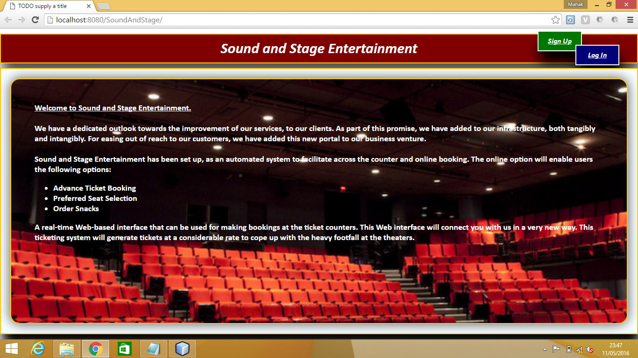

**2.Registration.jsp**

This is user registration page.Here user can register itself..

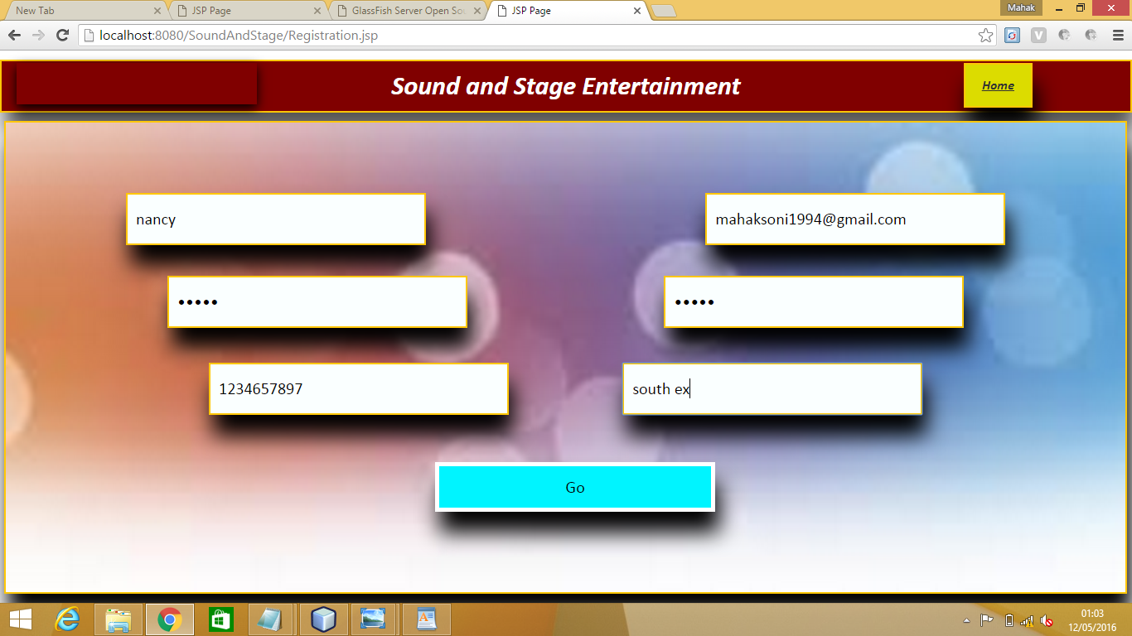

**3.Login.jsp**

This is login page for user and admin.This website can used by Admin and user.Admin can add,update,delete the data for the website.And user can use this website for online ticket booking.

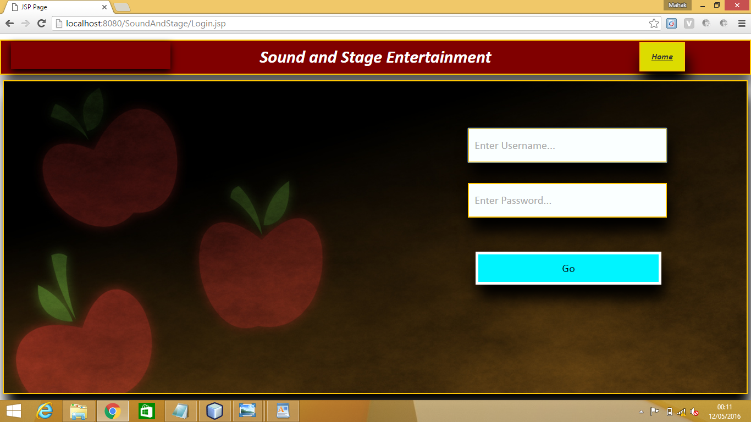

**4.AdminHome.jsp**

This is home page for Admin only.From here Admin can edit,update,delete data by clicking the several links like

Sites,PlanLayout etc.Admin can update data.

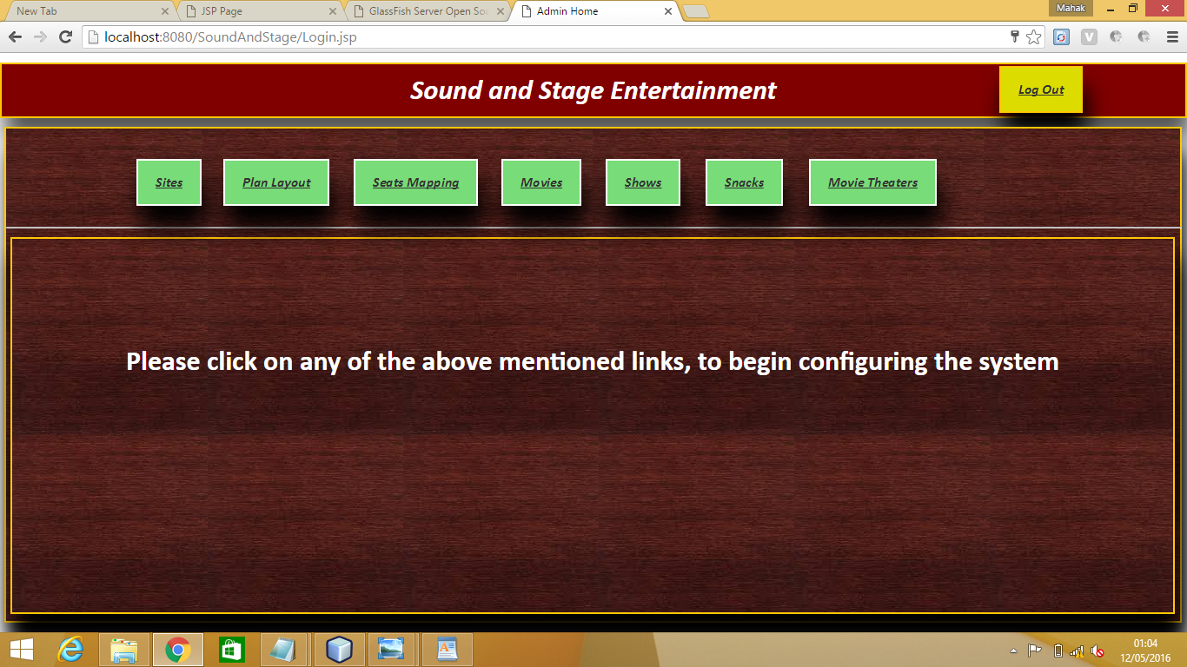

**As shown below:-**

By clicking sites link.

Sites:-

Here Admin add,delete,updateSite name and Site location.

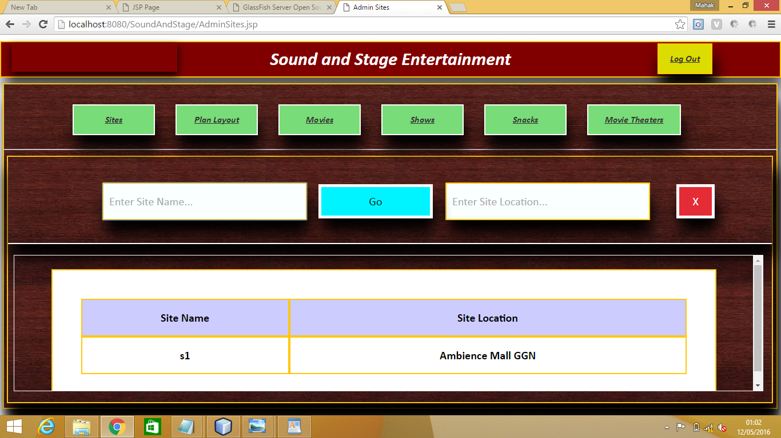

**PlanLayout**

By clicking PlanLayout link.

Here Admin can make sitting planning by entering no. of rows and columns.Seates are managed by Admin.

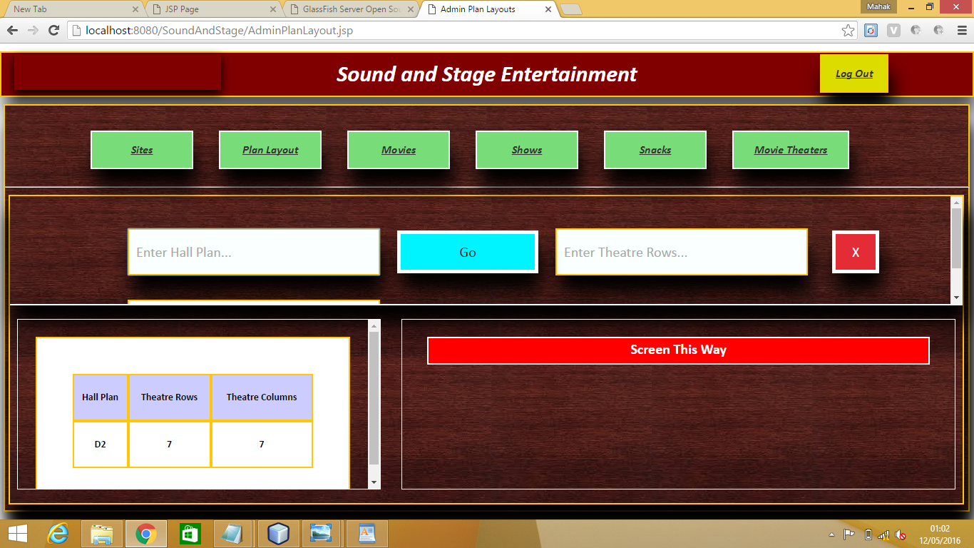

**Movies**

By clicking Movies link.

Here Admin can insert,update and delete the movie name,movie intro,genre,cast of characters.

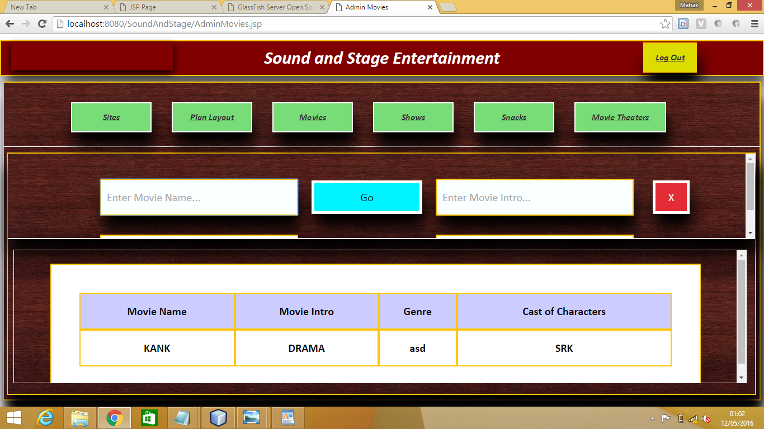

**Shows**

By clicking Shows link.

Here Admin can insert,update and delete Show code,Movie Name,Start Time,End Time,Hall code and Price for the shows.

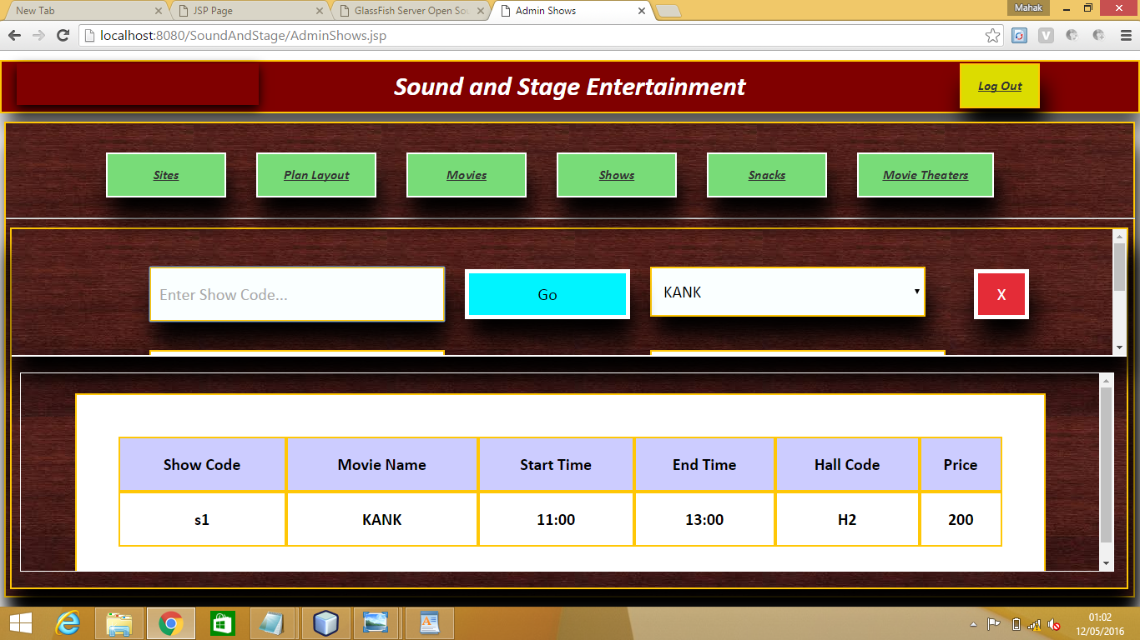

**Snacks**

By clicking Snacks link.

Here Admin can insert,update and delete the snacks available for the customers and their price too.

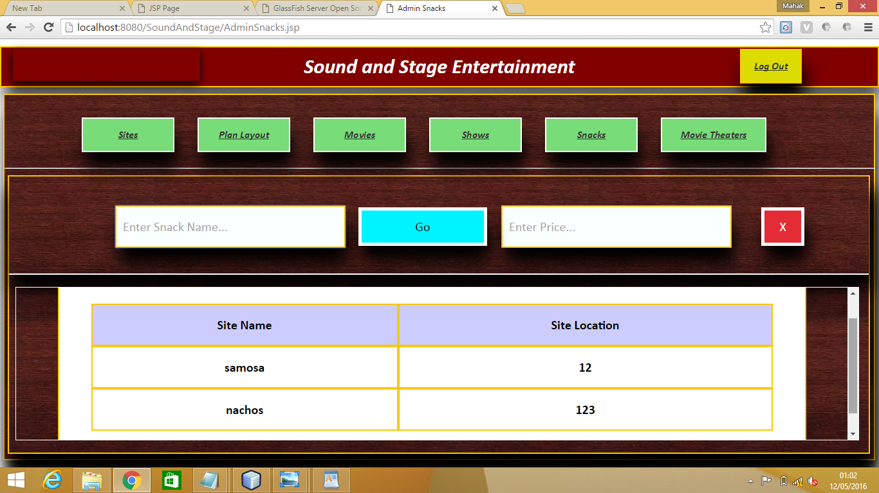

**MovieTheater**

By clicking MovieTheater link.

Here Admin can insert,update and delete the Hall code,Hall plan, Site name and snacks

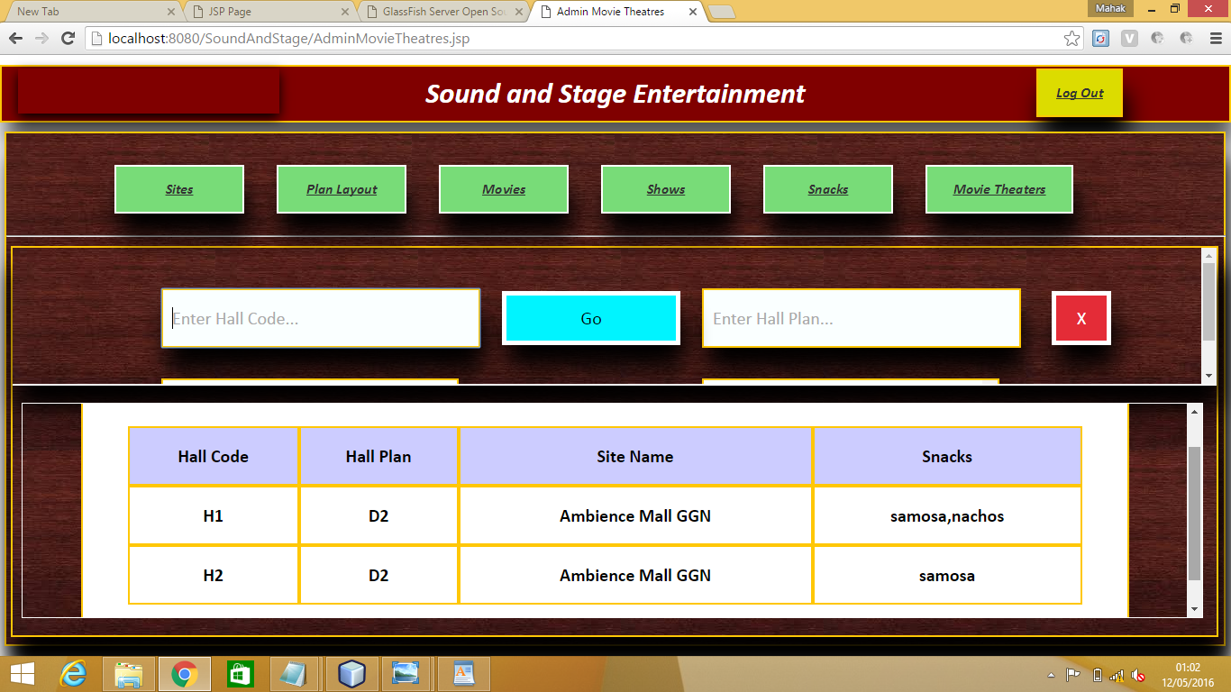

***Logout:*** logout link on each page can logged out user and admin direct from that page to home page.

***User View Movies***

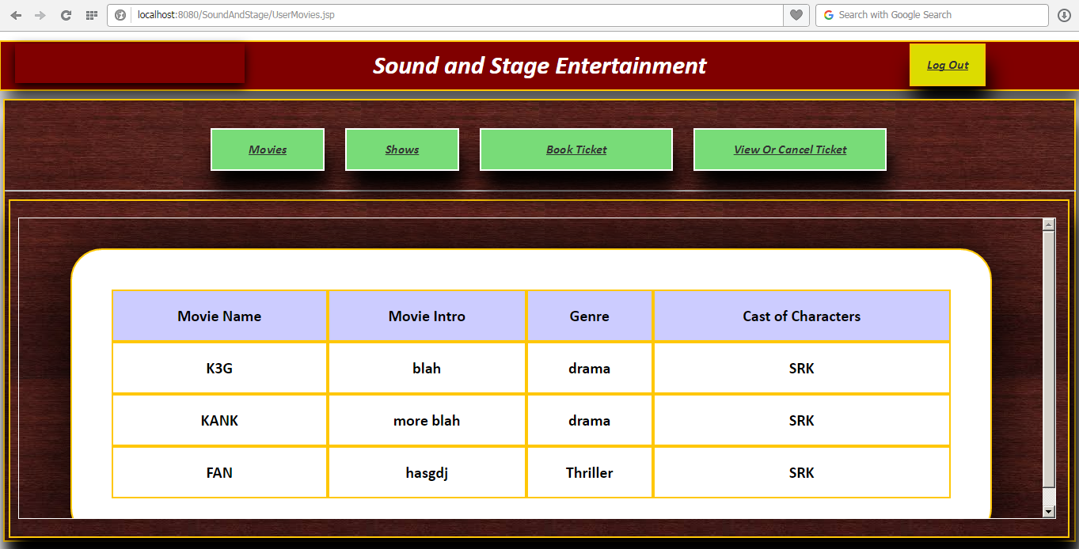

***User View Shows***

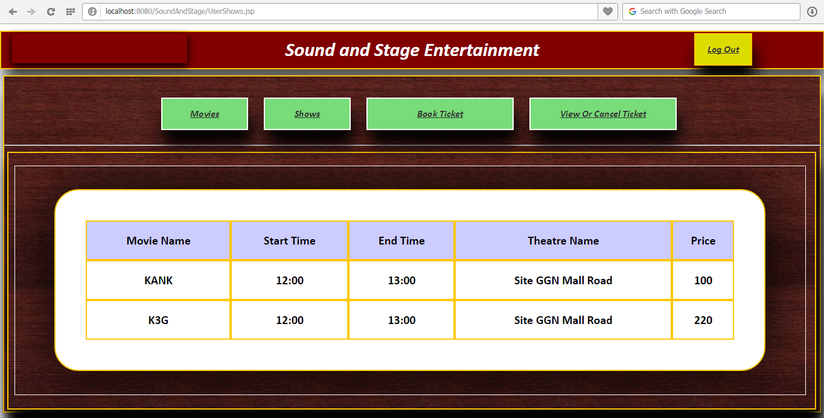

***User Book Ticket – Part 1***

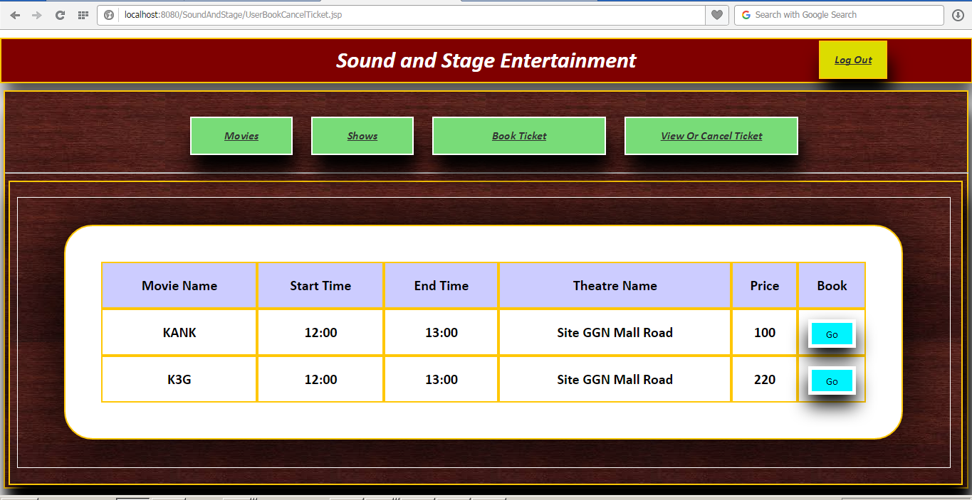

***User Book Ticket – Part 2***

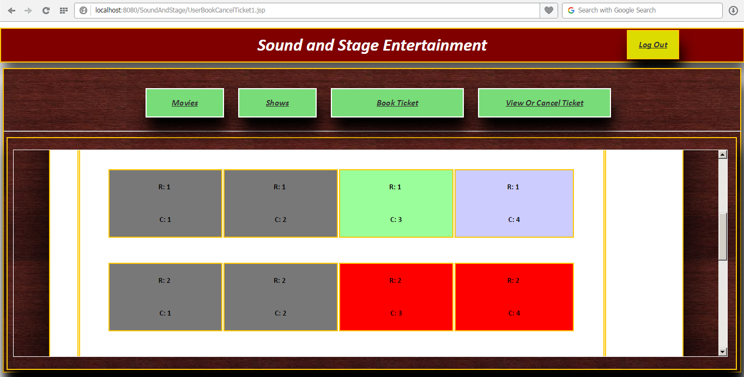

***User Book Ticket – Part 3***

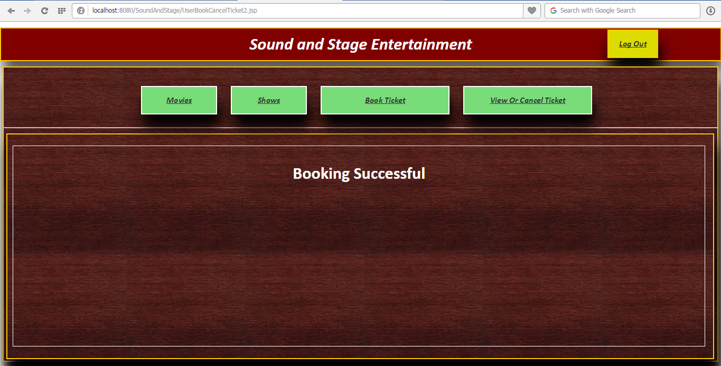

***User View or Cancel Ticket***

